The United States to Support Israel with Billions of Dollars
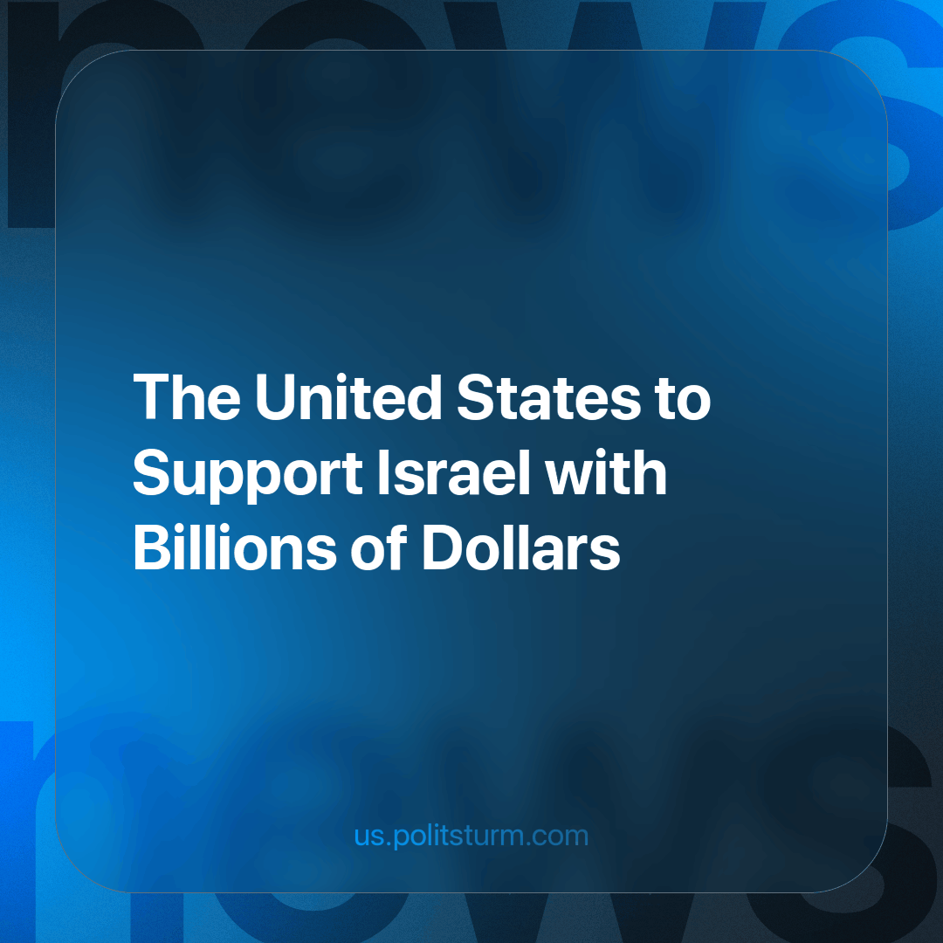

Original article
2023-10-20
2 min read

Israel is the largest recipient of U.S. foreign aid; Washington provides $3.3 billion annually in military aid and an additional $500 million in missile defense funding. The US was the first country to recognize Israel when it declared independence in 1948. The United States has provided Israel a total of $158 billion not adjusted for inflation, according to the Congressional Research Service.
The $3.8 billion dollars accounted for about 16 percent of Israel’s total military budget in 2022 — a significant fraction, but less than the amount that Israel depended on in the past. In 2022, Israel spent $23.4bn on its military, according to the Stockholm International Peace Research Institute (SIPRI), a research institute focused on conflict and armaments. This amounts to $2,535 per capita over the 2018-2022 period, making it the world’s second-largest spender on military per capita after Qatar.
The US continues to support Israel in the recent conflict in Gaza; the most recent shipment of ammunition by the American Military landed Tuesday last week at Israel’s Nevatim Air Force Base. The “Department of Defense” has ordered more advanced fighter jets including F-16s to squadrons in the region, it said this week.
US President Joe Biden also sided with Israel, stating in a formal address that he saw pictures of war crimes being committed by Palestinian armed groups. Unverified info about "beheading of Israeli children" has spread over the internet after the offensive by Hamas began over the weekend.
Since Biden's address, the White House stated that "US officials and the president have not seen pictures or confirmed such reports independently". It was later added that “the president based his comments about the alleged atrocities on the claims from Netanyahu’s spokesman and media reports from Israel”
In the wake of the recent attack by Hamas, it is sending guided missile carriers and F-35s among other equipment, and Congress is likely to authorize additional aid as well.
The continued support of the American capital to Israel shows a clear message of what American capitalists really want: influence in the region, rather than what main stream media coins as American exceptionalism, defending “liberties and freedoms” in the Palestine region.
It is our job as Marxists to dispose of the lies and make clear the capitalist interests and contradictions that started this imperialist war in the first place.
Sources
://www.aljazeera.com/news/2023/10/12/white-house-walks-back-bidens-claim-he-saw-children-beheaded-by-hamas?traffic_source=rss
https://www.washingtonpost.com/world/2023/10/12/us-involvement-israel-gaza-war/
https://www.aljazeera.com/news/2023/10/11/how-big-is-israels-military-and-how-much-funding-does-it-get-from-the-us
https://www.vox.com/world-politics/23916266/us-israel-support-ally-gaza-war-aid

Original article

