The United States Terminates the INF Treaty
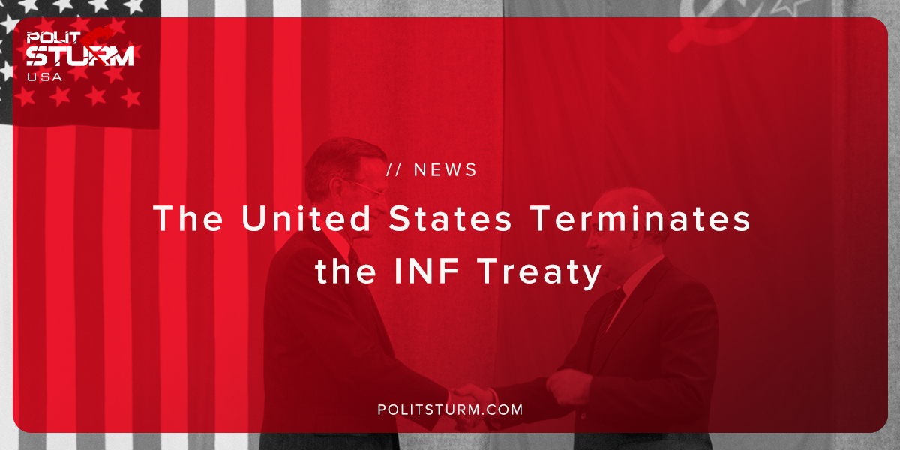

Original article
2018-10-27
1 min read

US President Donald Trump said that his country would withdraw from the Treaty on the Elimination of Medium and Small-Range Missiles (INF) signed between the USSR and the USA in 1987.
“If they get smart and if others get smart and they say let’s not develop these horrible nuclear weapons, I would be extremely happy with that, but as long as somebody’s violating the agreement, we’re not going to be the only ones to adhere to it,” Trump said during a speech in Nevada.
An assessment of the aggressive behaviour of capitalists should be made not on the basis of international relations, but on the basis of class character and economic status.
The economic crisis and the greedy thirst for profit by the bourgeoisie are the main reasons for the movement towards a world imperialist war.
Competition forces capital to grow constantly – if you don’t grow, then a competitor does, and you’ll be in for a crash. The slowdown in growth rates induces capital to go for any crime, at any cost.
With all this, the interests of capital are defended by a befuddled working class, which will suffer all the innumerable disasters of war.
To compulsory familiarization: “Imperialism, as the highest stage of capitalism” V.I. Lenin.
Sources: 1 2

Original article

