The Terrorist Attack in Moscow
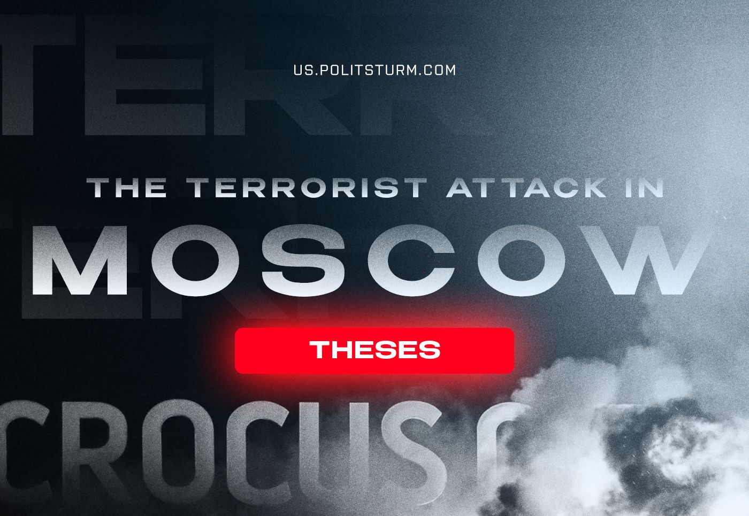

Original article
2024-03-23
2 min read

1. Yesterday in the city of Krasnogorsk in the Moscow region, a terrorist attack occurred in the “Crocus City Hall” building. Before the planned concert, a group of unknown gunmen started shooting and set the building on fire, after which they managed to escape. As a result of the terrorist attack, more than 100 people died, including children, and more than 150 were injured.
2. On the morning of March 23, none of the most likely potential organizers claimed responsibility for the terrorist attack. At night, President Putin’s address to the nation was announced, but later the official media deleted this information, explaining the reason for this as “technical problems”. Western media reported the involvement of ISIS*. Some pro-Kremlin media and officials pointed towards the “Ukrainian trace”.
In the morning, Russian state security published a statement about the arrest of four terrorists in the Bryansk region and indicated that they planned to cross the Ukrainian border and also had “relevant contacts on the Ukrainian side”. Representatives of Ukraine declared non-involvement in the terrorist attack.
3. The most severe repressive laws, millions of security forces, including police officers, the Russian National Guard and the FSB, cameras with a facial recognition system, an Internet traffic control system and huge state budget expenditures on security – all this could not prevent the terrorist attack. Moreover: 3 days before the terrorist attack, the President of the Russian Federation, speaking at the FSB board, called statements about the possibility of these events in Russia “blackmail”.
4. The key questions are who the Russian bourgeoisie will blame as the culprits of the tragedy and what consequences should be expected: a toughening of the reaction, a new wave of mobilization, an escalation of the ‘SMO’, or all of the above.
5. The Politsturm team offers condolences to the victims of the terrorist attack, their families and friends. The main reason that gives rise to such acts of terror is the system of capitalism with its most severe contradictions: the struggle of capitalist groups, endless wars, violence, poverty, oppression and exploitation of millions of people.
Only the establishment of communism can stop terrorism, military conflicts for the redivision of the world and violent deaths.
*recognized as extremist and terrorist organization in Russia

Original article

