What is the Role of Police?
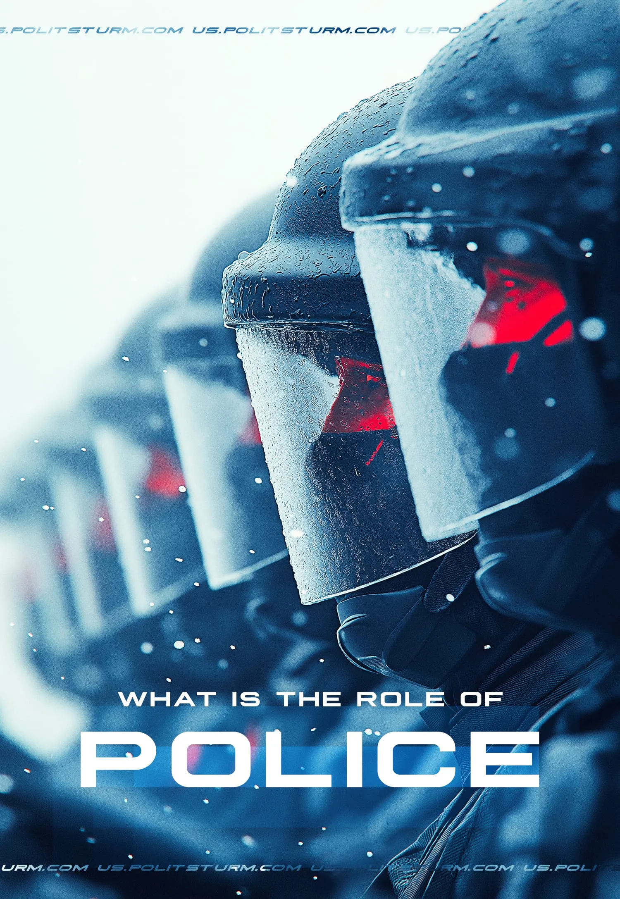

Original article
2024-10-19
15 min read

Feeling safe is one of the things that we begin to appreciate only when we get into danger. Nominally to protect citizens from various types of threats, the state has a number of services and departments. At least that's what we've been told since childhood. Let's examine the activities of such a service as the police and figure out who it really protects and from whom.

The Police as the Guard of the Capitalist Order
The police is one of the public services whose vocation is to ensure the implementation of laws and, in case of violation, take certain measures against the violator. It is postulated that only the police (and other branches of the state) have a monopoly on the legal use of violence. At the same time, the bourgeois intelligentsia (scientists, media, "experts", etc.) always try to hide the essence of the police behind the most general phrases. “The police are a constituted body of persons empowered by a state with the aim of enforcing the law and protecting the public order as well as the public itself." [1]
The first mistake of this definition is that it misrepresents the history of the emergence of the police, i.e. a special structure that monitors "order". The police function is one of the first functions of the state, originating in the Athenian state. As K. Marx wrote: "... public power originally existed only as a police force, which is as old as the state...". (Marx, K. and Engels, F., Op., 2nd ed., Vol. 21, p. 118). Since this function existed at the beginning of the emergence of the state system in general, the question arises of what "order" or, in modern terms, "public order and the public itself" really means. What is the essence of this order?
And here we come to the second problem of general definitions - that the class nature of the police is not widely understood, i.e. what kind of society this police protects from encroachments. If we are talking about modernity, then the police are called upon to protect the capitalist "order", the capitalist state and the corresponding relations of exploitation of man by man.
Formally, the police do not directly obey capitalists, i.e. Bill Gates, Elon Musk or the owner of the company where you work cannot approach a policeman and order you to be arrested. To whom is the police subordinate? It is subordinate to the state. The state, as we know both from Marxist theory and from everyday life, is an instrument of the ruling class to suppress the exploited masses and preserve its privileged position.
Since the interests of the capitalist class are sharply opposed to the interests of the overwhelming majority of the population, the bourgeoisie is forced to hide the class character of its state in every possible way. The bourgeoisie is trying to present this state in the form of an allegedly supra-class, nationwide, in the form of a state of "pure democracy". But in fact, bourgeois "freedom" is the freedom of capital to exploit other people's labor; bourgeois "equality" is a deception that covers up the actual inequality between the exploiter and the exploited, between the well-fed and the hungry, and between the owners of the means of production and the mass of proletarians who own only their own ability to labor.
A striking example is the recent speech by billionaire Elon Musk at a rally of US presidential candidate Donald Trump. While providing media and public support, Musk does not forget to also provide financial help; the New York Times reports that "some of Elon Musk's closest friends" are financing Trump [2]. This is not surprising after all, as Musk has received billions in subsidies in turn from the US state.
The capitalist class implements its class aspirations and will through laws. It is the laws that formalize and try to consolidate the current state of affairs - since 2015, the richest 1% of people own more wealth than the rest of the planet [3].
The law "...is nothing without an apparatus capable of enforcing compliance with the norms of law" (Lenin V. I., Complete Collection of Op., 5th ed., vol. 33, p. 99). And so the police are precisely forcing compliance with the norms of bourgeois law, which is beneficial to capitalists and enshrines their right to exploit the workers who make up the majority of the population.
Based on the above, it is possible to define the police as a system of special surveillance and coercive bodies in exploitative states, as well as punitive internal troops that protect the existing social order through secret or open repression [4].
We have mentioned that all this can be verified by the example of everyday practice:
- Activists opposed to Israel's military actions against Palestine were confronted with an unexpected fact: according to them, there is "collusion between the government, a foreign private arms manufacturer, the Royal Security Service, the Public Prosecutor's Office and the police" [5].
- The demonstrators in Barcelona say that "representatives of the property market from all over the world will meet in Barcelona to deepen the dynamics of robbery and accumulation with which they have been driving us into poverty, evicting us from our homes and destroying the environment for years". A police cordon prevented them from protesting near the ongoing property developers' exhibition. [6]
- During the farmers' protest, Spanish tractor drivers broke through the police cordon and made their way to the administration so that the deputies could personally listen to all the claims and register them in court. At the same time, the protesters threatened to throw the police into the ditch. [7]
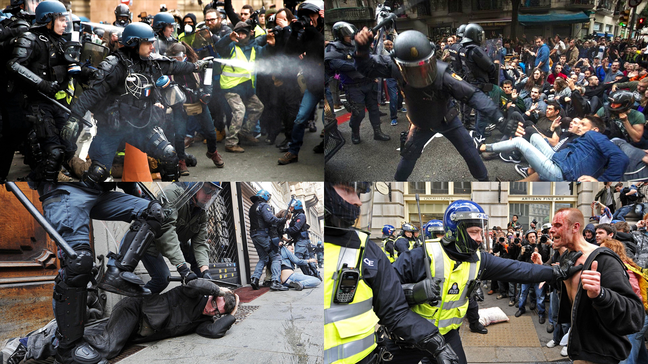
In addition to such news, the bourgeois police regularly break up protests, accusing the demonstrators of violating bourgeois "public order". When workers form picket lines around or block factories, the police or special forces may come to break the blockade. In all significant class confrontations, the police play their role as the enemy of the working class. And they defend not some abstract "social order" but the concrete interests of the capitalists.
Another important nuance is the myth that the police have a monopoly on violence. If you have been to an anti-government rally in Europe, you might really get the impression that unarmed people are being attacked by people with special equipment, with weapons, water cannons, tear gas and other special means. But they are not alone, the capitalists also have personal guards, and the big companies always have a security service which has the same role as the police (to protect the class interests of the bourgeoisie), but they do not protect the bourgeoisie in general, but the very specific capitalists that employ them and their very specific interests.
Speaking of the monopoly of violence on a state scale, in some countries in Africa, Latin America and Mexico, private security companies directly replace the police [8]. Public order is still bad there, but for companies and local capitalists, the necessary level of security is provided by these private security companies. In addition, the cartels or the megacorporations themselves can often take on the mantle of the state in the areas which they control.
If you look at the list of countries where this happens, it becomes clear that these are far from the most prosperous states. The rate of profit is falling all over the world, but capital must grow no matter what it costs. Therefore, the imperialist system itself, squeezes more and more out of the dependent countries, thereby forcing local capitalists to tighten their belts more. And they save, not on their own parasitic consumption, but by reducing the working class's share of the social wealth - defunding education, medicine, culture and now, as we see, on security. The strength of the state represents the collective strength of the local capitalists and the degree of their unified interest, in relation to their counterparts abroad and hostile competing or illegal elements domestically.
The question of the use of this violence and its appropriateness will not be dealt with separately here. The more the working class threatens the position of the capitalists, the more armed and equipped the police become, and the harsher their "responses" to the violation of "public order". In the US, for example, the Black Lives Matter movement began with the story of a black man killed in custody, which the capitalists cleverly turned to their advantage. Instead of class interests, racial issues came to the fore. As a result, instead of criticising the police as defenders of capitalism that oppresses the entire working class, the opposition began to emphasise the racial aspect of the issue and got bogged down in the general problem of the use of violence.
Does all this mean that the police do not catch the real criminals and do not protect society? Bourgeois propaganda can tell us anything, but words mean nothing if they are not backed up by actions. The police, in their "normal" mode, fight criminals, try to maintain compliance with capitalist laws, and fine their own population for minor offences, thereby partially recouping the cost of maintaining them. But as soon as the class struggle escalates and the working class begins to defend its interests, the police immediately begin to openly perform their main function. At such moments, the police do not act as "defenders" but directly as enemies of their own people. They are protecting the interests of capital, not "maintaining public order". But will the police always obstruct the class interests of the working class?

2. The Militsiya Guard the Socialist Order
In socialism, as long as there is a state, there will be a system of institutions to protect the socialist social order. In the USSR this was the militsiya. The militsiya (from the Latin militia – army) is an administrative and executive body designed to ensure the protection of public order, socialist property, rights and legitimate interests of citizens, enterprises, organisations and institutions from criminal encroachments and other anti-social actions [9].
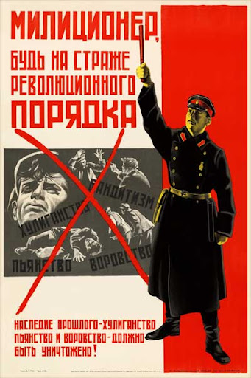
“Militiaman, be on guard of the revolutionary order. The legacy of the past - banditry, drunkenness and theft must be destroyed!”
The role of the militsiya is to protect the interests of the working class, i.e. the vast majority of the population. First of all, the militsiya fought against all the inherited vices of capitalism - homelessness, drunkenness, theft. By identifying the causes, the Soviet militia were called upon not only to punish the criminal, but also to correct him. After all, it is not socialism that creates the conditions for crime, but the previous social conditions and their remnants (some of which still persisted under Soviet Socialism) that create criminal tendencies in people.
If you guarantee people a job, a home, free education, and accessible cultural institutions, then crime loses its "mobilization reserves". The USSR showed us how to actively fight against conditions that give rise to crime - work was guaranteed by law, and homelessness (after the First World War, revolution, civil war) was fought by building a new and expropriating the old housing stock from former elites, housing was provided free of charge. The militia actively fought hard against child homelessness, placing them in families or orphanages. Even the ruthless Cheka, encouraged by their leader, Dzerzhinsky, donated a portion of their salary towards the construction of orphanages.
"I want to throw part of my own efforts and primarily the forces of the Vecheka to combat the problem of homeless children…Two considerations have prompted me to this conclusion. Firstly, this is a terrible calamity! For when you look at the children, you cannot fail to think – everything is for them! The fruits of the revolution are not for us, but for them. And yet, how many of them are crippled by the struggle and by want! It is necessary to rush at once to their rescue, as we would if we saw children drowning…
…I think our apparatus is one of those that work most efficiently; it has branches everywhere. People reckon with it. They are rather afraid of it. And yet, even in such a thing as the salvation and provisioning of children, one meets with negligence and even pilfering! We are steadily going over to peace-time construction, and so the thought has struck me, why not use our militant apparatus to combat such a calamity as homelessness among children?" – F. Dzerzhinsky (From “Communist Morality,” published by Progress, Moscow, c. 1963)
As child homelessness was eliminated, the militia provided a similar function, but for adults. The impact on illiteracy was caused by the policy of likbez (elimination of illiteracy) and the introduction of free education. There was an unprecedented flourishing of culture, which had become accessible to the masses and was put at the service of the working class, not the exploiting classes. Nearly double the books produced in 1912, were produced in 1925 [10]. By the 1950s the USSR would produce and read more books than the rest of the world combined [11]. As a result, there was less crime, because people did not want to endanger ordinary life, and their social conditions were not desperate and did not bring them to a semi-insane state when the choice in favor of crime did not seem so bad.
But only the first stage of communism, socialism, was built in the USSR and it was still stamped with the birthmarks of the society from which it emerged. The remnants of capitalism have not yet been completely destroyed in it. Bourgeois law still existed (in the service of the working class), as well as an entire structure that was engaged in the capture and trial of criminals.
The second point is that since there is a socialist state, it means that capitalism still exists in the world, or that capitalist elements have not been eliminated in the country. And since they exist, they will try to take revenge on the victorious working class in various ways. The militsiya is also called upon to fight against this and to protect the class interests of the workers.
Could the Soviet militsiya have broken up a rally or a workers' strike? They could, if these measures were necessary to protect the interests of the working class as a whole. But did it systematically use violence and intimidation to break up and prevent protests? Did it confront the workers and prevent them from expressing their interests? The Soviet militsiya did not do this, because power belonged to the workers. And it was the workers whom the militsiya served. The Soviet militsiya was only an enemy of the capitalist elements who obstructed or planned to obstruct socialist construction.
This is the main difference between the bourgeois police and the Soviet militsiya.
But for this militsiya to be able to protect the interests of the working class, a socialist transformation of the whole of society is necessary. To organise the working class to this end, a communist party is needed, however, in most countries, no such parties exist. We are already working in this direction, if you want to help us, join Politsturm.
Sources:
[1] - Miller, Eric J. "The Concept of the Police"p. 573-595 (May 27, 2023).
[2] - The New York Times - “Elon Musk Allies Help Start Pro-Trump Super PAC” - July 15, 2024
[3] - Credit Suisse - Global Wealth Report 2016 - November 2016
[4] - The Great Soviet Encyclopedia. in 30 t.. – 3rd ed.. – M. : The Council. Encycl., 1969 - 1986.
[5] - The Guardian “Activists say they have proof ministers tried to influence police over Israeli arms firm protests” - September 30, 2024
[6] - Publico “Police have charged protesters for housing rights at the entrance to the county real estate fair” - September 25, 2024
[7] - Larazon “A group of farmers confronts police in Zaragoza and calls for officers to be thrown into a ditch” - March 1, 2024
[8] - Forbes “Customer Pain: How Private Companies are Replacing Police in the Global South” - October 1, 2024
[9] - The Great Soviet Encyclopedia. in 30 t.. – 3rd ed.. – M. : The Council. Encycl., 1969 - 1986.
[10] - Soviet Union Information Bureau “NEWSPAPERS AND BOOKS” 1929
[11] - The Library Quarterly “Publishing and Book Distribution in the U.S.S.R.” Oct. 1958

Original article

