The Richest Russians Have Become Even Richer
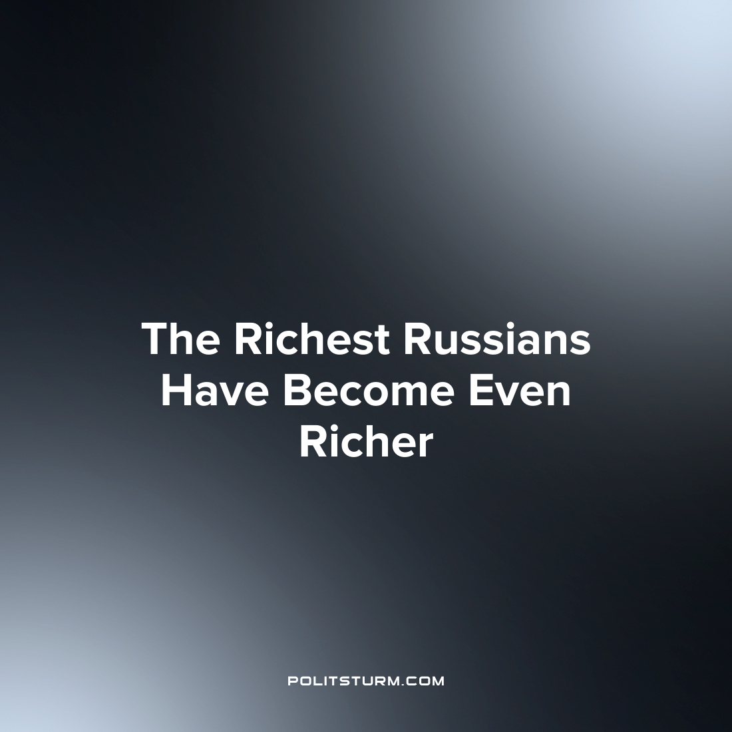

Original article
2023-09-17
2 min read

The total wealth of the richest Russian businessman has grown by $32.341 billion since the beginning of 2023. TASS reports this with reference to Bloomberg's Billionaires Index study.
The Billionaires Index is calculated based on the share price of companies in which billionaires own shares. The ex-head of the oil company LUKOIL, Vagit Alekperov, earned the most money in 2023. Since the beginning of the year, his capital has grown by $7.25 billion and reached $22.6 billion. Chairman of the Board of Directors of NLMK Vladimir Lisin, who increased his fortune by $4.36 billion and reached $24.2 billion, has also become richer, as well as the head of " Novatek" Leonid Mikhelson - plus $3.49 billion, an increase to 28.1 billion.
At the same time, if we evaluate their overall financial condition, the richest Russian businessman remains one of the main owners of Norilsk Nickel, Vladimir Potanin. He also increased his net worth (by $1.13 billion), bringing his net worth to $29.7 billion. Mikhelson is in second place in the ranking, and Lisin is in third.
Previously, Forbes compiled its ranking of rich Russian women, which was headed by the CEO and main owner of Wildberries, Tatyana Bakalchuk. Her capital is estimated at $7 billion, and she received it directly from the Wildberries marketplace. According to Forbes, the company's revenue in 2022 increased by 41%, to 317 billion rubles, and net profit exceeded 10 billion rubles.
At the same time, every fifth Russian said that in recent months his financial situation has worsened. The Public Opinion Foundation reports this, citing a survey. Only 10% of Russians recorded an improvement. For 69%, their financial situation has not changed.
As can be seen, the unequal distribution of wealth in a capitalist society, where property owners get everything and workers get nothing, once again raises the question: “Why do the rich get richer and the poor get poorer?” Fortunately, there is an answer. The whole point is precisely in the existing capitalist system, built on the private appropriation of the results of other people's labor. No reforms, taxes on excess profits, etc. will be able to change the situation of the working population. Only the transition to socialism, to public ownership of the means of production, can reverse this dynamic.
Source: Central trade union newspaper "Solidarity" – «The richest Russians have become even richer» From September 1, 2023

Original article

