The Rich and The Poor: On Poverty in the US
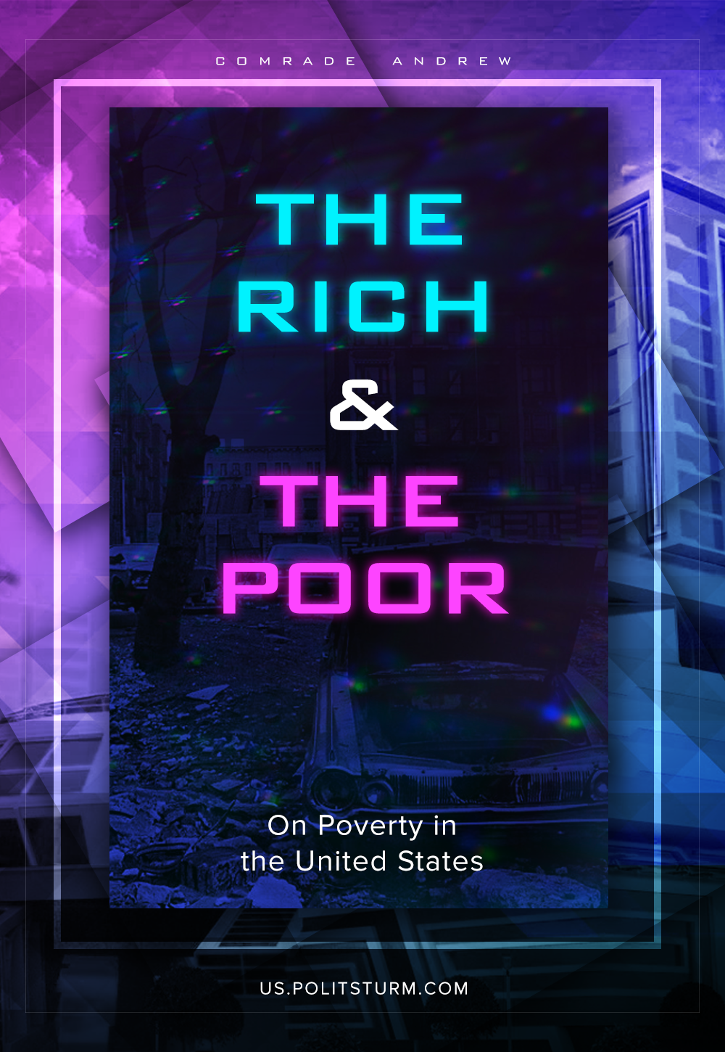

Original article
2021-08-27
4 min read

There are many problems in modern society. One of the most important is poverty. The United States – one of the richest countries in the world – is in fourth place in the world ranking in terms of poverty. The US authorities claim to fight this problem using various payments and benefits, but are they that effective under capitalism?
According to a study by the Urban Institute, which is devoted to the impact of lump-sum payments and other social security programs expanded during the pandemic on the poverty level in the United States, compared with 2018, the number of poor people should decrease from 13.9 % to 7.7 %. Besides, it is expected that child poverty will fall from 14.2 % to 5.6 %.
Meanwhile, Columbia University provided the other data: poverty will decrease from 12.8% to 8.5%. This is due to large-scale social assistance in the form of one-time benefits, an increase in unemployment benefits, as well as new monthly child benefits and an expansion of the food stamp program. However, poverty is expected to increase by 2022 due to the end of a number of programs.
Why is there such a difference? The fact is that the Official Poverty Measure (OPM) was developed almost 60 years ago and is still used today. Thus, it turns out that poverty is calculated on the basis of the food basket and the family income before taxes. This means that various benefits, such as food stamps, housing subsidies are not taken into account. The same thing happens with tax deductions. Moreover, OPM does not take into account housing prices and pre-school education. Because of this, difficulties arise with the most objective calculation of the poverty level.
Therefore, we can not say that such poverty control measures are effective. Moreover, it does not even temporarily solve the problem. This is confirmed by the story of the family, who risks being left without a home due to debts, despite any payments from the state.
For an understanding of how to overcome poverty and unemployment, it is necessary to find their cause.​ The problem lies in the capitalist basis of society. Capitalist logic defends only the interests of capitalists in extracting maximum profit. Therefore, the population receives a miserable pittance, which it is forced to spend on paying debts, buying medicine, paying for housing, and so on, which ultimately returns the money given to the population to circulation. Then the money is redistributed to pay for private companies that fulfill defense orders, to satisfy the interests of the lobby of pharmaceutical companies, the automotive industry, and even for state support of billionaire Elon Musk.
The bourgeois government is really worried about the fate of this particular class, since it exists exclusively in the interests of the capitalists. ​ If capitalism was interested not in obtaining maximum profit, but in systematically improving the material situation of the majority of the population, then this would no longer be capitalism. This is confirmed at least by the fact that the owners of drug manufacturing companies demand hundreds and sometimes thousands of dollars from their fellow citizens for a drug that costs ten times cheaper in Canada or Cuba, where many Americans go to buy medicines.
History teaches us that all these problems can be solved. For example, in the Soviet Union, unemployment was completely eliminated, and the difference in income of the population was leveled by the availability of material goods, which made it possible for the majority of the population to use the achievements of modern medicine, industry and meet their needs. It was all due to the fact that the socialist government was concerned about the welfare of the majority of the population. This became possible only with the abolition of private ownership of the means of production, which deprived the privileged minority of the basis for dictating their conditions.
Sources:
- https://www.jobted.com/salary
- https://worldpopulationreview.com/country-rankings/poverty-rate-by-country
- https://www.urban.org/research/publication/2021-poverty-projections-assessing-impact-benefits-and-stimulus-measures
- https://www.washingtonpost.com/dc-md-va/2021/07/28/broke-again-child-tax-credit-payments-collide-with-debt-eviction-working-families/
- https://www.vox.com/22600143/poverty-us-covid-19-pandemic-stimulus-checks
- https://www.brookings.edu/testimonies/why-the-united-states-needs-an-improved-measure-of-poverty/

Original article

