The Question of Stalinism
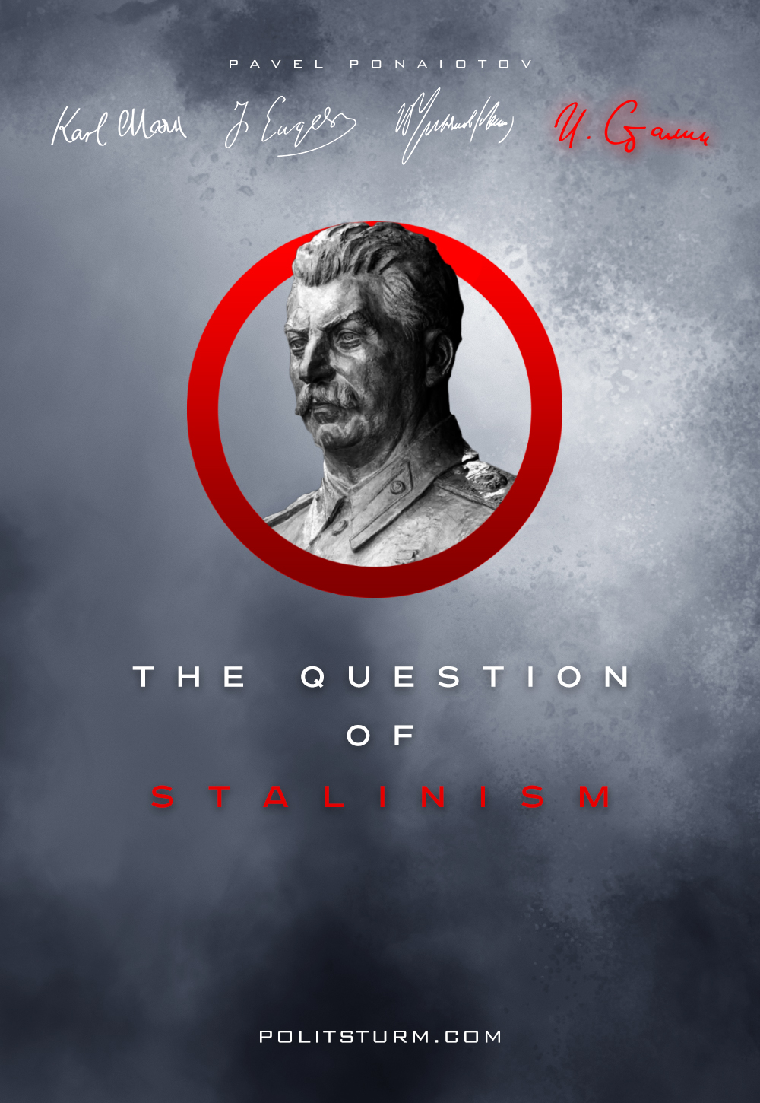

Original article
2017-09-19
19 min read

There exists a certain tradition: naming ideas after a certain person. Cases in point: Christianity, Buddhism, Confucianism, Darwinism, Marxism, Bonapartism, Keynesianism, etc. And figure of J. Stalin also has its own “-ism”. Stalinism became an example of subjective understanding in many discussions, usually having a negative connotation, being a negative branding of sorts. Yet when you are asking people questions about definition of Stalinism, everyone suddenly has their own definition, slightly different from others. That way, we have a term, but no clear definition of it. So what is Stalinism, and does it really exist?
The former researchers and the critics of Stalinism, as well as those who operate with such a notion, acted in an unscientific way. Stalin’s analysis without understanding the formation of the nominal flow is ridiculous. It is understandable, because these people are not interested in truth, but in delusion. Guided by the same science, it is necessary first to find out the principle that underlies the formation of all personal “-isms”. Using the scientific method, at first, we need to know the underlying principle of how “named” movements are coming into being.
The study of the most famous and large nominal currents has led to interesting conclusions. It turns out that every person, after whose name was called the system and/or practice, created something unique in their activities and/or just turned out to be the first one to think up such an idea, such a decision or concept. The principle is similar to why we say “Einstein’s theory of relativity”, “Ohm’s law”, “Mendeleev’s table”, “Pythagoras theorem”, etc. These people were pioneers, and their theories, their constructs, proved to be extremely unique in their kind.
Charles Darwin was the first to put forward a unique position about natural selection as a key mechanism of evolution. Therefore, we are now talking about Darwinism. Hegel first discovered the laws of dialectics (using them then for the movement of ideas, spirit), and in combination with his ideas about the Absolute Spirit, his views on the state, law, etc., created his unique philosophical system. Therefore, we are talking about Hegelianism. So it is possible to tell about each known current. In addition, every pioneer, every creator of a philosophical, religious and ethical system or a theory, soon developed a number of ideological admirers and followers. And these followers not only accepted the ideas of their idol, their spiritual mentor, but propagated them, applied them in practice, and developed them (sometimes creating offshoots). Thus, in order to distinguish the corresponding “-ism”, we need:
– A critical conjunction of unique beliefs, new methods, as well as practical improvements to the system; or the same person was the one to perform truly unique praxis (be it politics, marketing, etc.);
– A wide range of ideological associates and followers of those practices and ideas that were developed by this person.

1. Birth
Now we can look into Stalinism itself. But first – a bit of history. For the first time term “Stalinism” was used by bourgeois journalist W. Duranty while working in Moscow bureau of New York Times. While working in Moscow at the time of industrialization, Duranty described the state of affairs as “Total state control, party dictatorship as well as personal tyranny of J. Stalin”. To describe it in one word, Duranty came up with the term “Stalinism” (analogous to Hitlerism). Some years later, the term was picked up by none other than Leon Trotsky. <Он вообще очень горазд подбирать за буржуазией её терминологию и использовать в своей демагогии, но об этом в другой раз> From 1930-s Trotsky and his followers actively describe Soviet Union as “Stalinism”, and later every opportunist and bourgie bootlicker picked the term as well.
“Stalinism” was predominantly used in political circles – the term was parroted by Anarchists, Trotskyites, Western “Marxists”(aka revisionists) and most of it all by liberals. Then the term leaves the bounds of purely political discourse, seeping into history, sociology, and even psychology. So, by the hand of bourgeois journalists and demagogues like Trotsky the term “Stalinism” became a part of language for Trotskyites, liberals, and wannabe historians. The fact that the bourgeoisie is behind popularity of this term says much about so-called Stalinism.

2. Stalinism as theory
Every researcher who describe Stalinism as a theory list the following attributes of Stalinism:
– Socialism in one country;
– Commodity production and the law of value under socialism;
– Exacerbation of class struggle and strengthening of the state during transition to socialism;
– The need in a state in socialism.
Yes, Stalin did support “socialism in one country”, and worked on practical implementation of it. In 1936, Stalin declared that the creation of socialism in USSR is complete. Yet Stalin wasn’t the author of the idea. First one to come up with the idea of “socialism in one country” was G. Vollmar. In 1879 he wrote about probability and even inevitability of building socialism in one country. Despite Vollmar’s views being not exactly Marxist, they are very telling. But there’s more: in August of 1890 F. Engels writes the following in his letter to Otto Von Boenigk: “To my mind, the so-called “socialist society” is not anything immutable. Like all other social formations, it should be conceived in a state of constant flux and change. Its crucial difference from the present order consists naturally in production organized on the basis of common ownership by the nation of all means of production.”. Yes, exactly “by the nation”. Despite all this, some theorists not only impute that Stalin was the author of “socialism in one country”, but also say that Stalin revised Marxism, perverting Marxist theory. And apparently, Engels was a revisionist too… As a cherry on top – Vladimir Lenin, based on his brilliant knowledge and application of dialectical materialism and the law of uneven development under capitalism, puts forward and develops the thesis about the possible and inevitable victory of socialism, firstly in one country, and about the possible and proper construction of socialism in one country. You can see this in his works such as: On the Slogan for a United States of Europe, The Military Programme of the Proletarian Revolution, The Impending Catastrophe and How to Combat It, The Present Situation And The
Immediate Tasks Of Soviet Power. This is what Lenin wrote in 1915: “The unevenness of economic and political development is the unconditional law of capitalism. Hence it follows that the victory of socialism is possible first in a few or even in a single, separately taken, capitalist country. The victorious proletariat of this country, having expropriated the capitalists and having organized socialist production, would stand up against the rest of the capitalist world…”
Pay special attention to the phrase “… having organized a socialist production …”, this is a very important point. Some particularly dodgy demagogues interpret these words of Lenin in their own way, in their favor. They affirm that here we are talking about socialism as a social movement, and the victory of socialism is only the establishment of the dictatorship of the proletariat. But here Lenin clearly and clearly speaks of the victory of socialism as a social order. Moreover, Lenin says this again: “In order to defeat capitalism in general, it is necessary, first, to defeat the exploiters and to uphold the power of the exploited – it is the task of overthrowing the exploiters by revolutionary forces; secondly, the task is to build new economic relations, to show an example of how it is done. These two aspects of the task of implementing the socialist revolution are inextricably linked and distinguish our revolution … The first task has already been basically solved, but if we do not solve the second task, then our successes, our victories in overthrowing the exploiters, in military resistance to international imperialists will be for naught, and a return to the old will remain unavoidable … The proletariat must now resolve the second task…”
It turns out that Engels and Lenin were not only revisionists, but also Stalinists. It’s funny, isn’t it? Now we go further. Stalin has certainly recognized the necessity of the state under socialism in general and the specific conditions in which the Soviet Union was founded (for example, the capitalist encirclement). However, Engels wrote about the existence of the state under socialism. So in one of his letters to F. Sorge he wrote that the necessity of the state under socialism will be due to the insufficient development of communism, the still insufficient consciousness and education of the working people of the new social system.
But another “malicious revisionist” (according to some) is also worthy of mentioning – V. Lenin. In one of his fundamental works Lenin writes: “In the first phase of communist society (which is usually called socialism), the “bourgeois law “is abolished not completely, but only in part, only to the extent of the economic revolution already achieved, that is, only in relation to to the means of production … But the state still remains in its other part, it remains as a regulator (determinant) of the distribution of products and distribution of labor among members of society. And there is still a need for a state that, while protecting common ownership of the means of production, would guard the equality of labor and the equality of product sharing. The state is withering away because there are no more capitalists, there are no classes anymore, so no class can be suppressed. But the state has not completely died out, for there are remains of the protection of “bourgeois law”, which sanctifies the actual inequality. Full demise of the state requires full communism ”
On the aggravation of the class struggle and the “strengthening” of the Soviet state, J. Stalin first speaks in 1926 in response to the theory of N. Bukharin and L. Kamenev about the kulaks “growing into” socialism, about the fading class struggle. However, the author of this idea is P. Lafargue. In a number of his articles and correspondence, he writes that the successes of the proletariat on the road to build a communist society will inevitably meet the resistance of the broken classes and their representatives, and will exacerbate the class contradictions.
Perfect, isn’t it? Things and theses are being labeled as Stalinism, theses that were developed long before Stalin and not by Stalin entirely. And is there at least something that Stalin developed, since we are talking about his views and innovations? It turns out that at least in some ways our pseudo-researchers of Stalinism are really right – Joseph Stalin was one of the first Marxist theoreticians to put forward, theoretically substantiate and practically apply the provision about the necessity for a certain period of commodity production under socialism. However, they again speak about revision, and refer to Engels’ “Anti-Duhring” and “Critique of the Gotha Programme” of Marx.
In the well-known lines of these works, the classics say that under socialism commodity exchange is impossible, as well as money circulation is impossible. That the product will be distributed by labor cards. But the plaintiffs forget that Marx and Engels here make a superficial prognostic description. They could not know in detail what the realities of the socialist revolution would be. Moreover, at the time, only England possessed the conditions and resources in order to socialize the agriculture immediately to socialism. For other countries, a certain period of curtailed and controlled, dying commodity production under socialism, was necessary.
Commodity production without capitalists and speculators, without exploitation and accumulation, without capital itself, where the labor force and the means of production are no longer commodities. Thus, commodity production under socialism is only a special case of socialist construction at a certain level of development of the productive forces and within the framework of a concrete historical situation. At this point, the remarks from the researchers of Stalinism usually end, but here’s the work of Stalin is not limited to this. Digging deeper, we will see: the theory of the nation, the law of cultural enrichment, the need for party control, the laws of socialist construction, the basic law of socialism, the provision of the need to develop new categories for the economy of socialism, all developed by Joseph Vissarionovich. Strictly speaking, these are all the real innovations of Stalin, all of Stalin’s uniqueness:
– The theory of the nation;
– Party control;
– Commodity production under socialism;
– The basic law of capitalism;
– The basic law of socialism;
– Development of new economic categories for socialism;
– The Laws of construction of Socialism.
And this is categorically insufficient (neither quantitatively nor qualitatively) to distinguish the creativity of Stalin, of Stalin’s ideas in a separate stream, whose name would be “Stalinism”. All this still quite seamlessly fits within the framework of the previous course of Marxism-Leninism.

3. Stalinism as praxis.
If Stalinism is not a theory, then perhaps this is a special political practice? Like Bonapartism or McCarthyism, for example. Many researchers really talk about Stalinism as a special political practice of Stalin, a special political regime tied to the personality of Stalin. All theorists and researchers of Stalinism (gentlemen L.D. Trotsky, R. Pipes, E. Fromm, A.N. Medushevsky, G.Kh. Popov and many others) singled out in Stalinism such defining features as:
– Personal dictatorship and cult of the leader;
– Totalitarianism and police state;
– Command-administrative system and rampant bureaucracy.
Marxism-Leninism teaches us that there is no power of personalities, parties, etc. Power is always in the hands of the class (and its separate faction), comes from the class and is carried out in the interests of the class. There are no personal and party dictatorships, there is only a dictatorship of one class over another and it can’t be any other way in class society. What is meant by the “dictatorship” (the rigid regime of unlimited power of one person) is only an open domination of the class, an open class dictatorship that expresses in the most severe suppression and oppression of exploited classes and strata. Excessive powers in the hands of one leader do not yet make him a power in itself, it’s just the ruling class that gave him carte blanche and the widest powers to execute his will quickly and efficiently. The degree of monopolization and personification of the political system shows us whether the class as a whole or a separate faction is currently ruling. Thus, parliamentary democracy says that the whole class of capitalists politically rules the whole. Under fascism, only one faction of financial capital rules the whole.
But it’s all in theory, so let’s return to Stalin. Being the general secretary of the Central Committee of the Party and later Chairman of the Council of Ministers of the USSR, Stalin did not have absolute “power” in his hands, did not have extensive and extraordinary powers (even during the Great Patriotic War). He was not an autocrat, not n the sense some persons wanted to see. Iosif Vissarionovich completely obeyed all party and Soviet decisions, and depended on them. The so-called “cult” was mainly a grassroots movement, from the masses themselves, and was more a recognition and respect for the merits of Stalin than a “cult”. Certainly, sometimes it went through any reasonable boundaries, both below and above – and Stalin reacted extremely disapproving of such servility and excess.
So, in one of his responses to pharisaism of the functionaries, Stalin writes: “You speak of your devotion to me … I would advise you to throw away the rotten principle of devotion to persons. This is not Bolshevik way. Have devotion to the working class, its party, its state … But do not confuse it with devotion to individuals, with this pharisaical trinket … ” Also, Stalin sharply criticized the impulses of the masses to exalt individual personalities, especially his own. In response to the forthcoming book “Stories about the Childhood of Stalin”, Joseph Vissarionovich himself wrote: “I am strongly against the publication of “Stories about Stalin’s Childhood”. The book is full to the brim with exaggeration and undeserved praise … Booktend to root in children’s consciousness (and in people’s consciousness in general) the cult of personalities, leaders, infallible heroes. Any such book … will harm our Bolshevik cause “. The comparative “youth” of the proletarian state, the presence of a large peasant population in the country (often idealizing leaders) and the remnants of past formations in the minds of the masses, the enormous achievements of the CPSU (Bolsheviks) under the leadership of Stalin in the organization of socialist construction can also be regarded as the reasons for such phenomena. Totalitarianism is a fiction of the bourgeoisie, whose roots go to the first full-fledged theoretician and ideologue of fascism – Benito Mussolini, first in the context of the “total state”. According to this “concept” the totalitarian regime is a regime in which everything is subject to the state and everything is controlled by the state.
However, the state is not an independent entity, it is just an instrument in the hands of the ruling class. In the society of the class struggle, in the society of the domination of a certain class, everything in one way or another is subordinate to this class, works for this class and is controlled by this class (or in the name of this class). Capitalists, without any totalitarianism, even in the most democratic countries, exercise total control over the exploited and oppressed masses, over their competitors and their servants, carry out total propaganda and brainwashing, and, if necessary, pursue a policy of mass or individual terror (for example, the USA with their Echelon program, PRISM, etc., their “Patriot Act” and the prison in Guantanamo, not to mention McCarthyism, the policy of E. Hoover, etc.). The concept of “totalitarianism” allows classes to dominate openly, explicitly, while carrying out the most stringent policy of repression.
On the other hand, “totalitarianism”, when taken without a connection to concrete historical conditions, without connection to classes, allows bourgeois demagogues to demonize both their competitors and the socialist countries. From this sophistic angle, the term “totalitarianism” is applied to Stalin’s policy. That makes such term a meaningless moniker. The command-administrative system was an invention of the bourgeois sociologist and demagogue G.Kh. Popov, who in his articles writes about the Soviet system of social production. As command-administrative system, Popov understands the centralized planned economy, guided by the directives from above. The command-administrative system does not exist, since there are only modes of production and socio-economic formations, and this is precisely the socialist economy in those conditions. And the planning was carried out mainly from the bottom up. As we see, from a political point of view, Stalinism is nothing more than a set of bourgeois myths and cliches. The actual political practice of Stalin as a leader already has its name – the dictatorship of the proletariat. Of course there were errors and bends, and a lot of problems. This was primarily due to the level of class consciousness of the masses, to the level of development of the productive forces, to the historical situation in which the young Socialist state turned out to be and to the difficulties on the road to the construction of socialism. But the surest sign of ignorance is the shifting of the guilt from local and higher leaders to Stalin. As if absolutely all errors and excesses occurred exclusively at the will of one person, his decrees and with his approval. This is an absolutely incorrect position, to impose direct responsibility on one person, on whom “everything depends”.
So, Stalinism is fiction. Uncle Joe continued the work of Marx and Lenin, theoretically developing and practically applying the theory of Marxism-Leninism, always remaining in the mainstream of this theory. A fictitious forgery, a simulacrum of “Stalinism” is needed to replace orthodox Marxism – Leninism and the real practice of the dictatorship of the proletariat. Only the bourgeoisie benefits from the distinction and opposition of Lenin and Stalin to the discrediting of both of them, only it is necessary and advantageous for big capital to single out Stalin’s creative work in a separate independent trend, as it is possible to conceal and obscure Marxism-Leninism so that in no case can we break capitalism and build socialism, build a life without oppression and exploitation, without poverty and human suffering.

Original article

