The Problem of Neo-Colonialism
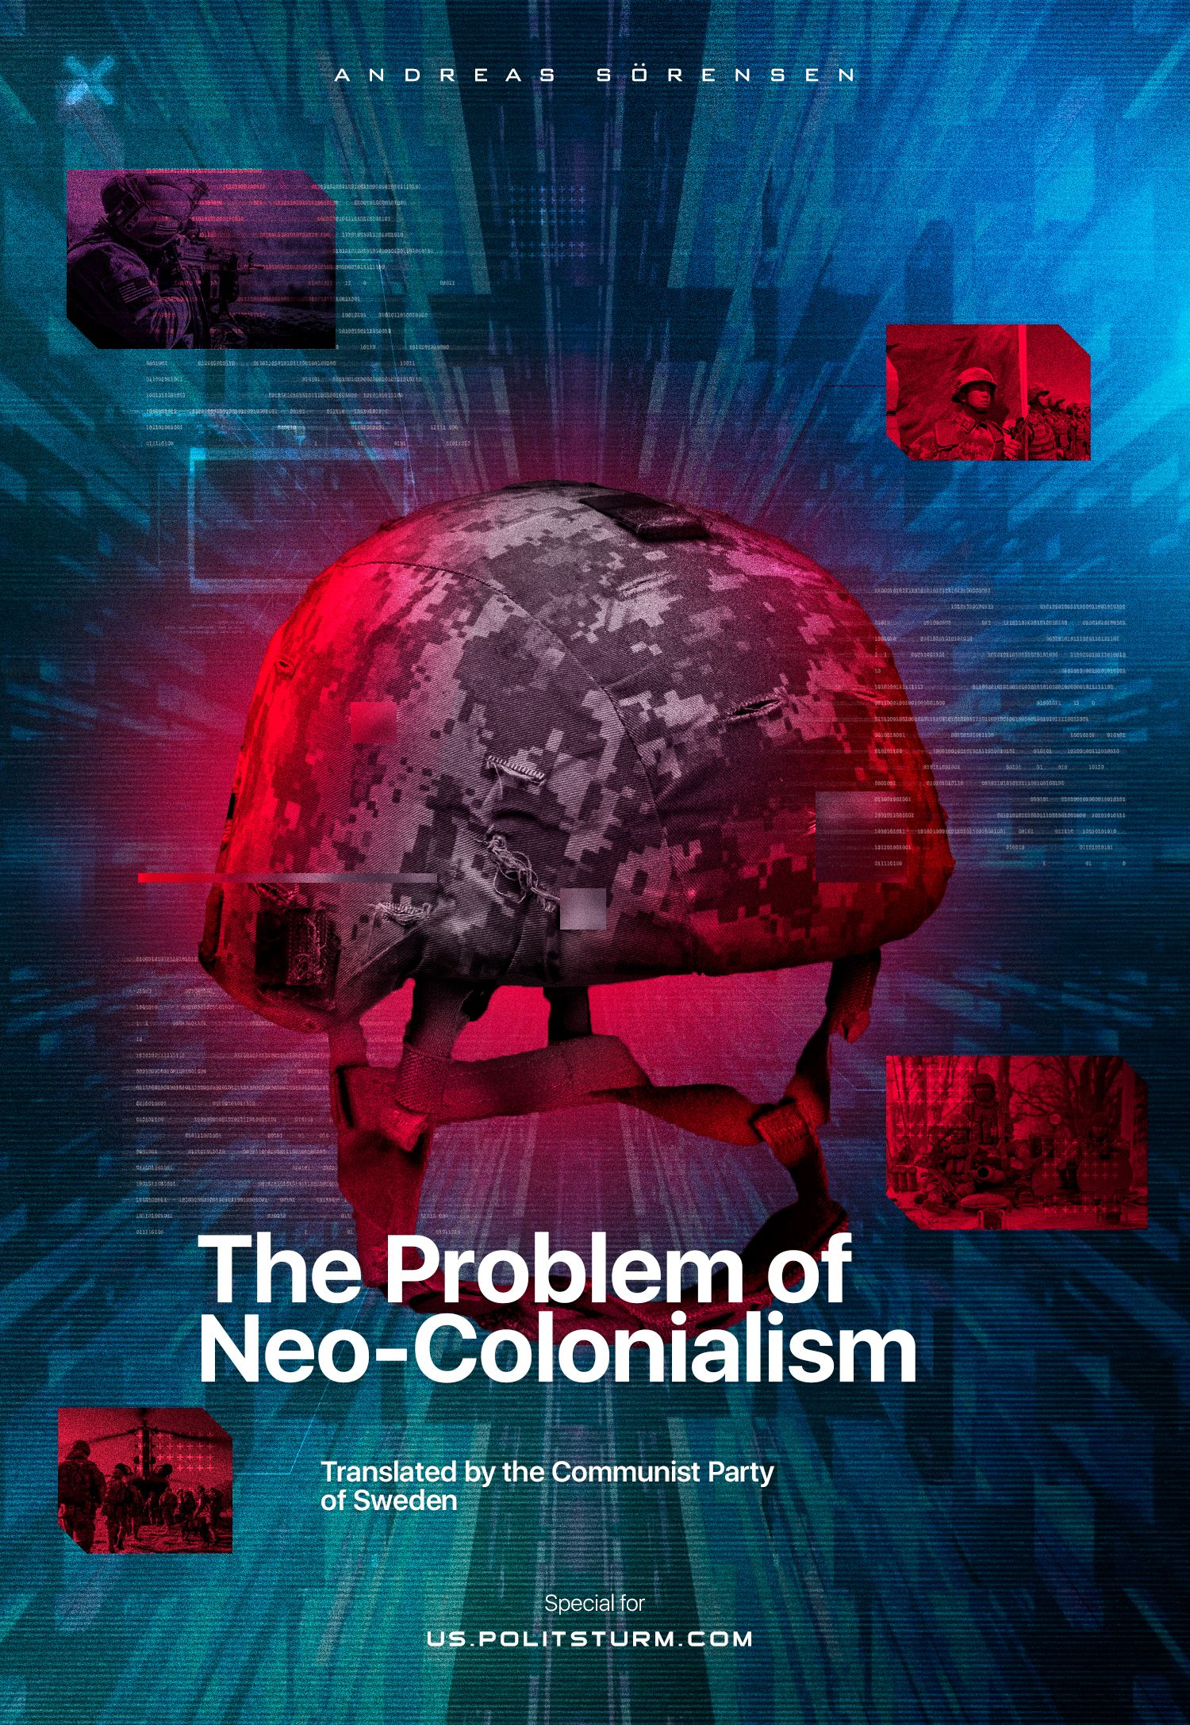

Original article
2023-03-15
11 min read

We continue our collaboration with the Communist Party of Sweden. This article by Andreas Sörensen – the General Secretary of the CP of Sweden – highlights the topic that is quite important. We see the term "neo-colonialism" being used by many politicians, not exclusively left-wing ones. What does this term describe? Does it fit the communist theory? The answers are provided in this material.
The original material titled "Neo-kolonialismens problem" was published in “Riktpunkt” magazine in December 2022.
One of the more diffuse concepts that exists within parts of the communist movement is neo-colonialism. There is no clear and unambiguous definition, nor is it clear what position the concept fills, and the question therefore arises: is it even a necessary concept?
Behind the concept is the first president and most famous freedom fighter of independent Ghana, Kwameh Nkrumah. In the book with the provocative title Neo-colonialism: the Last Stage of Imperialism (1965), he claims to build on the analysis made by Lenin in Imperialism: the Highest Stage of Capitalism. For those who were looking forward to a Leninist analysis, however, disappointment awaits, as Nkrumah's theoretical foundation falters most alarmingly.

What is Neo-colonialism?
The word itself is one of those words that mostly floats free. Many use it, but I guess most who do would have a difficult time defining it. At the same time, it gives the user an authoritative aura: the listener, who does not know how the term can be defined, must assume that the speaker knows and therefore does not question. However, the likelihood is that even the user of the word would have difficulty defining it precisely.
Since we still need a common ground to stand on if a discussion is to be fruitful, we return to Nkrumah himself and (re)discover the theoretical basis of the concept.
From the title of Nkrumah's book, we can deduce one thing: he aimed to describe a level in the development of imperialism. What Lenin could not see, Nkrumah claims to have seen. In a way, of course, this is true, since Lenin never experienced decolonization. The question is, however, whether this gave rise to a new stage or whether Lenin could not already identify similar tendencies.
However, we quickly leave Nkrumah's arrogance behind – in the actual analysis it is clear that this is not a stage in the development of imperialism, but an instrument:
Instead of colonialism as the main instrument of imperialism, today we have neo-colonialism.
The essence of neo-colonialism is that the state subjected to it is theoretically independent and has all the external attributes of the independent state. In reality, its economic system, and therefore its policies, are externally controlled [1].
A short summary of neo-colonialism could thus be: a way of dominating and exploiting former colonies through economic and thus political subordination. With this we also leave the idea of a new stage of imperialism and move, like Nkrumah himself, to consider neo-colonialism as an instrument.

Where and how does Neo-colonialism become an instrument?
Perhaps the easiest place to start is that neo-colonialism – or the attempt to place countries in a neo-colonialist relationship – exists where there is room for it to exist. As an instrument, it becomes timeless and adapts to the needs that exist. Nkrumah wrote his book in the 1960s, but it is not too far-fetched to call the US relationship with Panama, as it stood 100 years ago, neo-colonial, or the French repression of formally independent Haiti, the same. Similarly, one could call those countries which Lenin, in Imperialism: The Highest Stage of Capitalism, called semi-colonial, such as China, Persia or Turkey, precisely neo-colonial.
Here it is important to point out that neo-colonialism as a method and instrument exists where there is room for it and where there is a need for it. It is nothing new, having emerged from the decolonization that took place in the wake of the Second World War. This observation also raises the following problem: if nothing new has taken place that needs new methods and tools of analysis, why is it relevant to replace the concept of semi-colony with the much more diffuse concept of neo-colony?
We must also be clear that the competition for colonies also has an anti-colonial aspect: the non-colonial countries are seeking to strengthen their power over the colonized countries and, in their efforts to detach them from their colonial powers, they are acting as anti-colonialists. See in particular the United States in the period around the First World War, which promoted the slogan of the right of all nations to self-determination for its own benefit.
We must bear this in mind when trying to understand Nkrumah's conclusions. Decolonization created a series of formally independent countries that immediately seemed to become prey in the struggle for the (re)division of the world, and it must have seemed tempting to characterize this struggle for the spoils as precisely neo-colonialism. All of this must also have seemed particularly evident in the context of capitalist underdevelopment in the former colonies – nowhere had capitalism really taken off; the capitalist chapter had not yet begun for many colonies, which becomes central: the former colonies were by and large not yet capitalist and thus lacked their own national bourgeoisie.
Error loading image

The National Bourgeoisie
As the former colonies have become independent, they have also sooner or later embarked on a path of capitalist development, which in turn has created the conditions for the development of a national bourgeoisie in the former colonies.
The creation of a national bourgeoisie in a given country immediately creates a contradiction with the foreign capitalists; there is also, after the creation of national capital, a need to protect one's own market and base for expansion, which is in contradiction with the similar need of foreign capital for expansion.
In its struggle for domination, domestic capital must seek to take greater control of its own economic system and thus also of the political system. In this situation, it also becomes desirable to present one's own struggle against foreign capital as, for example, a struggle against neo-colonialism itself, because for the sake of one's own capital and influence one wants to stop the capital and influence of others. That is why it is important to always bear in mind who is using a term and for what purpose it is being used.
In the final analysis, one simply cannot imagine a national bourgeoisie without some power over the politics of its own country, even if it exists in the field of tension between the various strong capital groups of the different nations. Here I would also like to point out that alliances obviously arise between the various capital groups and interests that exist within different countries, from the least developed to the most developed capitalist nations. In all countries there are capital groups with different interests – some seek their allies in certain places, others seek them in other places. Such an alliance does not automatically mean subordination and exploitation of one party by the other, but the entry of the capital of the different countries into relations characterized by interdependence.
I believe that this becomes of paramount importance in the discussion of neo-colonialism – the use of the term neo-colonialism automatically exposes one to the risk of concealing the web of contradictions that characterizes modern imperialism; national capitals risk being hidden behind ideas of subordination of whole countries and the exploitation of one country by another. We must simply note that many of the former colonies and semi-colonies today constitute regional capitalist powers seeking success for their own capital.
The clearest examples of this are China and India. The former semi-colony of China is now the world's largest economy, and the former colony of India recently took over as the world's fifth largest economy from its former colonial power, Great Britain. Canada, also a former colony and, according to Nkrumah, effectively a "financial colony" of "American-dominated Western capital", is now one of the world's largest economies [2], with Brazil at number twelve and Mexico and Indonesia at fifteenth and sixteenth respectively.
Even outside the largest capitalist economies, countries such as Chile, Nigeria, South Africa, Iran, Turkey, and Egypt play regional roles. Also, further down the hierarchy we find capitalist countries, whose capitalists seek to find their own ways.
To discuss neo-colonialism, i.e., economic, and therefore political subordination, in this context would effectively hide the fact that in these countries there exists a national bourgeoisie with its own interests, which must act according to the same motivations as any other capitalist country: to increase its capital accumulation.

Interdependence instead of Neo-colonialism
There is no state in the world that is in a vacuum. Investment flows in all directions and no capitalist country can stand outside this flow.
This creates an interdependence among capitalists. It creates interdependence between the capitalists of the different countries. Each country is dependent on attracting capital in order to strengthen its own capital accumulation, in order to strengthen its own domestic market and its own position; at the same time, each country is also dependent on being able to export its capital when it is no longer most profitable to invest it in its own country.
If one follows the flow of investments, this becomes clear: Swedish investments flow to Germany and German investments flow to Sweden; Swedish investments flow to Lithuania, which in turn invests in Poland, Belarus and Latvia, while Poland in turn makes large claims on Ukraine for its own capital; Swedish investments flow to Bangladesh, which in turn flow to Myanmar or Ethiopia.
The capitalist world is intertwined, and a system of interdependence emerges, with capitalist countries taking up positions based on strength and capability. They take whatever position they can in the hierarchy and act with whatever means they can when they can. Violence, if necessary and possible. Other methods, if they work better.
The concept of neo-colonialism hides this. Instead, it classifies countries as more or less dominated. A few oppressors and many oppressed. Some independent and many non-independent. It makes the struggle for a given country's capitalist economic emancipation under capitalism the main struggle, when in fact it is a struggle against windmills – economic emancipation is not possible under capitalism-imperialism.

Can we use the term?
For a term to be used productively, it also needs to be defined, and in a serious analysis it must not be used carelessly or arbitrarily. Its use must lie in the fact that it explains the world, not obscures it.
Based on the discussion above, I think we can easily conclude that there is no basis for using the term neo-colonialism. It hides the real relations between the capitalist nations and therefore the reality, which is none other than the existence of interdependence between the capitalist nations and the capital groups of the various countries. The use of the term hides the emergence of national bourgeoisies and national capitalism in every country, even in the least developed countries.
There is also no analytical value in the concept, in that it does not create new categories of analysis that would thus add anything to Marxist ideology. Concepts such as semi-colony already exist in Marxist ideology as just descriptions of specific countries in specific situations. These do not claim to represent stages in the development of capitalism or to be an ideology in themselves.
In discussing the concepts mentioned in the paragraph above, it is also important to point out that Lenin, for example, never denied semi-colonies their aspiration to climb the hierarchy, as is often the case with nations, which are described as neo-colonial.
The conclusion can be no other than that there is no use for the term neo-colonialism and that there is no place for it in a Marxist vocabulary.
Andreas Sörensen
[1] Chapter IX in Neo-Colonialism: The Highest stage of Imperialism
[2] Page 231 in Neo-Colonialism: The Highest stage of Imperialism

Original article

