The Polish Question
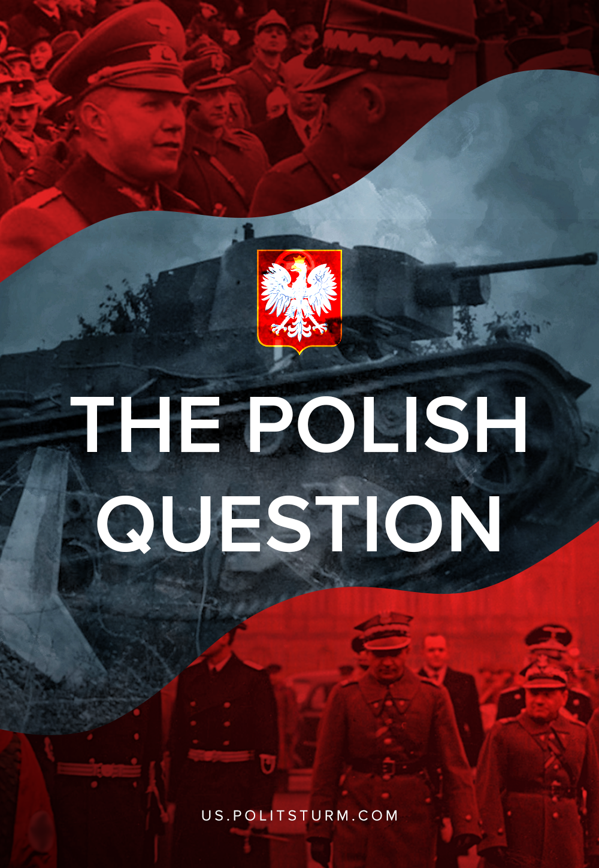

Original article
2020-09-01
22 min read

The fate of Poland and the subsequent Molotov-Ribbentrop Pact haunts every faction of the international bourgeoisie today. The so-called “partition of Poland” is among the most common smeers against the USSR. It’s used by the modern Russian bourgeoisie and the Western clique to present Stalin as an aggressor – seeking territorial expansion like his German counterpart. Particular interest in this topic grew after a recent statement of the Polish government blamed the Soviet Union for the outbreak of World War II. Questions linger over the legality and fairness of the Molotov-Ribbentrop Pact, its “aggression” against Poland, and so we will try to address these issues and put an end to an empty narrative.

The state of Poland
Attention should first be called to the nature of Poland herself between 1918 and 1939.
The Entente’s Versaille Treaty reconstitution of Poland was a landlord-bourgeois state with revanchist aspirations to former territorial glory as Rzeczpospolita: Greater Poland. Initially, the territory of Poland was limited by the framework of the former Kingdom of Poland. However, in the period of 1919 – 1922, the decision of the Versailles Peace Treaty and a special order of the League of Nations granted Poland with German territories – the province of Posen, parts of Silesia and Pomerania, as well as the “free city” Danzig [1].
But this was not enough. Driven by predatory aspirations, Poland looked to invade the young Soviet Union in the hectic year of 1919. Failures of an exhausted Red Army allowed Poland to seize the territories of Western Ukraine and Western Belarus, inhabited by non-Polish ethnic groups[2]; particularly Ukrainians, Belarussians, and Jews. More than 100,000 Red Army soldiers were held in Polish captivity over the course of their campaign. Held in Polish concentration camps such as Tuchola and Strzalkow, at least 60,000 of these men died[3].
The path was clear for the forcible seizure of the border territories of Lithuania, including the capital city of Vilnius. Despite the overtly aggressive and violent nature of this adventure, Polish occupations were officially approved by the decision of the League of Nations in 1923 [1]. But even with this, Poland’s colonial appetites were not satisfied. In 1938, she became an accomplice to the criminal Munich agreement with Hitler, occupying the Cieszyn region of Czechoslovakia[4].
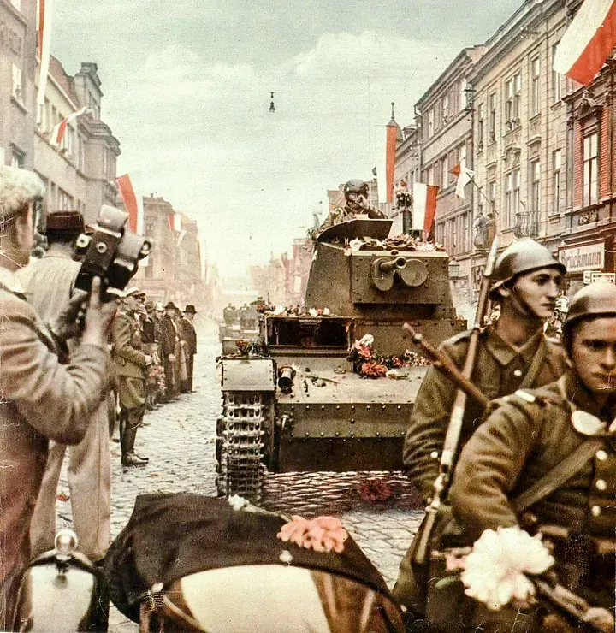
Polish troops in an occupied Czechoslovakian city, 1938.
Poland’s aggressive foreign policy was distinguished not only by military expansion. A key feature of her foreign policy emerged of the international diplomatic situation. Despite occasional cooperation with Germany (a 1934 non-aggression pact, a cooperation agreement, and their joint partition of Czechoslovakia), Poland didn’t want such an ally. On March 21, 1939, Hitler requested the transfer of German territories that had been torn away in favor of Poland. Proposals were made to open a “Polish Corridor” and join the Anti-Comintern Pact. If Poland had accepted these proposals, she, together with Germany, the next step would have been an invasion of the USSR. However, the Polish government firmly rejected German proposals and demands, not out of love for the Soviet Union, but because of a rational assessment of the situation and position of Poland in such a German-led partnership. Lacking a consistent political line, the short-sightedness of its Poland’s leadership eventually led her to disaster. Instead of a peaceful settlement, Poland faced the full military might of the Third Reich. [5]
Poland’s foreign policy at the time was fully consistent with a reactionary domestic policy. Since 1926, a military-police regime had been established in the country. Power was concentrated in the hands of First Marshal Józef Piłsudski. The non-Polish ethnic populations were deprived of basic political and labor rights and freedoms, and subjected to terrible repression. In 1934, a camp was created for the political opposition, including communists. Severe restrictions on the rights of press and gathering were introduced by the regime [6]. The established regime found itself intensely admirous of fascism.
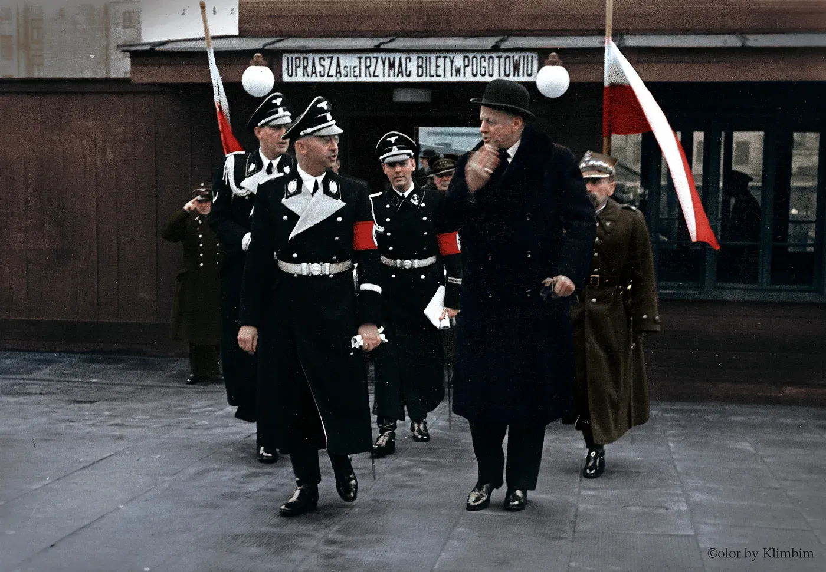
Heinrich Himmler, the Reichsfuhrer of the SS and Chief of the German Police, during his visit to Warsaw. He is accompanied by General Józef Zamorski, the Chief of the Polish State Police and Hans von Moltke, the German Ambassador to Poland.
This aggressively militaristic and repressive Polish Republic, which was so close to fascism, and whose policy led to tragic oppression, would soon find itself in the jaws of death. Its fate was set – without Danzig, Silesia and Pomerania, the Greater Germanic Reich of the German Nation was impossible, and Hitler, avid collector of German lands, would not be rebuffed by such an ‘inferior’ nation as the Poles. Neither Poland nor Britain nor France could defy the German war machine. On March 28, 1939, Hitler tore up the piece of paper he’d signed with Poland and laid hands on the Lithuanian city of Memel, preparing his grand campaign to seize Poland itself. With Poland, the road was opened to the Soviet Union; sworn enemy of all capitalists and fascists, an imperialist’s gold mine of raw resources, labor and captive buying-market.

International situation
Before we read into the Non-Aggression Pact between the USSR and the German Reich and the “aggression against Poland”, let’s examine the international situation of the 1930s which drove the world to misery.
The rise of the Nazis meant one thing – an imminent war for Europe. Two sides of this impending war were already clear; the side of the bourgeois class war against communism in Europe – against the USSR. The communist threat to the bourgeoisie was more than real, and the existence of the USSR as a bulwark of the world revolution, as a living example of the successful building of socialism, always put imperialism under threat. It was necessary to complete what the Entente and the White movement could not do during the Civil War. The other side was the imperialist massacre between Britain and France on the one hand, Germany-Italy-Japan on the other. Slaughter for the re-division of the world, including for the possession of Soviet territories and the Soviet people.
Great Britain and France very much hoped that when their class’ side of this war would make its opening move that Hitler would attack the USSR first. In the hope of this outcome, the guarantors of Versailles and the leaders of the League of Nations – strategically chose not restrain Hitler – indeed to directly empower him. Enshrining illegal annexations and funding the growth of Germany’s military power, the imperialists brought Hitler to the doorstep of the Soviet Union. What they could not accomplish with their White movement expeditions of the Russian Civil War was now to be done by the hand of the fascist Reich.
In 1933, Germany withdrew from the international conference on disarmament. Instead of drafting any retaliatory measures, like economic sanctions or diplomatic isolation, Britain and France simply shuttered the conference. On October 20, 1933, Germany left the League of Nations to finally stretch its legs outside the jurisdiction of international law. Between 1934 and 1935, Hitler both the Rhineland and Saar regions, territories of the German Empire which had since been kept in the protective custody of the League of Nations. In 1935, Hitler further broke with the Treaty of Versailles, accommodated by a naval agreement with Britain. Under the terms of this agreement, Germany gained the right to form a navy equal to 35% of the enormous, world-spanning fleet of the British Empire.
No retaliatory or preventive measures for the withdrawal from the League of Nations, the violation of Versailles, the buildup of military power or the seizure of territories would follow. The League of Nations, led by England and France (as well as the United States) coolly observed the revival of a militarised German industry, even aiding her in these endeavors. With the policy of the imperialists at his back, Hitler could act more boldly to push Anschluss with Austria and foresee the reaction to his moves against Czechoslovakia; upon which Chamberlain would happily exclaim: “which has now been achieved is, in my view, only the prelude to a larger settlement in which all Europe may find peace… And now I recommend you to go home and sleep quietly in your beds.”
Welding the huge industrial capacities and military arsenal of Czechoslovakia to its state machine, Germany became the implicit ruler of Europe. On the eve of World War II, Czechoslovakia was one of the most industrially and economically developed states in Europe. The well-known Czech plant Skoda produced tanks, aircraft, armoured vehicles, artillery and anti-aircraft guns, small arms, and ammunition for Germany throughout the coming war [18]. All this was a free advance from the great capitalists for the promised defeat of Soviet socialism.
Only one country would try at all to secure Europe against Hitler’s aggression, to prevent the capitalist’s war and ensure the safety of it’s peoples, and that was the Soviet Union. So, already in 1933, the Central Committee of the All-Union Communist Party (Bolsheviks) issued a special decree on measures to counter a war in Europe. The decree describes a collective security system – the military-political alliance with European states towards the end of containing Germany, isolating it and protecting each member of this system.
The geography of collective security was constantly changing, but a cornerstone of this strategy was always the participation of Poland [8]. In February of 1934, Poland refused. Repeated proposals within the so-called Eastern Pact produced few results, and later negotiations resumed in 1939 stalled at the uncooperativeness of Poland, leading to the utter failure of any collective security for Eastern Europe.
France, the United States and Great Britain held similar contempt for the proposals of collective security in 1934. However, after the breakdown of the non-aggression pact between Germany and Poland, England and France realized the inevitability of a military clash and even tried to move the matter forward, which resulted in protracted “Moscow negotiations” that were unsuccessful.
The stumbling block of these negotiations was Poland’s categorical refusal to let Soviet troops pass through Polish territory. This matter was vital, first for the defense of Czechoslovakia, then for the defense Polish territory itself. The rationality and necessity of this requirement were recognized by everyone, even the ardent anti-communist and future Prime Minister Winston Churchill, but not Poland itself. Neither Britain nor France would persuade Poland to compromise with Soviet proposals. Referring to Poland’s refusal, they wanted to get the Soviet Union to assume unilateral obligations.
Poland stands alongside all those others who led Europe to war; ultimately guilty of its own destruction.
The fate of Poland was a foregone conclusion, it had no chance whatsoever to withstand the incredible power arrayed by the Third Reich. At the same time, the fate of the Soviet Union too was unchangeably laid before it. Each was well aware that the Polish campaign would be the prologue for a war between antipodes. The Reich also had unspoken allies in the persons of the French and British capitalist whose banking systems and arms industries welcomed the prospect of Hitler’s endless wars. Leading a powerful military Germany had direct and powerful allies in Europe and Asia – the Soviet Union was hemmed in on every side. The USSR, which did not have such well-equipped allies or military support behind it, was not fully prepared for such a war and dreaded a massacre of two fronts – with Germany on its left hand and Japan on its right.
This road has led to a lethal precipice. How could we delay the inevitable in order to best ready ourselves against it, how best to protect oneself when every option has failed? How best, if possible, to secure people from the rumbling earth-slide when all sides have abandoned the cause of peace? In such a dire situation we negotiate the enemy’s expectations diplomatically and arrange some phantasmal guarantees which may be used against them. Such a manoeuvre gains precious time to prepare materials of war and to improve the strategic position at each opportunity.
Thus, on August 23, 1939, a Non-Aggression Pact was signed in Moscow between the USSR and Germany. Protocols on the delimitation of spheres of influence played a key role in this document. Under these terms, the eastern territories of Poland, Latvia, Lithuania and Estonia, as well as lands of Romania and Finland, were transferred to the Soviet Union [9, 10].
Soviet leadership understood perfectly well German intentions for the ethnic German regions of Poland and the destruction of the rest for their colonisation, enslaving all other peoples to German masters. Hitler essentially intended to do the same for all other countries of Eastern Europe: annexation and ‘Germanicized’ collaboration or colonization and extermination. To avoid either miserable destiny, in the name of safeguarding peoples and preserving territories (with their resources, infrastructure, economy and culture intact), the Soviet Union took the liberty of protecting them under the wing of socialism. Intentions for genuine protection are also evidenced by reports of the deportation of 320 thousand Polish people from the bordering territories of the Ukrainian and the Belarussian SSRs in 1940-1941 into the interior of the Russian continent – beyond the grim clutches of Germany and all Nazi atrocities [11].
On September 1st, 1939, the German war machine touched Polish soil. With the collapse of the Polish defense days later, the government fled to neighbouring Romania, and then to England where they would completely embrace Polish sycophancy to British needs. The Polish state had ceased to exist. On September 17th, the USSR Ministry of Foreign Affairs sent this diplomatic missive to the Poles:
“…Warsaw as the capital of Poland no longer exists. The Polish government has disintegrated and shows no signs of life. This means that the Polish state and its government have virtually ceased to exist. Thus, the agreements concluded between the USSR and Poland were terminated. Left to itself and left without leadership, Poland turned into a convenient field for all kinds of accidents and surprises that could pose a threat to the USSR. Therefore, being hitherto neutral, the Soviet government can no longer be neutral about these facts … In view of this situation, the Soviet government ordered the Red Army High Command to order the troops to cross the border and take under their protection the life and property of the population of Western Ukraine and Western Belarus…” [12]
As had been anticipated, it had become necessary to take control of the undefended territories, where fear and chaos already reigned over the multitudes fleeing the atrocities of German occupation. The assumption of state power in these territories created a buffer against the worst system of pogroms in human history, which the Soviet Union overthrew starting with the liberation of Majdanek on July 22, 1944. Based on the facts and the circumstances of imminent war, it is impossible to regard Soviet policy here as a true, expansionist act of military aggression against Poland – an impression confirmed by postwar results.

Liberation and Reconstruction
The course of the war reveals which country best acted for the liberation, restoration and prosperity of the Polish.
Polish bourgeois government had done everything possible to undermine its own security and nothing to meaningfully protect their people from the genuine threats of invasion and genocide. They elicited Nazi subjugation by acting in the interest of their national capitalists, leaving their home unprotected by real allies and abandoning the inhabitants of the Polish Republic to foreign flight and servitude. In the battle for their country, Polish troops were the equal of any nation in resilience and unbreakable fighting spirit. Over 400 thousand soldiers surrendered to the Nazis, and the same number were captured by Soviet troops; 80% of the total Polish army [13].
Poland’s imperialist guarantors – England and France – did nothing to protect or liberate it. For the sake of their own selfish ends, these capitalists undermined the collective security system of the entire continent and shoved Poland into the furnace of total war. Even the conclusion of military alliance and guaranteed military support in the event of German aggression, Britain and France proved to be extremely sluggish and weak. The battle for the Polish Republic is quite rightly called the “Phoney War” – the only effort any Ally made was limited to cynical self-interest on the high seas – far from the fields of Polish slaughter. On September 3, 1939, to Hitler seized upon Poland, and in that period between May 10, 1940, Denmark and Norway, and also made impressive preparations for the French campaign while Poland, England and France put up military resistance … Graciously, the United Kingdom allowed tens of thousands of soldiers and aviators to fight on Churchill’s terms.
The Soviet Union did the most of any nation for Poland and Polish people.
Since 1933, the USSR fought to protect Poland from German aggression, recognizing their importance as ‘German’ territories in the Polish state. The Soviet Union further rejected the “policy of appeasement” that had been pressured by the imperialists and opposed the annexation of Polish territories that the imperialists had facilitated in Czechoslovakia. Collective security supposed, from the very beginning, the participation of the Polish Republic in order to guarantee its territorial integrity and state sovereignty in the Soviet guarantee of protection from aggression and support during the defensive war.
The Soviet Union defended a good half of Poland by concluding this now-condemned Pact with Germany and resettling the Polish population away from the future invasions and infiltrations of Nazism.
Soviet forces, together with the Armia Ludowa and the Home Army, liberated Poland from the Nazi butchers in only 23 days. During these days, 43 thousand Soviet soldiers and about 1 thousand Polish soldiers died together, where over 400 thousand German soldiers were killed. [14]
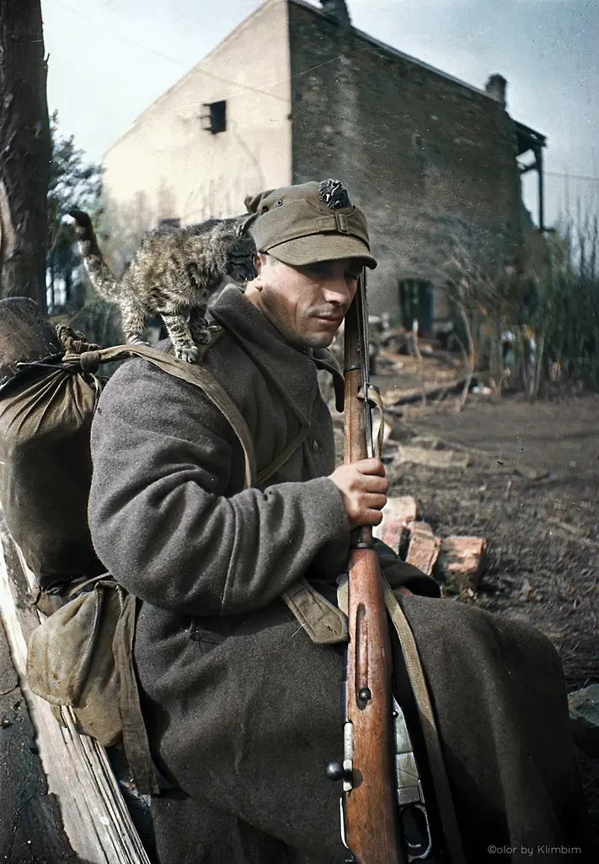
Private of the Polish Army (Wojsko Polskie), 1945.
After the battle against the German occupiers, the Soviet Union provided support in rebuilding the country from the utter devastation of the war. The restoration began even before the end of the war, so already in 1944, after the liberation of Warsaw, the Joint Fund for the Reconstruction of Warsaw was created with the active assistance of the USSR. By the end of July, 1945, Warsaw was significantly cleared of rubble and debris, ruins, etc. (700 cubic meters of ruins were dismantled) by the forces of Soviet soldiers and local residents found themselves with funds received directly from the bare stocks of the USSR. [15]
Three-year plans for the economic recovery of the Polish People’s Republic were developed and implemented jointly by Warsaw and Moscow. In 1947, when Poland was in drought, the USSR sent thousands of tons of food to the country, thanks to which the country avoided mass starvation. Further conclusions were reached in 1948 on the supply of Soviet industrial equipment to the amount of 500 million dollars, which ultimately turned out to be free of charge [16].
In the post-war period, the USSR and Poland arranged mutual resettlement of peoples. Thanks to this, the Polish Republic turned into a mono-national state of the Poles.
To this end, the USSR restored the pre-war Polish territories to this state: Gdansk (Danzig), Poznan (Posen Province), Breslavl (Upper Silesia), Eastern Pomerania, etc. Moreover, according to the decision of the Potsdam Conference, Poland was transferred to a significant part of the territories of Germany to the east of the Oder and Neisse rivers, and part of East Prussia [17]. In the east, only Western Ukraine and Western Belarus were returned to the Ukrainian and Belarussian republics of the USSR.
Polish “government in exile”, that imperialist rump office which the modern Polish state claims to succeed, has done absolutely nothing to accomplish Soviet-era prosperity once enjoyed by the country in nearly 30 years of rule – bringing the Polish people to a historic flight and immiseration.

Conclusion
Any adequate analysis of these matters will show that accusations of hatred by the USSR against the Polish nation are absolutely groundless; tens of thousands of Soviet soldiers gave their lives fighting for the liberation of Poland; an incredible amount of labour and resources of the Soviet people was spent on the restoration of Polish statehood, on the restoration and development of its economy; its infrastructure of medicine, housing, heating, electricity and transportation were all reinvigorated on behalf of the Polish people, as well as funding for cultural institutions. Right-wing opportunists can only misconstrue these efforts as acts of hatred against Poland.
This is despite the open hatred of the Soviet Union by the Polish bourgeois-landlords. Noteworthy again that only its own short-sightedness prevented their regime from successfully participating in the bloody division of Soviet territories.
The Molotov-Ribbentrop Pact was a just, necessary, and legitimate procedure in the event of German aggression. No matter how difficult and contradictory this decision was, there is no other way for genuinely preparing a defense of the great many peoples and territories in the warpath of Germany. The 1939 agreement and subsequent Red Army intervention campaign in Poland were parts of a well-calibrated strategy of political pragmatism and cautious calculation for the ultimate liberation of the Polish people- which was accomplished with the establishment of an independent Polish socialist state.
It should be emphasized that the Red Army’s Liberation Campaign was not an act of aggression against the Polish nation. It did not partition of Polish lands for itself, as Poland had once attempted. At the time of the military intervention, Poland had ceased to exist as a state and as an army force capable of repelling Naziism.
Modern Poland; with its architecture created with the assistance of Soviet architects, with its mono-national character, its infrastructure, independent culture and territories, are a testament to the policy of the Soviet Union. Perhaps the most important credit the USSR has earned is the very existence of the Polish people, their ability to live and prosper, and not to perish at the hands of fascism.
Sources:
[1] И.Н. Земсков и др. История дипломатии. Том 3. Дипломатия в новейшее время (1919-1939 гг.)
[2] Советская энциклопедия. Гражданская война и военная интервенция в СССР.
[3] Ю.В. Иванов. Задолго до Катыни. Красноармейцы в аду польских концлагерей // Военно-исторический журнал. 1993. №12. С.22-26
[4] И.Н Земсков и др. Документы и материалы кануна второй мировой войны. 1937-1939. Т.1, С. 224
[5] С.Б. Переслегин «Вторая мировая. Война между реальностями»
[6] M.Leczyk, Sprawa Brzeska. Dokumenty I materialy
[7] Документы и материалы кануна второй мировой войны. 1937-1939. Т.1-2.
[8] Документы внешней политики СССР, Т. 16, с. 876.
[9] https://en.wikipedia.org/wiki/Molotov%E2%80%93Ribbentrop_Pact#:~:text=Secret%20protocols%20in%20the%20new,dollars%20(31.5%20million%20Reichsmark).
[10] https://en.wikisource.org/wiki/German-Soviet_Boundary_and_Friendship_Treaty_28_September_1939
[11] А.Э. Гурьянов «Репрессии против поляков и польских граждан»
[12] https://histdoc.net/history/molotov_radio_17091939.html
[13] Чеслав Гжеляк «Польская кампания 1939 года. Начало 2-й мировой войны», с. 5, 385.
[14] Г.Ф. Кривошеев «Россия и СССР в войнах ХХ века. Потери Вооруженных Сил», Висло-Одерская операция.
[15] Русский архив: Великая Отечественная. Т. 14 , гл. 4
[16] А.И. Гладков «История социалистической экономики СССР», Т.5
[17] Шайдуров В.Н. История стран Центральной и Восточной Европы с древнейших времен до конца XX в. С.17
[18] Spielberger, Walter J. (1990). Die Panzer-Kampfwagen 35(t) und 38(t) und ihre Abarten (2nd ed.). Motorbuch Verlag.

Original article

