The Plight of Asylum Seekers in Great Britain


Original article
2023-08-26
17 min read

In Great Britain, there has been an ongoing crackdown on asylum seekers as the government seeks to distract workers from their most immediate and pressing concerns (i.e., the cost of living), and redirect them towards asylum seekers. The government claims that the asylum seekers are responsible for the lack of funds available for wage raises, and as such seeks to shift popular discontent onto this vulnerable minority.
A previous development on this issue was the British-Rwandan asylum deal, which we have previously covered, where asylum-seekers would be deported to Rwanda. It has since been revealed that should the still ongoing Rwanda deal fall through, the government plans to send the asylum seekers to Ascension Island, an 88km² island with a population of 806, and a lack of infrastructure to cope with the influx [1].
Asylum seekers are categorised as “legal” and “illegal”. The legal asylum seekers are people who have gone through the official channels to apply for refugee status and have either been granted it outright or reached a certain stage of the process, allowing them to legally live in the UK. Illegal asylum seekers are people who have undertaken the perilous journey across the channel in small boats and have requested to begin their application process for refugee status after having arrived in the country.
In 2022, 45% of asylum applications were made by illegal asylum seekers [2]. Many of these illegal asylum seekers are trafficked by smuggling gangs who prey on their desperation. Very often they are duped into taking huge loans out to pay for the smuggling transportation costs, and as such are compelled to make it to Britain in debt slavery to the gangs.
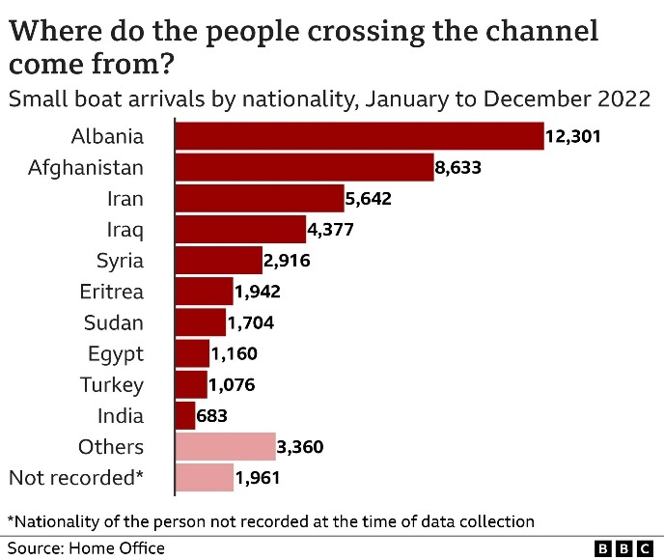
Asylum seekers are desperate people who are fleeing war, persecution, violence or extreme poverty and very often are from countries where the British military (acting in conjunction with other Western militaries) is (or very recently was) actively securing the interests of British (or Western) monopolies who are largely responsible for the dire straits of said dependent country. The most common nationality of asylum seekers is Albanian, followed by Afghani, Iranian, Iraqi and Syrian [3].
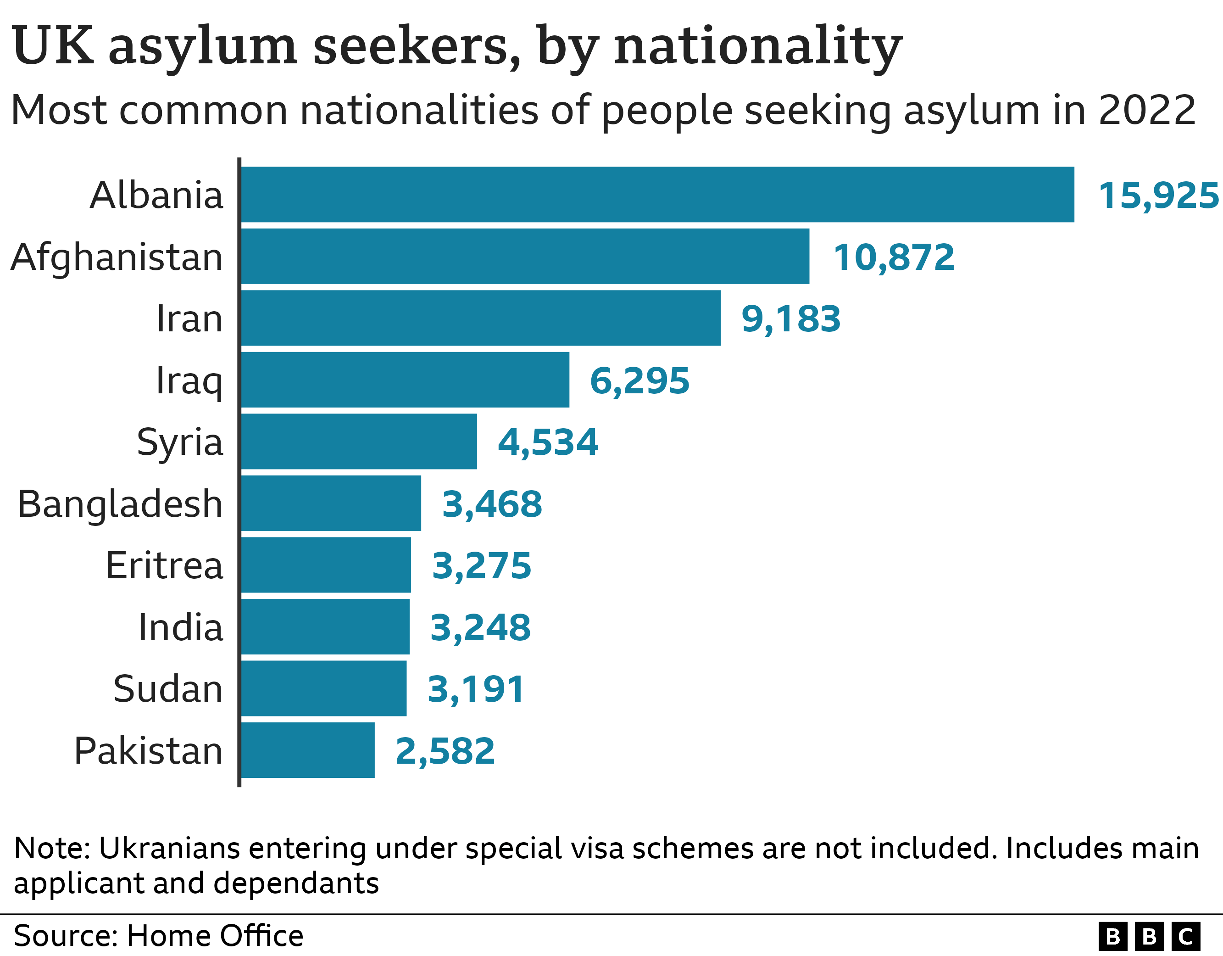
Albania is not a war-torn country, and as such the government seeks to vilify Albanians, especially for seeking a better life in the UK. However, Albania is the poorest country in Europe with a 30% poverty rate (defined as less than $5 a day) [4] according to World Bank data. In addition, the Albanian asylum seekers are largely from the north of the country, in regions where over 50% of households’ main source of income is social assistance and benefits. Previously, during the People’s Socialist Republic of Albania, these regions had productive mining industries which have since all been sold off, leaving the people with no livelihood or future prospects. The desperation that this poverty creates is great enough for Albanians to join the Afghanis, Iraqis and Syrians in taking the perilous illegal journey by small boat.
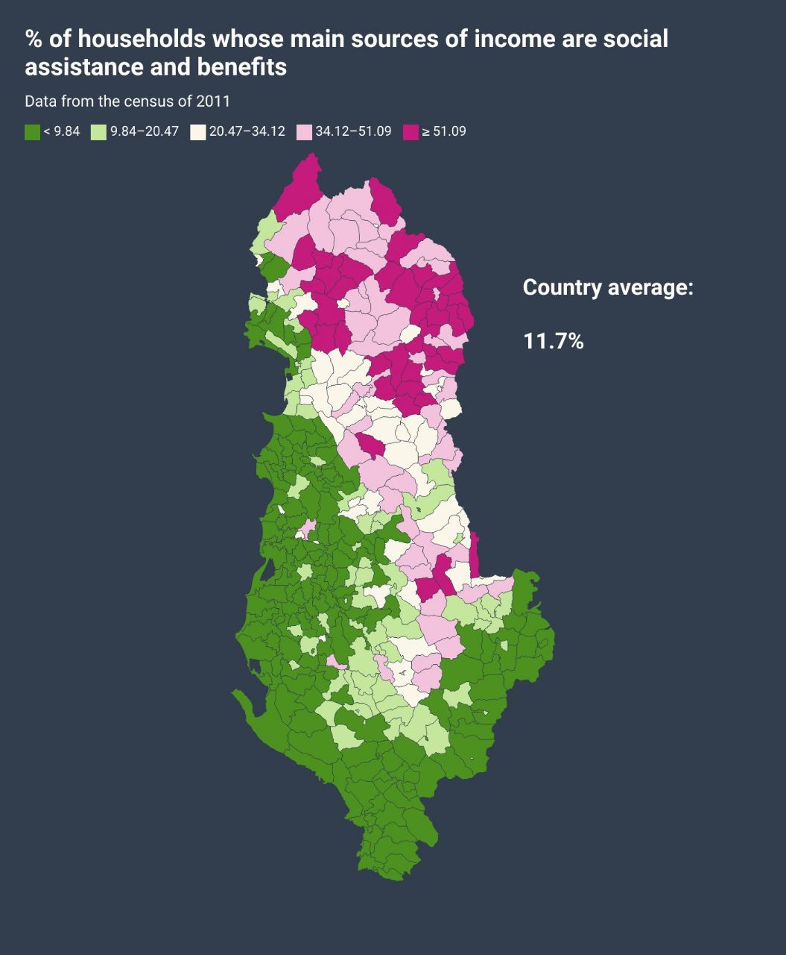
Over the past year, it has come to light that the British government spends over £6 million a day of taxpayer money, or nearly £2.2 billion a year to accommodate the 51,000 asylum seekers currently residing in hotels across the country [5]. This became a media spectacle and fuelled resentment towards refugees from the most reactionary and unstable section of the workers who are struggling with the cost of living under the current capitalist crisis and are easily duped by the ruling class. The resentment manifested itself in many anti-refugee protests around the country (often organised by the far-right) [6] including violent protests [7] and encouraged with statements by the current Home Secretary, Suella Braverman, of the ruling Conservative party, referring to the illegal migration as an “invasion of the South Coast” [8].
Additionally, the Home Secretary has insinuated that “simply being gay…is sufficient to quality for protection”, despite the fact that only 1.5% of asylum claims over the last year had sexual orientation as part of the claim [9].
Public opinion is fairly split on the issue, with 42% of people saying that they support the government's new more hard-line approach towards “small boat” asylum seekers, 39% say they oppose it and 20% don’t know, according to a YouGov poll [10]. To these groups it appears as if the government is spitting in their faces, letting British people starve and go homeless on one hand while lavishly showering the refugees with luxury hotel stays and free handouts for months and even years on end. Upon deeper examination, the truth is revealed. As Marx said in the introduction to A Contribution to the Critique of Hegel’s Philosophy of Right “To be radical is to grasp the root of the matter.”
First, let us examine the condition of the hotel accommodation and the experience of the asylum seekers there. The report “Lives on Hold: Experiences of People Living in Hotel Asylum Accommodation” published in July 2022 by the Refugee Council outlines the problems [11]. It states that “Living in the hotels is mentally and emotionally exhausting for all involved. Often suffering from physical and social isolation, clients struggle to integrate into their local communities due to a lack of access to local opportunities, clothing, public transport, mental health support and English classes.” Many asylum seekers have to grapple with mould and bed bugs which are not dealt with for weeks or months on end, entire families crammed into a single hotel room, lack of access to healthcare and sometimes even a lack of access to basic sanitary facilities [12].
It is not surprising that a welfare concern about asylum seekers in hotel accommodation is reported to the Home Office on average every 30 minutes, according to the Independent Chief Inspector of Borders and Immigration (ICIBI). Furthermore, other problems experienced by “accommodated” asylum seekers are a lack of or broken central heating, leaky ceilings and overcrowding in rooms shared by strangers [13]. Moreover, aside from poor living conditions, the asylum seekers are confined to their rooms for months and sometimes years on end with nothing to do as they are not legally allowed to work and their allowance is insufficient for the basic essentials let alone any entertainment or educational material.
These conditions, which are reminiscent of prison, are extremely taxing psychologically for people whose only “crime” was to flee violence or poverty, leading to a plethora of mental health issues including depression and suicide idealisation, which is especially horrifying for the many unaccompanied children asylum seekers staying at these facilities. The measly stipend that asylum seekers are granted is £6.77 per day for food, clothing and toiletries and this is reduced to £1.37 per day if the accommodation provides food [14]. Often there are delays with receiving even this meagre amount or the ASPEN card which they need to access the funds.

An example of a meal provided by accommodation for asylum seekers
So now the question must be raised: why is the government paying £6 million per day for such dilapidated accommodation? And for reference, if we divide the £6 million by the 51,000 asylum seekers, we arrive at around £117 per day for each asylum seeker’s hotel accommodation. The average price of a stay in a hotel room in the UK per day (according to an analysis of nearly 13,000 hotels) is £89.03 and the median price is £83.51 [15]. This reveals that the price that the government is paying for the shoddy accommodation offered to asylum seekers is higher than an average British hotel room, and bearing in mind the fact that asylum seekers are often crammed with multiple occupants per room the price the government is paying per room is likely more than double the national average!
The answer to the question about the reason for this exorbitant price charged to the taxpayer lies in the fact that the money is not paid to the asylum seekers directly themselves each day for them to seek hotel accommodation on their own, but directly to specific hotels they have deals with, which are private enterprises. The government guarantees this £6 million daily revenue of taxpayer money for the owners of the hotels, and the hotel doesn’t have to provide the same service it does to paying customers. For example, the firm Mitie has a contract worth £627 million for housing asylum seekers, Clearsprings have been awarded contracts worth £996 million since 2010, Mears has won three 10-year asylum accommodation contracts worth £1.15 billion and the largest is Serco, which has received £2.18 billion [16].
And government MPs (who are often capitalists themselves) often take money-spinning advisory board roles for these companies specifically and monopolies in general – often at the same time that they are performing their government role. For example, conservative MP Crispin Blunt earns £117 an hour on the board of Belvedere Hotels Limited, which is involved in accommodating asylum seekers in 50 hotels across the South of England [17]. The hotels can easily (and have) cut corners on safety, comfort, quality etc. for the asylum seeker occupants as they are guaranteed their income by the capitalist state. This thesis is further evidenced by the fact that this arrangement was initially “temporarily” enacted during the pandemic when the hospitality industry was struggling and was bailed out by the government, and has since ballooned as the government and hotel industry capitalists reap dividends on this mutually beneficial and very lucrative scheme.
And popular discontent towards the burden on the taxpayer can be effortlessly misdirected by the government towards the asylum seekers themselves, instead of the capitalists that profit from this arrangement. Both the asylum seekers and British workers lose and suffer, while the capitalist state and hotel owners win. This process is very characteristic of the imperialist stage of capitalism that we live under; where the dominance of monopolies and finance capital is established. However, this process had begun as early as the 19th century, as Marx outlines in Part I of The Class Struggles in France, 1848 to 1850:
“Since the finance aristocracy made the laws, was at the head of the administration of the state, had command of all the organized public authorities, dominated public opinion through the actual state of affairs and through the press, the same prostitution, the same shameless cheating, the same mania to get rich was repeated in every sphere, from the court to the Café Borgne to get rich not by production, but by pocketing the already available wealth of others, Clashing every moment with the bourgeois laws themselves, an unbridled assertion of unhealthy and dissolute appetites manifested itself, particularly at the top of bourgeois society – lusts wherein wealth derived from gambling naturally seeks its satisfaction, where pleasure becomes crapuleux [debauched], where money, filth, and blood commingle. The finance aristocracy, in its mode of acquisition as well as in its pleasures, is nothing but the rebirth of the lumpenproletariat on the heights of bourgeois society.”
Unfortunately, the plight of the asylum seekers does not end here; it gets even worse. Due to the discontent that the government has stoked regarding the situation of asylum seekers, they are also publicising their search for alternatives to the “lavish” hotel stays they are offering. The latest development is the barge “Bibby Stockholm” which can hold 500 asylum seekers in 222 cabins. Costing £7.3 million per year to lease, it is a saving of less than £10 for the taxpayer per migrant, placing it still well above the national average price of a hotel room, revealing it to be another corruption scheme [18]. The barge was previously used for housing homeless people and construction workers but has been refitted with bunk beds and other modifications to greatly increase its capacity.
It is symbolically moored off the Isle of Portland in the exact same location a prison ship used to be. As usual, the government made conceited announcements about how generous and suitable the barge was, however barely even a week after it had started to be occupied, not only were they showered with complaints about the terrible living conditions, but Legionella bacteria was discovered in the water supply on the 11th of August [19]. Legionella bacteria can cause Legionnaire’s disease, a form of pneumonia with a 10% fatality rate [20]. Conservative MP Lee Anderson, during that week, stated that refugees who do not wish to be housed in the barge should “**** off back to France” [21], a statement that the Prime Minister agreed with and defended [22].
In the wake of these statements, on the 12thof August, six Afghani asylum-seekers drowned in the English Channel attempting to make the journey on a small boat [23]. The mayor of the Isle of Portland, Carralyn Parkes, attempted a legal challenge against the government arguing that the barge is in violation of planning laws, as well as the 2010 Equality Act. However, on the 11th of September, the High Court ruled in favour of the government; the barge remains [24], and it will be re-occupied by asylum seekers on the 16th of September [25].
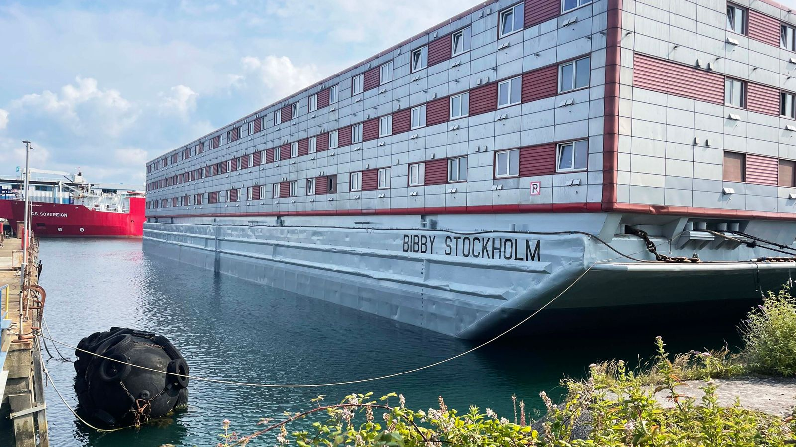
The barge “Bibby Stockholm”
Facing pressure to deal with asylum seekers in a more cost-effective way, and unwilling to actually take care of and assist them them, the government has now pledged to process all “legacy” asylum claims (defined as those made before the 28th of June 2022) by the end of 2023. What this means is that the government will grant or reject each of the over 50,000 asylum seekers that fall into this category. Of those who are accepted as refugees, they will have at most 28 days (in some cases as little as 7 days) to find alternative accommodation, as well as a job, or apply for unemployment benefits, before they are kicked out [26].
As one can easily imagine, as this would not likely not be enough time for a normal British citizen to make an entirely new life for themselves, it is certainly not enough for a refugee who has arrived in the country with nothing and is unfamiliar with the local language and culture. Even if they could afford rent (which, on average costs 40% of income), it is difficult to find housing at all in such a short time span due to the current housing shortage [27]. As a result, this measure will likely doom a significant proportion of the refugees to a fate of homelessness and social ostracization.
The capitalist state’s attempts to split the workers who are struggling with the cost of living by pointing fingers towards the even more desperate and poor is the kind of despicable and fascistic rhetoric we have come to expect from the capitalists of Britain. The asylum seekers live in abject misery and are denied the opportunity to work and contribute to society by the British government.
Even after they are finally granted refugee status and the right to work or if they flee their confinement and seek work illegally, they are still especially poor, vulnerable and unfamiliar with the local language and culture, making them easy for the most predatory capitalists as well as lumpen elements within illegal industry to exploit as modern slave labour [28]. This phenomenon is sadly growing globally and we have previously written about it.
This is not only the case for the average asylum seeker, but there are many great people amongst asylum seekers, as well, who are denied the opportunity to realise their human potential due to their dire circumstances. A recent winner of the Fields medal for mathematics was a Kurdish refugee who arrived in Britain in the early 2000s [29]. For everyone that makes it despite their conditions, there are 10 who do not. In addition, Karl Marx was a refugee seeking asylum in Britain. The capitalists of Britain, while they enjoyed a monopoly on imperialist domination worldwide, could afford to allow such a “dangerous” refugee, while he was refused and persecuted by every other national ruling class of Europe. Now the capitalists of Britain point abuse and blame, like the rats that they are, towards the desperate and poor. This is indicative of the process of fascistisation that is ongoing in the UK as well as around the world, and the slow march towards the open terrorist dictatorship of finance capital as it continues to expand ever greater like the tumour that it is and dominate society to an ever-greater extent.
There are more than a million job vacancies in Great Britain, and a lot of work that needs to be done for example to address our crumbling infrastructure, and decrepit public services and transition the economy to a thoroughly sustainable basis, yet we have “normal” unemployment in addition to these asylum seekers sitting idly, poor and miserable. This is because labour is currently a commodity and subject to the same irrational whims of the market as all else under capitalism. The task of communists is to free human labour from its current status as a commodity by eliminating the division of people into classes, some of whom own the means of production and can compel the others who own nothing but their own labouring power to sell it to them. Under this system, all will be free to labour on the communally owned means of production, where the free development of each becomes the condition for the free development of all.
Sources:
[1] https://www.dailymail.co.uk/news/article-12378945/Channel-migrants-sent-Ascension-Island-4-000-miles-UK-South-Atlantic-Rwanda-scheme-thwarted-radical-Plan-B-ministers.html
[2] https://www.bbc.co.uk/news/uk-53699511
[3] https://www.bbc.co.uk/news/explainers-63473022
[4] https://albaniandailynews.com/news/30-of-albanians-to-live-in-poverty-until-2023-world-bank-report-1
[5] https://homeofficemedia.blog.gov.uk/2023/04/03/accommodation-sites-factsheet-april-2023/
[6] https://www.theguardian.com/uk-news/2023/feb/17/asylum-seekers-living-in-fear-far-right-uk-anti-migrant-protests-planned
[7] https://inews.co.uk/news/knowsley-refugee-protest-dehumanising-language-ministers-2143985
[8] https://www.lbc.co.uk/news/britain-facing-invasion-south-coast-asylum-broken-suella-braverman/
[9] https://www.bbc.co.uk/news/live/uk-politics-66922119
[10] https://yougov.co.uk/topics/politics/survey-results/daily/2023/03/27/5d316/1
[11] https://www.refugeecouncil.org.uk/wp-content/uploads/2022/07/Lives-on-hold-research-report.-July-2022.pdf
[12] https://www.independent.co.uk/news/uk/home-news/asylum-seeker-real-life-stories-b2089046.html
[13] https://www.itv.com/news/granada/2021-11-03/asylum-seeker-shares-disastrous-food-and-hotel-conditions
[14] https://www.gov.uk/asylum-support/what-youll-get
[15] https://www.budgetyourtrip.com/hotels/united-kingdom-GB
[16] https://bylinetimes.com/2021/12/09/meet-the-companies-for-which-asylum-policy-is-big-business/
[17] https://bylinetimes.com/2021/10/20/conservative-mp-takes-job-for-scandal-hit-asylum-hotel-firm/
[18] https://www.bbc.co.uk/news/uk-england-dorset-66099583
[19] https://news.sky.com/story/migrants-on-board-bibby-stockholm-not-told-to-stop-showering-or-drinking-water-despite-bacteria-discovered-source-claims-12938493
[20] https://www.independent.co.uk/news/uk/home-office-portland-dorset-nhs-parliament-b2391642.html
[21] https://news.sky.com/story/tory-mp-lee-andersons-f-off-back-to-france-comment-shows-govt-trying-to-distract-from-failings-says-labours-yvette-cooper-12936590
[22] https://news.sky.com/story/lee-anderson-downing-street-backs-tory-deputy-chairman-after-he-told-migrants-who-dont-like-barges-to-go-back-to-france-12935966
[23] https://www.bbc.co.uk/news/uk-66484699
[24] https://www.msn.com/en-gb/news/world/putin-s-bizarre-tiny-island-ally-off-australian-coast-that-props-up-russia-in-un/ar-AA1i2BN0
[25] https://news.sky.com/story/bibby-stockholm-asylum-seekers-told-they-will-return-to-barge-next-week-12981248
[26] https://www.theguardian.com/world/2023/oct/05/more-than-50000-refugees-could-be-made-homeless-in-asylum-backlog-clearance
[27] https://www.theguardian.com/society/2023/oct/05/england-worst-place-in-developed-world-to-find-housing-says-report
[28] https://www.thesun.co.uk/news/23372313/enslaved-albanian-migrants-skunk-cannabis-industry/
[29] https://www.theguardian.com/science/2018/aug/01/former-refugee-among-winners-of-fields-medal-the-nobel-prize-for-maths

Original article

