November 7 — The October Revolution Day
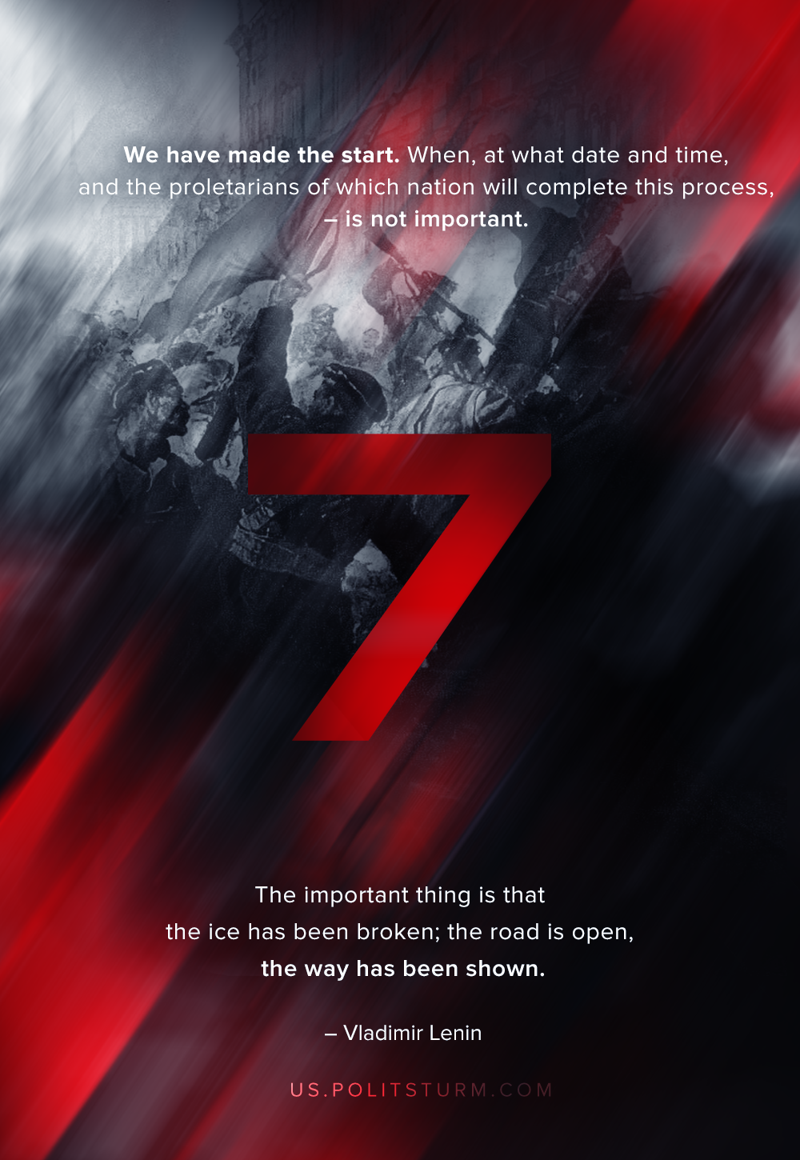

Original article
2019-11-07
1 min read

This first victory is not yet the final victory, and it was achieved by our October Revolution at the price of incredible difficulties and hardships, at the price of unprecedented suffering, accompanied by a series of serious reverses and mistakes on our part. How could a single backward people be expected to frustrate the imperialist wars of the most powerful and most developed countries of the world without sustaining reverses and without committing mistakes! We are not afraid to admit our mistakes and shall examine them dispassionately in order to learn how to correct them. But the fact remains that for the first time in hundreds and thousands of years the promise “to reply” to war between the slave-owners by a revolution of the slaves directed against all the slave-owners has been completely fulfilled—and is being fulfilled despite all difficulties.
We have made the start. When, at what date and time, and the proletarians of which nation will complete this process is not important. The important thing is that the ice has been broken; the road is open, the way has been shown.
V.I.Lenin, “Fourth Anniversary of the October Revolution”

Original article

