The New Silk Road: How China Subjugates the World
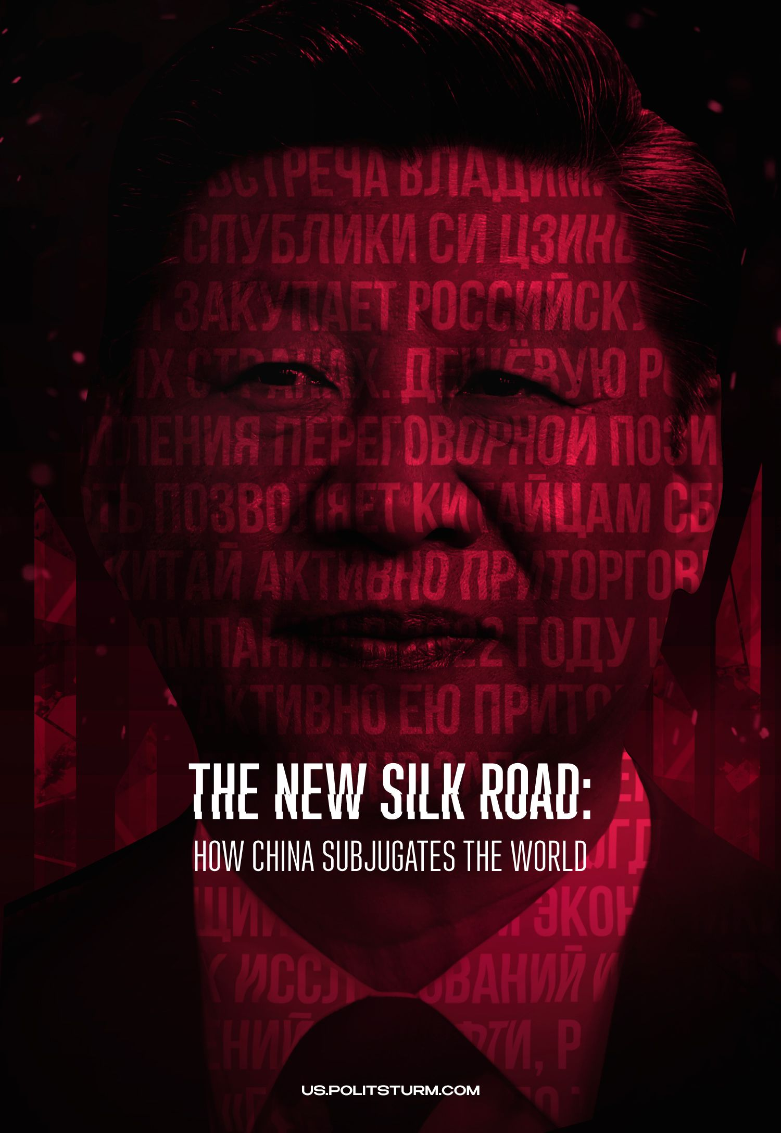

Original article
2023-12-13
24 min read

This year marks the 10th anniversary of the Chinese "One Belt – One Road" project. China's trade partners present it as a new way of "open cooperation" and "joint development", China's investments in "friendly" countries have long been referred to as cooperation and the "union of peoples". The Chinese authorities insist on the joint implementation of "excellent prospects and practical actions for the joint creation of the Silk Road economic belt and the maritime Silk Road of the 21st century".
But this initiative is not actually aimed at mutual cooperation. The essence of the "New Silk Road" comes down to its significance as a tool for Chinese imperialism to economically subjugate the countries of Eurasia.
Earlier we touched on this topic in the article "The Export of Capital in the 21st Century as an Instrument of Expansion", which we recommend to familiarize yourself with beforehand. In chapter IV, we highlighted the investment policy of the PRC and the mechanism of their enslavement of other capitalist countries through the "New Silk Road". In this article we will continue the analysis of this topic.

I. What is the "New Silk Road"?
In September 2013, Chinese President Xi Jinping put forward the concept of the "New Silk Road", calling it "One Belt, One Road". The project included the construction of transport infrastructure from the Western borders of China through the countries of Central Asia and Iran to Europe: railways, highways, pipelines and ports, the creation of which, according to representatives of partner states, will lead to the "economic development" of these countries.
In October 2014, China created the Asian Infrastructure Investment Bank, referred to in the media as a competitor of the International Monetary Fund and the World Bank. In the spring of 2015, the Silk Road Company investment fund was created for the construction of the project and about $40 billion was allocated.
"For the entire continent of Eurasia as a whole and for the regions near the Indian Ocean, the concept of "One Belt and One Road" was put forward, which combines two concepts: the "economic belt" of the Silk Road and the Maritime Silk Road. In fact, this concept will provide China with a new market for exporting goods and at the same time will stimulate the economic development of countries and regions along the "belt", which will eventually contribute to prosperity and stability in this region." – "Development of modern foreign policy of the PRC" Yu Han.
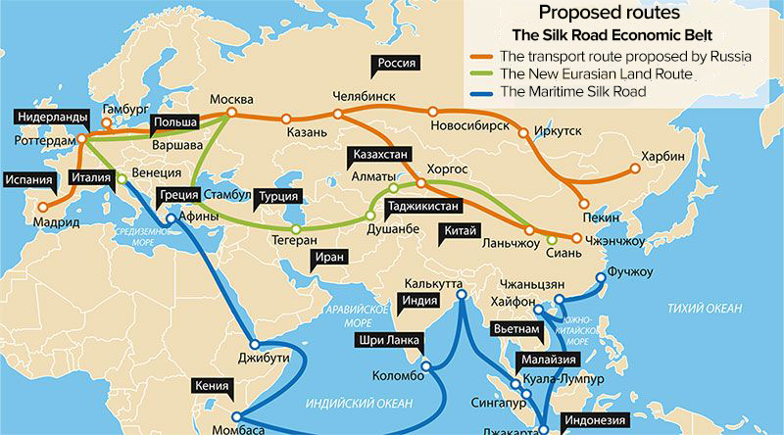
Map of the "New Silk Road"
The appearance of the "One Belt, One Road" project in 2013 clearly showed the interests of the Chinese bourgeoisie to expand its economic influence on the international market. The "New Silk Road" is aimed precisely at strengthening the position of China's large capital at the global level, obtaining new trade contracts and additional profits due to the exploitation of the labor force of other countries.
For this reason, Beijing is actively involved in UN affairs and is the second largest supplier of contingents for the organization's peacekeeping operations, and is a member of the BRICS and the G20. Large Chinese companies, for example, Ping An Insurance company, Sinosteel Group, the largest Chinese iron ore and steel trader, or Lenovo and Xaomi equipment manufacturers, show their ambitions in the markets of Europe, the USA and the CIS. Chinese companies Oppo, Vivo, Haier and Midea have a significant share in the Indian market of technology and home appliances.

II. Economic Subordination
The New Silk Road project allows the Chinese bourgeoisie to make huge profits and expand its political influence. Therefore, it is worth mentioning separately what profits and opportunities the "One Belt, One Road" gives to big businessmen of the Middle Kingdom, with which countries the PRC already maintains "partnership" relations and how it is going to strengthen them.
Since 2016, exports from Central Asian countries to China have grown by 42.8% and amounted to $16.4 billion in 2020, and $44.5 billion in 2021. According to the data of 2022, China's foreign trade turnover with Kazakhstan, Uzbekistan, Kyrgyzstan, Turkmenistan and Tajikistan increased by 40%. Trade with Kazakhstan has increased 16 times, with Kyrgyzstan 24 times, with Tajikistan 100 times, and with Turkmenistan 200 times.
"The trade turnover of the Central Asian countries with China has grown more than 25 times in 20 years. For comparison, China's total foreign trade has grown nine times over this period. According to the Central Asian states, trade with China amounted to $ 33.7 billion in 2021."— writes the “Rhythm of Eurasia” newspaper.
After the collapse of the USSR, China and Central Asian countries implemented a number of major projects to create gas pipelines (China-Central Asia) and oil pipelines (China-Kazakhstan). This allowed the PRC to obtain cheap natural resources and strengthen its political influence over the countries of this region, to ensure their economic dependence on the “Middle Kingdom”.
Adviser to the Office for Trade and Economic Affairs of the Embassy of the People's Republic of China in the Republic of Tajikistan Sun Yan, in an interview with the Tajik agency "Avesta", reported on the large-scale activities of Chinese companies in the country.
Thus, Tajik-Chinese Mining Company LLC allocated funds for the construction of the Confucius Institute, Confucius classes throughout Tajikistan and another 3.1 million somoni on a grant basis to improve the learning conditions in 9 more educational institutions.
China's ZTE donated 10,000 wireless stationary stations to the Ministry of Education and Science of Tajikistan to improve the education infrastructure, donated 300 GOTA communication terminals for emergency communications to the Ministry of Communications of Tajikistan and video conferencing systems to the Ministry of Economy and Trade of Tajikistan for internal teleconferences.
LLC "16th Construction Management "Sinohydro" has outlined the task of building three new schools, equipped with premises for 1,200 students in Tajikistan from 2017 to 2020. JSC "TVEA" has built four schools, including sports grounds, stadiums of "Sino-Tajik Friendship" with a total building area of 27,000 sq. m., with a construction site of 114,000 sq. m. and a total investment of 80 million somoni (580 million rubles.).
Recall that on January 12, 2011, the Tajik parliament voted to transfer thousands of square kilometers of disputed territories in the Pamir Mountains to China. And on October 6th, 2011, the process of transferring the territory of 1.158 square kilometers under the jurisdiction of China was completed, which accounted for 5.5% of all disputed territories.
In 2021, it became known that the PRC intended to build a new, second military base on the territory of Tajikistan, and the Tajik parliament on October 27th, 2021 allowed such an initiative. At that time, Russia was planning to build the 201st military base on the territory of Tajikistan, for joint actions with the PRC.
From such "initiatives" aimed "at combating extremism" by the Afghan terrorist organization Taliban (an organization banned in the territory of the Russian Federation), it becomes clear that Chinese and Russian capital intend to strengthen their influence on the Tajik government and control over the country's borders.
The big bourgeoisie is engaged in the "improvement" of the infrastructure of another country, investing in its economy only with the desire to strengthen its economic power and get more profit. Therefore, the Chinese capitalists are interested in expanding their influence on the territory and economy of Tajikistan, are interested in extracting cheap natural resources, locating their enterprises in the country and conquering new markets and labor.
The website of the Chinese Embassy in the Republic of Kazakhstan notes that from January to November 2022, trade between China and Kazakhstan increased by 23.1% year-on-year, i.e. by $ 28.2 billion.
It states that China remains the second largest exporter of products from Kazakhstan, the second largest source of imports for Kazakhstan and the second largest trading partner. The “Middle Kingdom” finances the construction of the Atyrau State Petrochemical Complex, the Kyzylorda State Glass Factory, the East Kazakhstan Nuclear Fuel Assembly Plant and the Almaty State Shelek Wind Power Plant.
From the words of the Chinese ambassador to Kazakhstan, Zhang Xiao, it becomes clear that Chinese businessmen are also building their enterprises on the territory of Kazakhstan. Car assembly plants were established: Jianghuai Automobile and Yutong Bus. This is how the Chinese ambassador describes the "One Belt-One Road" project.
"The two countries have successfully built a comprehensive and three-dimensional interconnection network covering roads, railways, aviation and oil and gas pipelines. There are 7 pairs of multi-year ports, 5 cross-border pipelines for oil and gas transportation, 2 cross-border railways and 1 international center for cross-border cooperation between the two countries. The China-Kazakhstan logistics cooperation base in Lianyungang helps Kazakhstan to get direct access to the Pacific Ocean. As of mid-December this year, more than 12,000 China-Europe (Central Asia) trains were running through the railway ports of Alashankou and Khorgos, which is an innovative historical record."
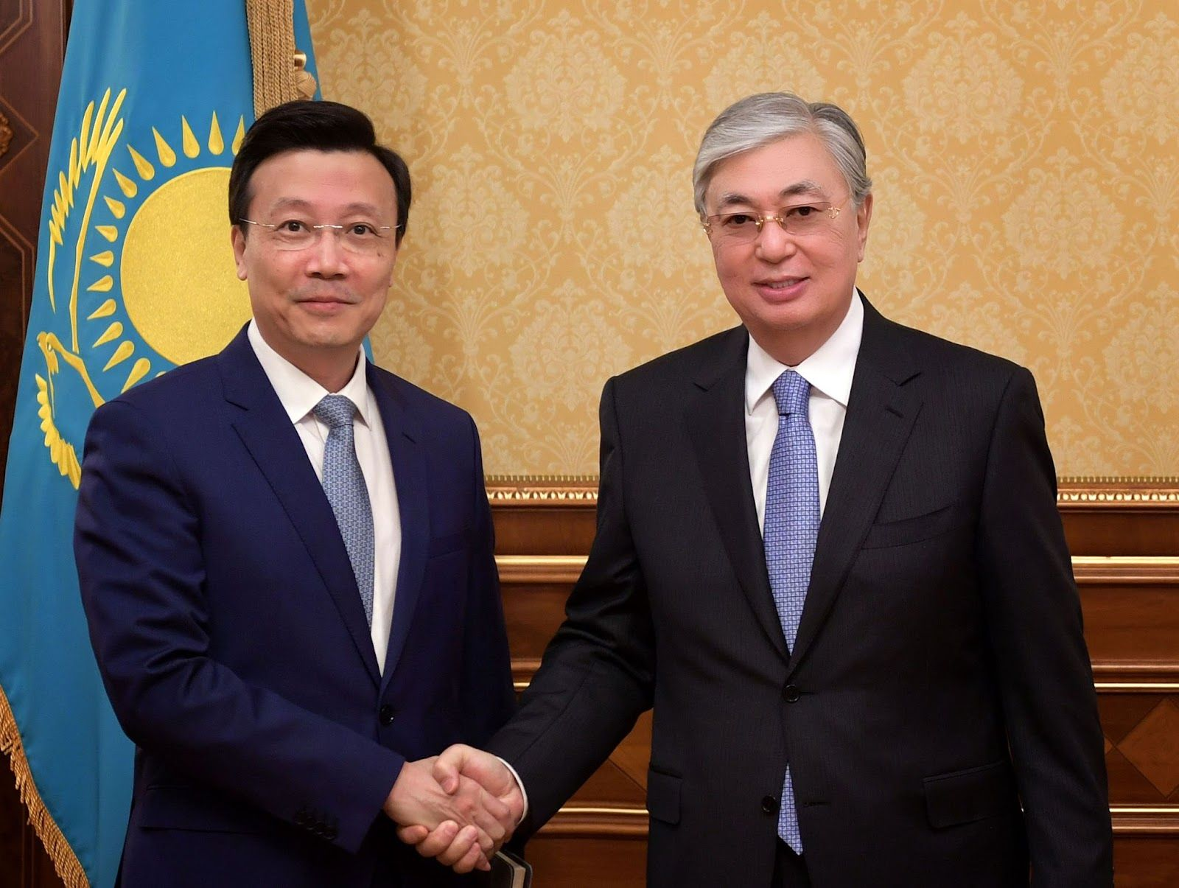
In the photo: Ambassador Extraordinary and Plenipotentiary of the People's Republic of China to the Republic of Kazakhstan Zhang Xiao and President of the Republic of Kazakhstan Tokayev
In 2015, the Asian Gas Pipeline company, which is a joint venture of Kazakhstan's KazTransGas and China's Trans Asia Gas Pipeline, transported about 31.5 billion cubic meters of natural gas. The China-Kazakhstan Pipeline delivered more than 10.8 million tons of crude oil. The Chinese Sinohydro was engaged in the construction of the fifth section of the Western Europe - Western China highway. China International Hydropower Corporation has completed the construction of the Moynak hydroelectric power station in Almaty region.
Shaanxi Province, Almaty and Zhambyl regions jointly built the China-Kazakhstan international demonstration park of agricultural science and technology, the volume of investments in which exceeded $ 1.5 billion.
In 2016, the direct flights Almaty-Xi'an and Almaty-Sanya were opened. The transport infrastructure was supplemented by the Western Europe-Western China highway, more than 10 China-Europe cargo container routes passing through Kazakhstan, and a number of oil and gas pipelines.
It should be added that the implementation of 21 projects began on the territory of the Chinese Consular District in Kazakhstan only in 2017. Consul General of the People's Republic of China Zhang Wei said that they are related to the development of mineral deposits, mechanical engineering, chemical industry and clean energy.
Thus, China uses Kazakhstan and other Central Asian countries as a raw material appendage. The Kazakh bourgeoisie is unable to impose its policy or resist the integration of Chinese capital and its enterprises into the domestic market of the country. Chinese businessmen invest in the construction of industrial enterprises and infrastructure, increasing the economic and political dependence of the republic on China.
Within the framework of the New Silk Road project, it is beneficial for China to establish economic and political ties with Russia as well.
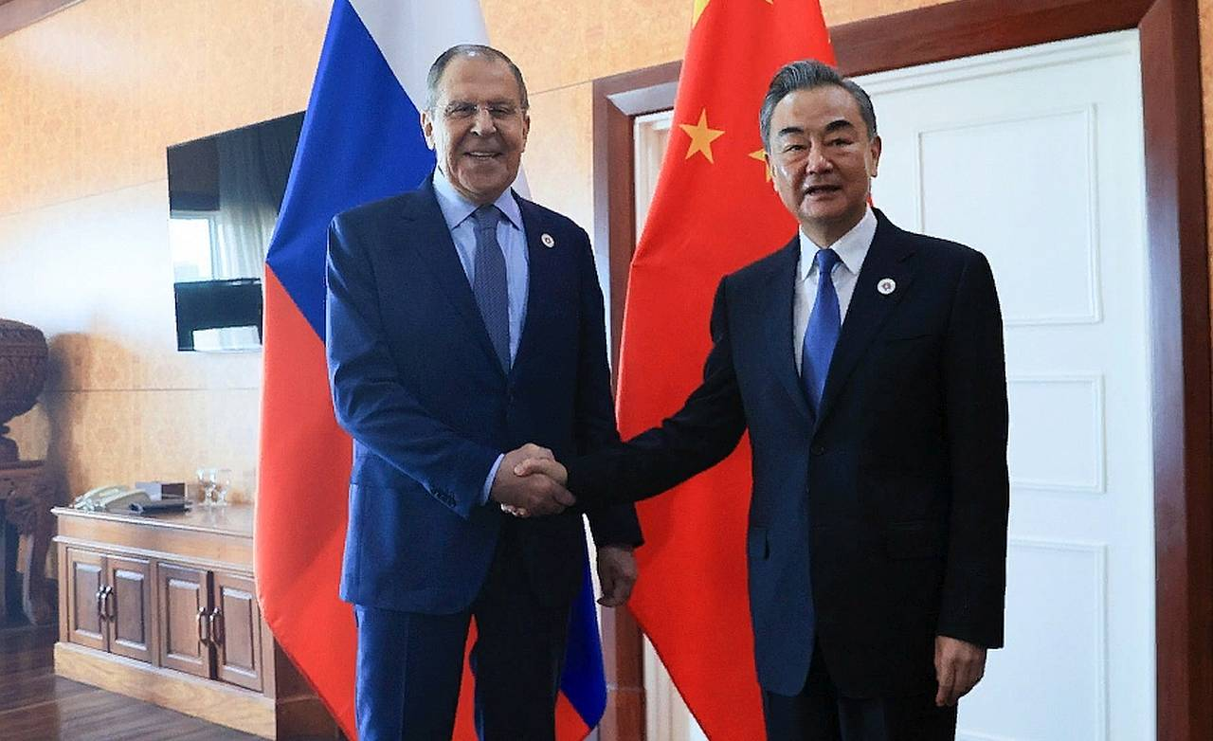
Russian Foreign Minister Sergey Lavrov and Chinese Foreign Minister Wang Yi
Cooperation between Russia and China takes place in the field of cargo transportation, financial and diplomatic spheres. Thus, the China– Mongolia– Russia transport project includes more than ten projects in the field of infrastructure development, modernization of border checkpoints on the territory of these countries and the construction of new railway and automobile routes.
In 2017, the construction of a road bridge between China and Russia in the Far East across the Amur River began. In the Jewish Autonomous Region, a railway bridge is also being built across the Amur River, connecting the village of Nizhneleninskoye and the Tongjiang City District of Heilongjiang Province. Other transport infrastructure facilities that Russia could offer to partners on the New Silk Road even before its widespread development were never built, which is why the bourgeoisie of the Russian Federation lost the advantage in attracting traffic flows.
The Primorye-1 and Primorye-2 international transport corridors have become effective, but require further investments to develop capacity, reconstruct Russian port facilities and roads.
The MTK opens the shortest access to the sea through the Primorsky Territory to the northeastern provinces of the People's Republic of China. At the same time, it is planned to build a high–speed Beijing–Moscow highway with the first segment of the Moscow-Kazan HSR, which will be extended to the “Middle Kingdom”. The construction of the Power of Siberia gas pipeline is taking place in close cooperation between Gazprom PJSC and the China National Oil and Gas Corporation (CNPC).
African countries are also part of the "One Belt, One Road" project, and "socialist" Chinese businessmen are actively investing in the African economy. The number of Chinese investor companies in Africa increased by 108% only from 2013 to 2016, the number of Chinese projects increased by 112%, and jobs expanded by 413%. These investments contribute to increasing the dependence of African countries on China.
According to the Primakov National Research Institute of World Economy and International Relations of the Russian Academy of Sciences, China's direct investments in Morocco increased by 195% from 2011 to 2015. In 2016, the King Mohammed VI Bridge, built with Chinese help, was opened – the longest cable-stayed bridge in Africa, part of a large-scale project to create the largest highway network in Morocco.
In 2016, a railway with a length of 187 km was built in Nigeria, the project was led by China Civil Engineering Construction Corporation. In January 2017, a new 756 km long railway linking Ethiopia and Djibouti was created, its organization cost $3.4 billion, which was generously paid by the Eximbank of China. The largest infrastructure project of the PRC in Kenya is considered a railway, the construction of which is estimated at $ 3.8 billion, and 85% of the cost of the project was paid by Eximbank.
China's annual direct investment inflow to Africa increased from $ 74.8 million in 2003 to $5.4 billion in 2018. In 2019, there was a decline in investments – a decrease to $ 2.7 billion, but in 2020, new growth is noticeable – up to $ 4.2 billion. For 17 years, the volume of China's direct investments in Africa has grown 100 times, and the lending carried out by Chinese companies for the period from 2000 to 2019 is estimated at $ 153 billion.
The Chinese ambassador to the United States, Qin Gang, stated in 2022 that lending to Africa has no commercial basis, but is a "sincere matter" for the PRC.
"Over the past decades, China has provided loans to help Africa in socio-economic development. Construction works are underway everywhere on the continent <...> obviously there is no trap or conspiracy in this. This is a completely transparent and sincere matter."

Speech by Chinese Ambassador Qin Gang at the Washington Summit in 2022
The transparency and sincerity of Chinese "aid" is perfectly demonstrated by the examples of Montenegro, Greece and Sri Lanka.
In 2006 Montenegro separated from Serbia. The new state faced an increase in the flow of Chinese investments into the country's economy and infrastructure. After some time, the Croatian consortium Konstruktor-IGH-Tehnika undertook the construction of the 170-kilometer Bar-Bolyare highway with a project cost of €2.77 billion, but turned out to be financially insolvent and Podgorica transferred the project to the Chinese company China Road and Bridge Corporation, having issued a loan to China Exim-Bank. According to the project, 32 tunnels and 45 bridges and viaducts were built near the capital of Montenegro. From 2006 to 2019, China's investments in the Montenegrin economy amounted to only €10 million. And in 2020 alone, China invested up to €71.2 million.
The inability of the Balkan Republic to repay loans has put the local government in a position dependent on China's demands. The public assumes that China can withdraw the port of Bar and take the 93% completed highway as a concession for 100 years.
After the financial crisis in Greece, the PRC and the local government "consistently strengthened their economic and political relations and ties" through China's investments in telecommunications, energy and infrastructure in Greece. Thus, the Chinese state Grid owns a minority stake in the Greek electricity grid operator ADMIE, and Chinese businessmen from State Grid have expressed interest in participating in the ADMIE program for the construction of an underwater power cable connecting the island of Crete with the mainland by the end of 2023. The program is estimated at € 1 billion.
Further, the representative of the Central Bank of Greece met with the management of the commercial Industrial and Commercial Bank of China and announced that he was ready to open his representative office in the territory of the Hellenic Republic. In the same month, Bank of China Europe opened its representative office in the country.
In 2016, the Chinese company Cosco acquired a controlling stake in the Port of Piraeus. It is noteworthy that its location between the Asian and European continents will greatly facilitate and increase traffic flows from China and the Far East to the European Union, the Balkans and the Black Sea region, which is another strategic step of the Chinese bourgeoisie to implement the "One Belt, One Road".
In 2017, the Government of Sri Lanka announced the official transfer of the deep-water port of Hambantota to China for 99 years. With such measures, the authorities are trying to get rid of the external debt to the PRC, but the transfer of the port will repay only the loan to China.
After that, in 2018, former Sri Lankan President Mahendra Rajapaksa and ex-Minister of Economy Basil Rajapaksa create the Sri Lanka Podujana Peramuna party, exploiting anti-Chinese rhetoric and nationalist slogans.
The Indian authorities, who traditionally had extensive political influence on these lands, were also concerned about the increase in the economic influence of the “Middle Kingdom” on Sri Lanka. New Delhi has begun negotiations with Beijing on the long-term lease of another unprofitable Sri Lankan project - the empty Mattala International Airport. India is seeking to reduce China's influence in Sri Lanka and the southern province of Hambantota, which China views as "an important link in the maritime component of the Belt and Road strategy."
Thus, China's "cooperation" with the countries of Africa, Central Asia, Russia, European countries and other "partners" consists in the implementation of infrastructure and transport projects that are beneficial for Chinese capital.
The implementation of the lending policy of some countries leads to an increase in their economic and political dependence on China. The examples of Sri Lanka, Greece and Montenegro show that the strengthening of the PRC's power over these states leads to a pro-Chinese policy there, which proves the desire of Chinese capital to increase profits and its influence within the framework of the "One Belt, One Road" project.

III. Political influence
The economic dependence of Central Asia on China is also reflected in the official position of the politicians of these states regarding "cooperation" with China.
In 2014, Xi Jinping visited Tajikistan, and "expressed gratitude to President E. Rahmon, the Government and the people of Tajikistan for the warm welcome that demonstrated the sincere friendship of the two peoples." Then the prospects of Chinese-Tajik "cooperation" were discussed, including the implementation of the "New Silk Road", i.e. strengthening the influence of the Chinese bourgeoisie on Tajik "partners", which was officially supported by President E. Rahmon:
"I fully agree with President Xi Jinping's assessment of this visit, which greatly contributed to the development of Tajik-Chinese relations. One of the important results of the visit is that President Xi Jinping and I have become close brothers."
"Tajikistan is ready to expand practical cooperation with China in the fields of trade, energy, agriculture and transport, deepen humanitarian exchange, enhance cooperation in the enforcement of law and security in order to create a wonderful future for the two countries and the region," Rahmon said at a meeting with Chinese Foreign Ministry representative Wang Yi on July 31, 2014.
During the Olympic Games in Beijing in 2022, the President of the People's Republic of China and the President of Kazakhstan K. Tokayev held a bilateral meeting and "summed up the results of 30 years of Chinese-Kazakh relations". Then the Chinese Ambassador to Kazakhstan Zhang Xiao said:
"China firmly supports Kazakhstan in protecting its independence, sovereignty and territorial integrity <...> China will always be a reliable friend and faithful partner of Kazakhstan and is ready to assist Kazakhstan in maintaining stability, developing the economy and improving the standard of living of the population. China is ready to work with Kazakhstan to deepen political mutual trust, expand comprehensive cooperation with the desire for common development, steadily protect the Sino-Kazakh friendship, steadily deepen cooperation and steadily support each other."
"Currently, the joint construction of the "One Belt, One Road" between China and Kazakhstan is in full swing, bringing great benefits two countries and two peoples. In the next 30 years, both sides should continue to focus on the high-quality joint implementation of the "One Belt, One Road" initiative, giving priority to production capacity, trade, agriculture and infrastructure, as well as constantly increasing the level of interconnectedness. At the same time, focus on the development of new growth factors in green energy, modern medicine, artificial intelligence, e–commerce, digital finance and other areas and focus on the joint creation of the "Green Silk Road", "Silk Road of Health", "Digital Silk Road", - said the Chinese Ambassador to Kazakhstan Zhang Xiao.
Thus, the strengthening of China's economic power over the countries of Central Asia and Africa, the implementation of the "One Belt, One Road" or "New Silk Road" project leads to increased political dependence of the governments of these countries on the will of the big capital of the “Middle Kingdom”.

Conclusion
The "New Silk Road" expresses the desire of Chinese imperialism to increase its economic and political power over the "partners" of the “Middle Kingdom”. "One Belt-One Road" is the path to the consistent enslavement of the countries of Central Asia and Africa. The bourgeoisie of countries, which are "friendly" to the PRC, sells natural resources and labor, sells the vaunted state sovereignty and changes its policy in accordance with the expectations and desires of the Chinese masters.
Through lending, direct investment in the economy and infrastructure improvement, China subordinates the countries of Central Asia and Africa. This leads to an increase in the external debt of these states to the PRC, their political dependence, which will soon overtake Tajikistan, Kazakhstan, Uzbekistan, African countries and has already befallen Greece, Sri Lanka and Montenegro. Thus, China intends to create a belt of countries dependent on it to increase its profits and influence on the world stage.
It should be understood that such unions of imperialist states as NATO also seek to increase their profits and influence. Therefore, China seeks to create its own union of imperialist states based on their economic dependence on the PRC. This strategy has long been carried out by the United States and the Russian Federation.
To the peoples of the countries that are part of the "New Silk Road", this rapprochement with China promises only increased exploitation, deterioration of the material situation and well-being in the interests of large owners. Eventually, the subordinate peoples will be drawn into a new world war for the redistribution of markets.
The only way to get rid of this is to unite the working masses of all nationalities and nationalities in the struggle against the causes of their exploitation and oppressed situation, against the capitalist system.
Sources
The Rhythm of Eurasia – China's trade turnover with Central Asian countries has grown more than 25 times in 20 years – from November 11, 2022.
Politsturm – China is rapidly increasing its influence in Central Asia — from April 10, 2023
Politsturm — Chinese Imperialism — from January 10 , 2023
Website of the Consulate General of the People's Republic of China in St. Petersburg - Xi Jinping completed a state visit to Tajikistan – from September 14, 2014
Website of the Ministry of Foreign Affairs of the People's Republic of China – President of Tajikistan E. Rahmon met with Chinese Foreign Minister Wang Yi – from August 01, 2014
Avesta – The activities of Chinese companies are aimed at improving the welfare of Tajikistan – from March 15, 2018
Gazeta.ru – Russia and China will divide Tajikistan – from October 28, 2021
Website of the Embassy of the People's Republic of China in the Republic of Kazakhstan – Ambassador Extraordinary and Plenipotentiary of the People's Republic of China to the Republic of Kazakhstan Zhang Xiao gave an interview on the occasion of the visit of the President of Kazakhstan K.Tokayev to China and participation in the opening ceremony of the Winter Olympic Games in Beijing 2022 – from February 17 , 2022 .
Website of the Embassy of the People's Republic of China in the Republic of Kazakhstan – Ambassador Extraordinary and Plenipotentiary of the People's Republic of China to the Republic of Kazakhstan Zhang Xiao gave an interview to the Kazakh media about the XX National Congress of the Communist Party of China, Sino-Kazakh relations and other issues – from December 30, 2022.
Rossiyskaya Gazeta – The amount of investment projects of Kazakhstan and China exceeded $70 billion – dated May 29, 2017
Xinhua News – The Chinese Ambassador to the United States denied allegations of a Chinese "debt trap" in Africa – from December 14, 2022
Website of the IMEMO Institute of the Russian Academy of Sciences – China and Africa: results of economic cooperation in recent years
Website of the IMEMO Institute of the Russian Academy of Sciences – China has taken a long-term lease of the deep–water port of Hambantota in Sri Lanka - from December 20, 2017.
Finversia.ru – China will turn the main port of Greece into the largest in Europe – from November 15, 2019.
TASS – Montenegro's debt pit. Chinese version – from April 21 , 2021
Sea News of Russia – Russia's place in the Chinese project "New Silk Road" – from March 14, 2018

Original article

