The Last American General Strike: 75th Anniversary
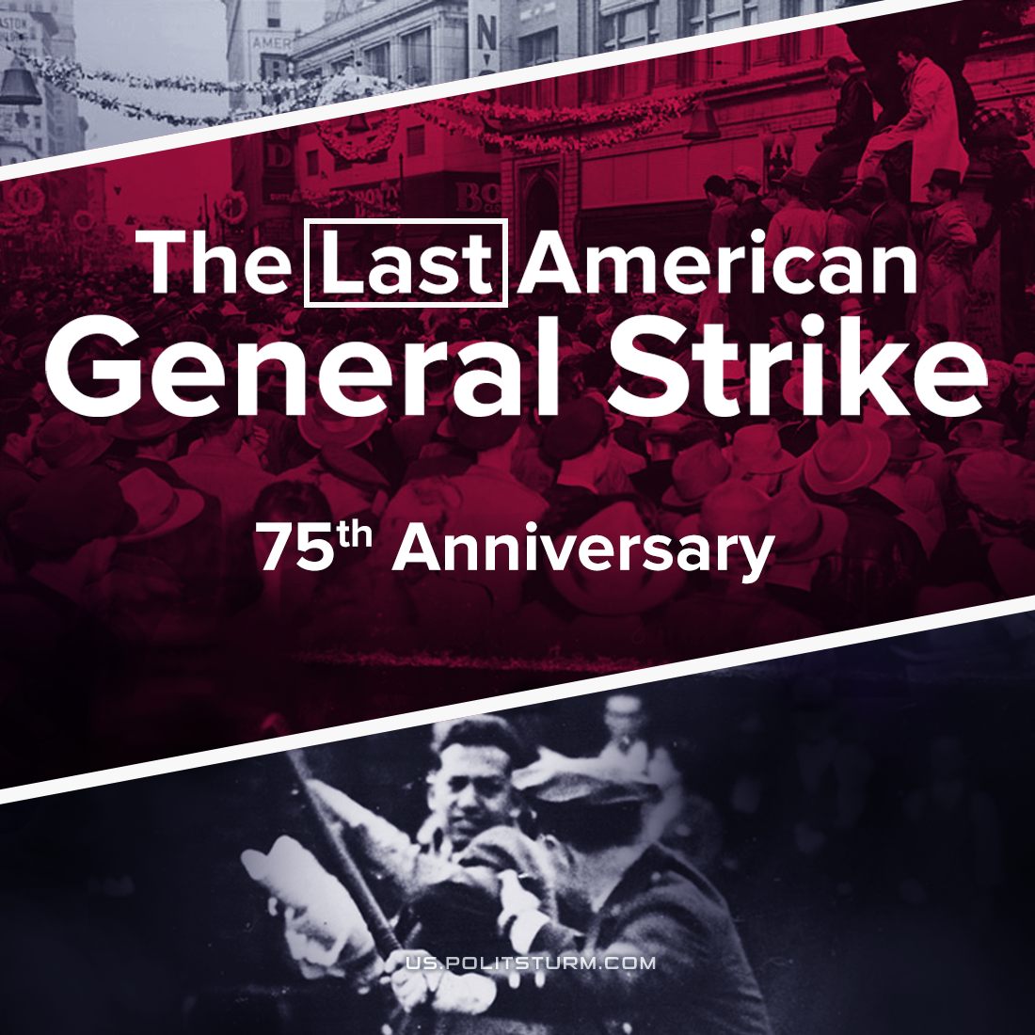

Original article
2021-12-03
8 min read

75 years ago, the last and largest major metropolitan general strike in America shook the Bay Area of northern California. That Tuesday, December 3rd, the unions controlled the streets of Oakland as over 130,000 workers halted commerce across Alameda county.
After 1945, those returning from America’s ‘war for democracy’ were appalled at the reality they found at home: increasing reactionary trends in the state and the abuse of striking workers who had for years agreed not to strike. Now that the war was over, and industrial profits were sinking, the iron hand of the market came down to scoop profits out of American society.
After WWII there was a crisis: between Spring 1945 and Winter 1946 the weekly wages of war, workers fell 31% while those of non-war workers declined 10%. A government study released in May 1946 showed that “in most cases, wages during the first phase of reconversion were inadequate to maintain living standards permitted by earnings in the year preceding Pearl Harbor.“
The general strike in Oakland was the end of a year of the most intense strike activity America has ever seen.
From ten-minute stoppages to total urban shutdowns, over four million and 600 thousand people participated in work stoppages. Ten per cent of the entire country's workforce struck at some point that year, thousands for weeks at a time, with general strikes gripping cities like Lancaster, Pennsylvania and Houston, Texas.
All general strikes were bitterly opposed by AFL union leadership and only came about from the hyper-participation of the massive union bodies.
This strike wave was, in greater part, the response of rank-and-file members to the changing attitude of the U.S. state towards labor. When President Truman nationalized the railroads and coalfields in upstate New York in May 1946, which would have dissolved the favorable terms that unions had won, workers in Rochester went on general strike.
Error loading image
The Strike
Oakland’s general strike was born out of the efforts of, at first, mostly older women who had for years been excluded from unionized fields, but who now found the confidence to unionize the department stores as strikes rippled towards them from across the country.
For five months, this new union, AFL Local 1265, struck modestly without any recognition or bargaining from the owners – only baton blows as scabs forced their way into work. But it had eaten into the pockets of the store owners: patrons were ashamed to cross through the line of picketing employees on their way inside.
On December 1st, city council, responding to local business interests, initiated a policy to break the strike directly. 250 police officers were called out to the middle of Oakland to assault the crowd of strikers and supporters, tow the cars blocking the road, and guarded the road as scabbing trucks made multiple deliveries.
One striking retail worker recalled;
“It wasn’t bringing in strike-breakers, necessarily, that started the general strike…
but the thing was using the police force, that we were paying taxes for, to beat us off our own streets!”
Error loading image
Before 5am on Tuesday morning, December 3rd, an electric tram driver saw the police barricade, and, refusing to cross a picket line, took out the controls to his street-car and blocked the lane behind him. Hundreds of workers joined in to sabotage the scabs, filling the streets as they stepped out of their trucks, busses and street-cars, instead of going to work.
Thus the general strike had its impromptu beginning in defiance of their union organizations. Workers flooded their union representatives, demanding the formalization of the solidarity strike.
Alameda Central Labor Council officially declared what was dubbed a “work holiday”, a term which well described the festive attitude of the people filling the streets, but which also harkened back to the labor tradition of having stoppage days legalized as holidays, like the original May Day. But most hardened union organizers in 1946 would have remembered another of America’s first general strikes – the 1934 San Francisco Strike.
That strike had been brutally beaten down by police. Lacking the institutional legitimacy of mass action in 1946, they however showed the capabilities of a strong union network which included organized leadership by the CIO and the Communist Party alongside the activities of the city’s broader and conservatively-led labor organizations like the ISU. Half of those arrested in 1934 were registered by police as ‘Communists’; militancy which won the favor of many Bay Area workers as the Communist Party demonstrated its ability to lead from the minority.
This strike had been undone by the reactionary forces which led the big unions. After the war, the workers would strike again and with greater confidence, but this time, the demands of the Bay area general strike would not be driven forward into strengthening developments by those Communist elements who had pushed for gains 12 years before.
Error loading image
By Wednesday, sailors had armed themselves from ships bound for the occupation of Japan, and union-assigned tickets dictated access to cordoned streets of the city. After two days, the capitalists certainly did not want the strike to expand at all, which would energize events, but instead to comprehensively extinguish the prevailing mood.
AFL leadership was terrified of potential CIO involvement, loudly announcing their discomfort over publicized ties to the Communist Party. This weakness mounted to a breaking point when the thousands of workers filled the impromptu strike meetings, demanding the AFL take greater lengths to support their walk-out and stand against the city’s use of police for strike-breaking.
CIO’s strike meeting was scheduled for that Thursday night, and local CIO leaders promised that if the general strike was still on when this meeting was held, lights would go off for scabbing business owners as 30,000 industrial and utility workers looked to join the shut-down.
So, on Wednesday afternoon, Teamsters National Vice President Beck, who called events in Oakland “more of a revolution than a labor dispute” ordered local truck drivers to break off the strike.
When the city’s general strike ended Thursday morning, it had ‘officially’ lasted two days and 6 hours, without resolving any of the union issues of the retail workers for whom the general strike had begun in solidarity.
In the end, the AFL Alameda Central Trades Council, the men credited as leaders of the general strike, took a promise by city government that police wouldn’t be used to undermine the department store strike, and the Council utilized this as their excuse to issue the back-to-work order. Without official strike-absence protections, the party was over. Almost as soon as the general strike had ended, police were once again pushing scabs through the picket lines.
Aftermath
The energy of that early December ‘work holiday’ was efficiently piped into the local electoral system by the newly-formed AFL political committee, with a progressive coalition of the AFL, CIO and NAACP winning four seats out of nine on the Oakland city council.
As if as a reward, or fearing the support the city might have to change labor policy, the department store owners recognized the retail worker’s union a week after the election. Those four candidates, who the AFL had touted as the winnings of the general strike, would never actually take a stance for labor; serving unassuming terms without achieving any significant goals.
1946 marks the end of the general strike in American labor: with the dissolution of the Communist Party and the new federal anti-union laws, the activities of labor had been enclosed in economism and driven to the margins.
Never again would we see a labor dispute throttle the general commerce of a whole city. Over the next decade, McCarthyism eradicated the Communist element from the labor movement. We’ve seen the result since then. The ubiquity of the unions which underpins this story is lost on us today, and it was out of a great effort on the part of the bourgeoisie that this power was lost.
In order to give the general strike its true political force, Communists must lead the formation of labor solidarity, galvanize the most radical elements of the masses, and direct labor onwards to its higher goals.
Sources: 1, 2, 3 , 4 , 5 , 6

Original article

