The International Day of Human Space Flight
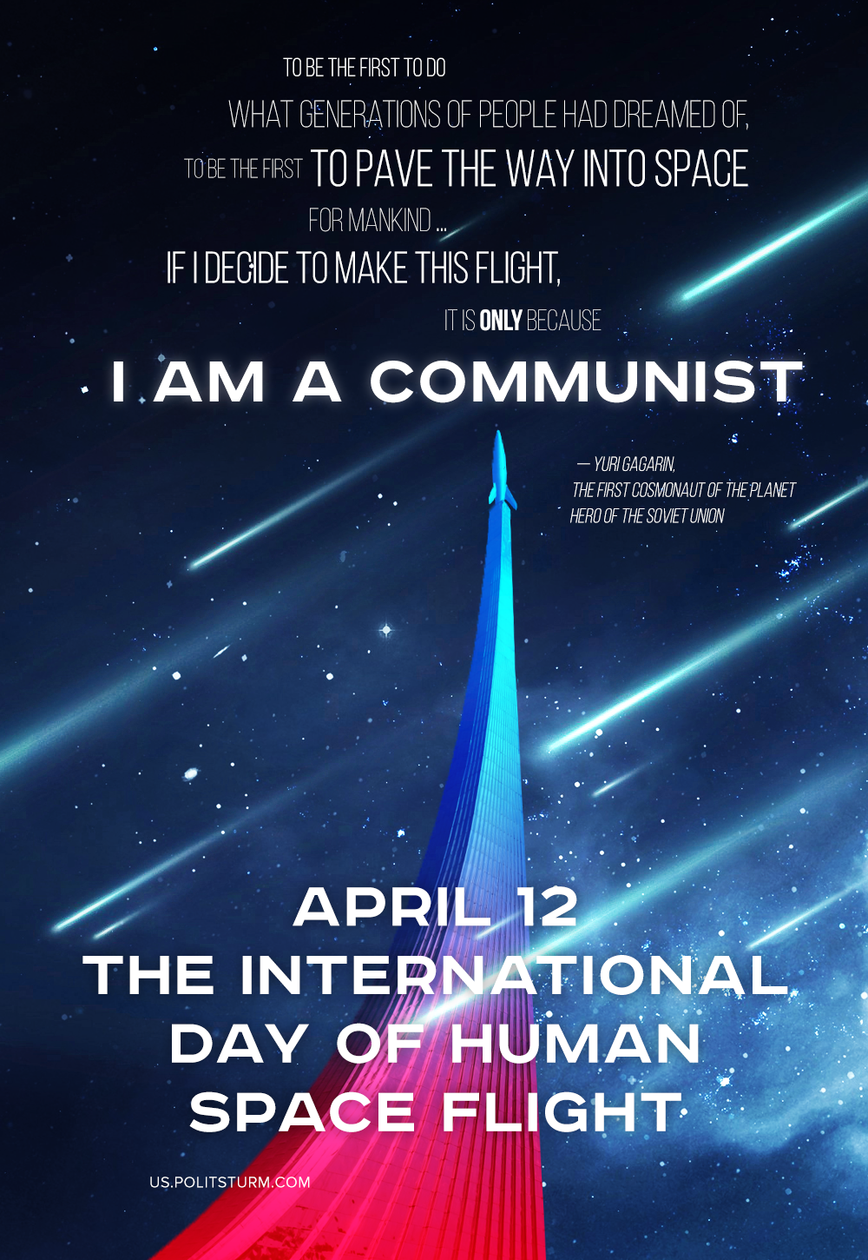

Original article
2020-04-12
1 min read

Politsturm congratulates readers on the International Day of Human Space Flight and reminds that the true space exploration is impossible without eliminating the capitalist system, based on the exploitation and injustice, which drives the whole world into endless crises, wars and hardships, as well as uncontrollably consumes all the resources of the planet.
Only a society of free workers, a society without private property and exploiters, a society based on the principles of justice, humanism and the desire for progress, can bring humanity to a new stage in the space era.

Original article

