The Hollywood Strike: Results and Importance
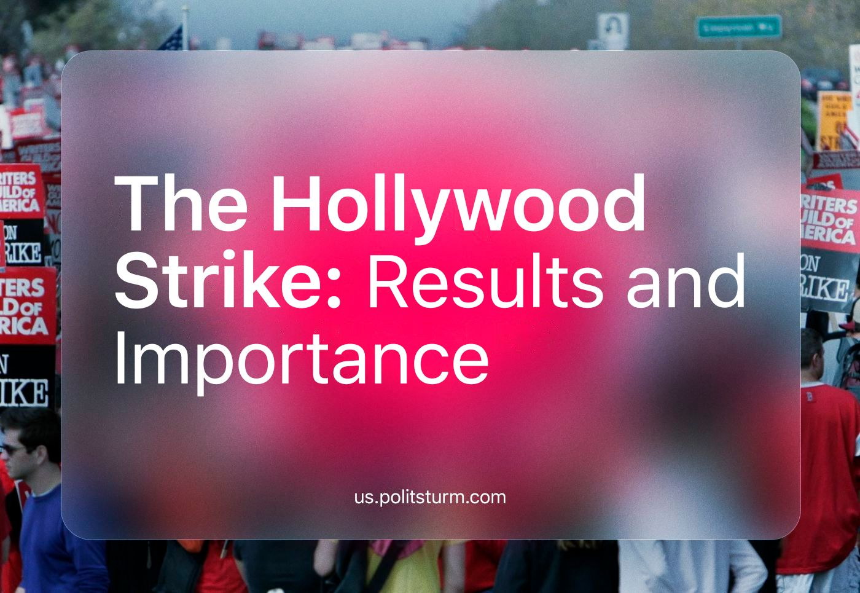

Original article
2024-02-16
13 min read

Last summer, the SAG-AFTRA writers' and actors' strike began. This marked the first strike in Hollywood in 43 years. The strike was initially announced by screenwriters but later gained support from actors, as their demands for better pay, health insurance, and protection from harassment and discrimination coincided. Additionally, the widespread use of artificial intelligence by corporations was a significant factor. It was the first joint strike between writers and actors in 63 years.
What did the course of the strike reveal about the state of the American working class? How did class solidarity emerge, despite the specifics of the industry and the seeming differences between professions? Why is it worth paying attention to this strike?

1. Reasons for the strike and its consequences
In July 2023, the SAG-AFTRA guild, representing 160,000 Hollywood actors, went on strike [1] after failing to reach an agreement with the Producers Alliance. In effect, it joined the then-ongoing strike by the WGA, which represents screenwriters.
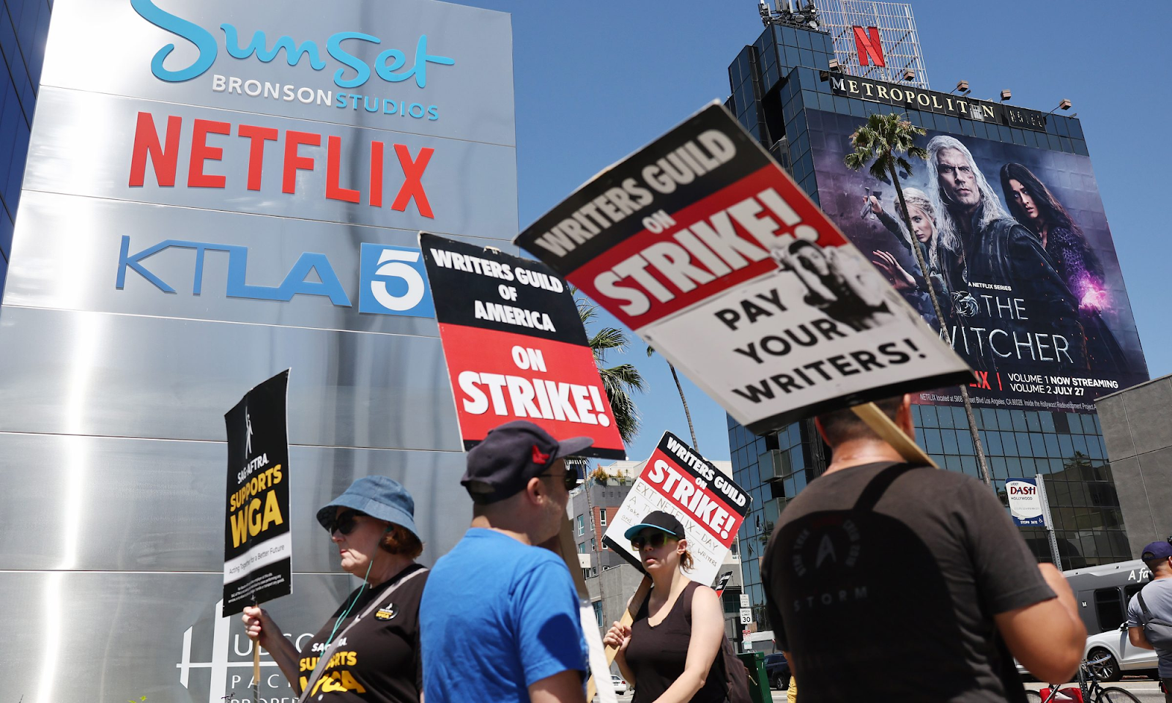
Photo: Mario Tama / Getty Images
Falling wages, falling social security, worsening working conditions, and competition with AI have forced film production workers to assert their right to a better life by going on strike. CNN predicted [2] that the strike could cost about 4 billion dollars and affect not only the U.S. economy but also other countries.
The rapid development of streaming platforms was cited as one of the reasons for the drop in screenwriters' and actors' salaries. Initially, services like Netflix expanded the labor market, as they needed to turn out more products, and therefore the need for workers increased. However, as the industry evolved, corporations began to produce shorter series because they provided the greatest financial return.
As a consequence, screenwriters and actors began to be paid less, and the amount of labor in the industry increased. In other words, it was a classic example of labor intensification to achieve the highest possible profit.
The struggle with artificial intelligence was an illustration of the fact that production is becoming more and more capital-intensive as time goes on, and if, for example, it used to take a well-trained person to create a piece of music, now it can be done by a machine. Of course, we are not talking about creating a masterpiece, but about a certain range of technical tasks at a sufficient level for mass-production.
This clearly shows a pattern typical of capitalism: the growth of constant capital (means of production) leads to a decrease in the part of variable capital (wages of workers). In other words, the development of technology leads to a reduction in the number of workers needed for production.
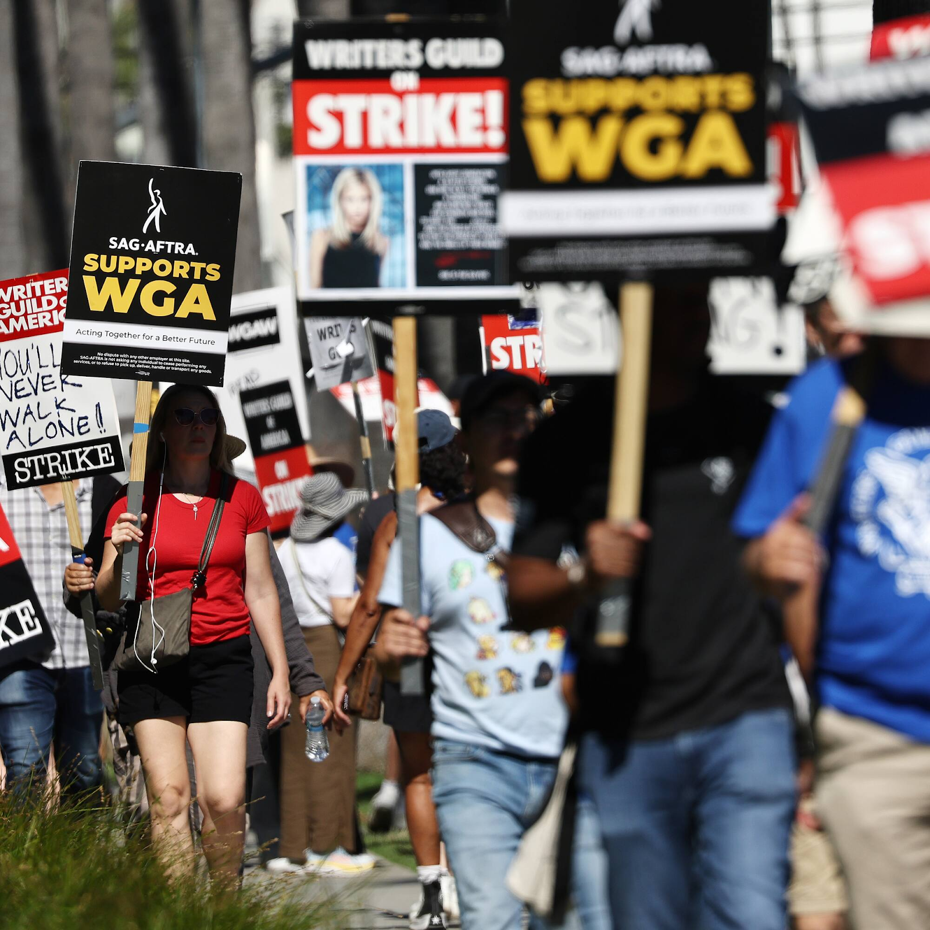
Photo: Mario Tama / Getty Images
The guilds in their struggle tried to limit the use of AI in the industry. In March, WGA representatives declared [3] that it was unacceptable to use AI algorithms to create texts, calling such content "plagiarism". Union members demanded restrictions be put in place to protect workers "from unauthorized use of their looks, voices and performances."
«Artificial intelligence poses an existential threat to creative professions, and all actors and performers deserve contract language that protects them from having their identity and talent exploited without consent and pay», — said [4] SAG-AFTRA president, Fran Drescher.
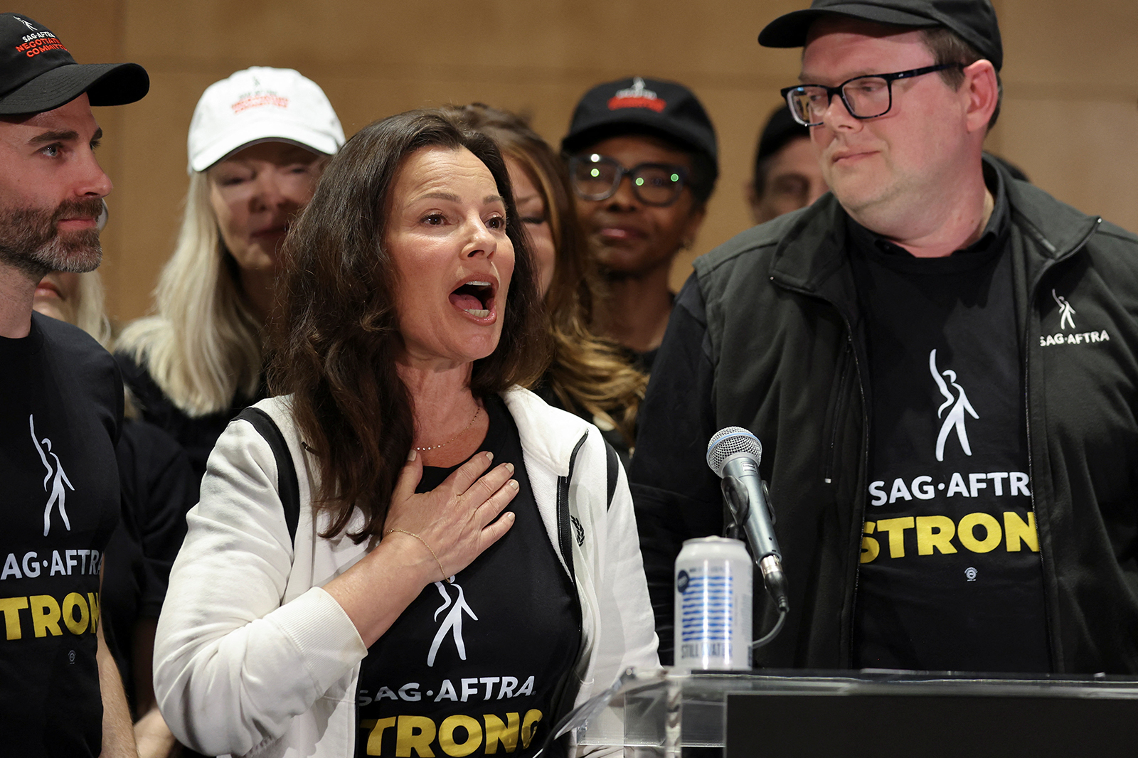
Photo: speech of the SAG-AFTRA president Fran Drescher. Source: Mike Blake/Reuters
Interestingly, the last major screenwriters' strike was also related to technology. It lasted [5] 100 days from November to February 2007-2008. At that time, the screenwriters could not reach an agreement with the Alliance of Motion Picture and Television Producers to receive a percentage of DVD sales and online screenings. Eventually, the screenwriters did get to the point where they began to receive a percentage of the disk and online distribution of merchandise [6].
Economic leverage in labor conflicts is always the main way of pressure in the confrontation between employees and employers. The entrepreneur waits for the fervor and cash reserves of the workers to run out. The workers, in turn, are waiting for the costs to the entrepreneur due to production downtime to become unreasonably high.
At a certain point, the parties to the conflict meet each other and find a compromise, but during the struggle, the actions on the part of the businessmen can be quite dirty. For example, the studios intended to resume [7] negotiations no earlier than the end of October in order to exhaust the workers.
However, their plans were not meant to be. On September 27, 2023, the strike ended. The WGA was able [8] to achieve restrictions on the use of artificial intelligence, the establishment of minimum staffing levels in TV writers' rooms on projects, bonuses for the number of views on streaming channels, and annual indexation of the minimum wage by 5%, 4%, and 3.5% for the next three years.
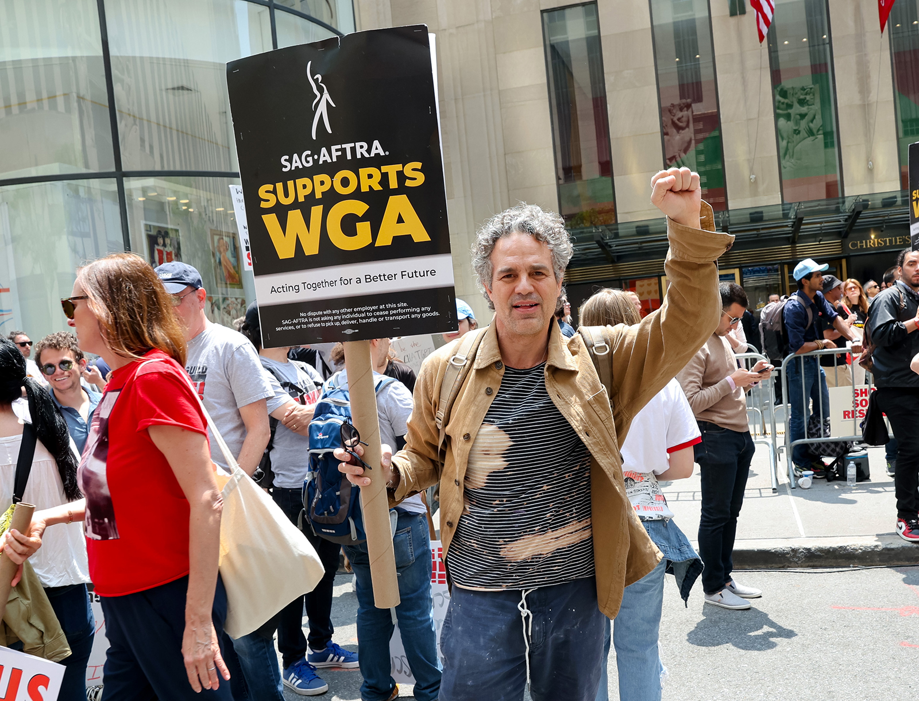
Photo: American actor and producer Mark Ruffalo joined the strike. Source: Jose Perez/Bauer-Griffin/GC Images/Getty Images

2. Class solidarity
Obviously, any strike affects its direct participants - employers and workers. Both the former and the latter suffer losses, but struggle for future conditions of existence.
When a single enterprise without a significant market share goes on strike, social production spontaneously compensates for the lack of goods: supply routes are changed, other producers are found, etc. But when an entire industry goes on strike, it is not only the entrepreneurs and workers directly related to the industry who suffer damage, but also the entrepreneurs and workers of related industries. Thus, the class conflict rises to a higher level and a much larger proportion of people are haphazardly drawn into it than it may seem at first glance.
Because of the downtime in the film production not only cameramen and makeup artists lose their jobs, but also representatives of other professions, such as carpenters and stylists. An unconscious worker, who does not understand the connection between their profession and the class interests of the entire proletariat, may take a negative stance toward the strikers and join the capitalists in blaming the workers. Conscious workers, however, understand this connection and express solidarity with the struggles of actors and writers.
"This struggle is our struggle," says [9] Corey Hunter, a cameraman from Los Angeles. After losing his main job, he's going to help a family member in the real estate business. His wife Julie Ganis agrees: "Our enemies are not screenwriters, but corporate owners who think profit is more important than anything else."
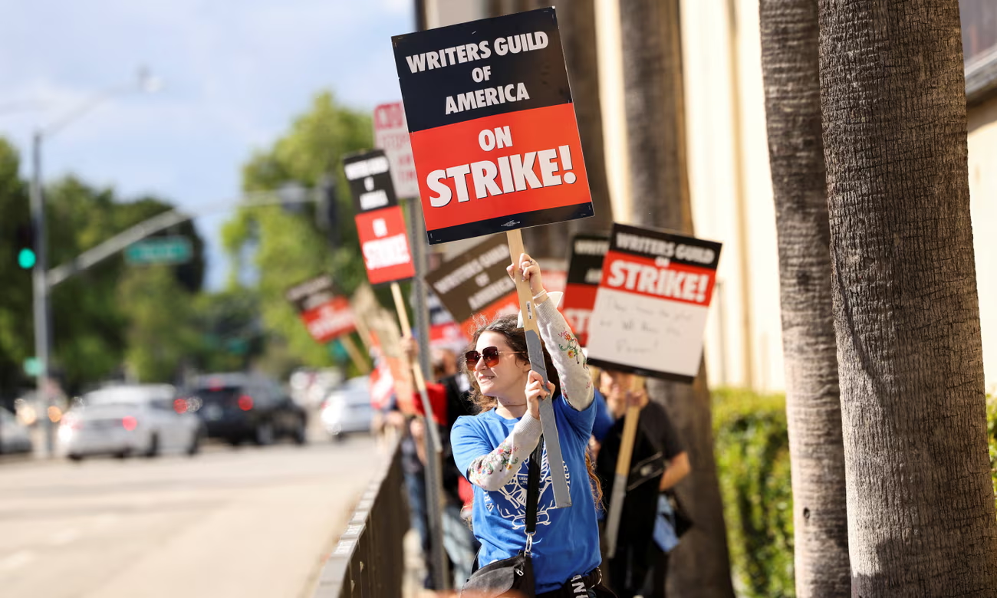
Photo: Mario Anzuoni/Reuters
IGN also spoke to representatives of visual effects companies. They reported [10] that their business will be down by the end of the summer, but that workers in the industry are also expressing solidarity:
«I hate the fucking strike but if VFX artists were in the same position and unionized and moved to strike because they were so frustrated they'd take the hit, then I'd be striking with them too...," one of them reasoned. - The fault of the strike lays firmly with studios. They could end it very quickly for less than the concessions they just gave to Directors. Anyone who has worked in VFX for a long time should know how ruthless film and streaming studios are. How terrible they can be as clients» — reported one of the specialists.
Of course, the economy of the state as a whole suffers: people use less [11] of the various services like restaurants, cleaning, and dry-cleaning, tied to the film studios. The industry of production of sets, costumes for film shoots, etc. is also obviously affected. All this happens because labor has a public nature. In this case, the labor of scriptwriters and actors makes meaningful the labor of the other workers tied to the industry.
But only the wageworker who does not understand his connection with the national working class can conclude from this that the cause of the strike is not the general conditions of capitalist exploitation of labor, but "bad" or "improper" workers.

3. Are actors and writers the proletariat?
In the so-called "leftist" discourse, there is often a prejudice towards cultural workers. There are theses that such workers are not proletariat because they do not produce material goods.
This is a superficial understanding of the question. A capitalist enterprise is not only a factory, but any enterprise that exists to increase capital itself and, accordingly, uses hired labor, alienating the product of the worker. A film or video effects studio is also part of the market, employing workers and likewise alienating what is produced. At the same time, any cultural worker, because they sell their labor, exists as a wage worker, living on wages - and is therefore still a proletarian. This is the main thing that defines the worker in contrast to the capitalist: the sale of their labor.
There is a stereotype of an actor as a wealthy person, but the lifestyle of a wealthy person can only be led by a small part of the entire professional community. For example, of the 160,000 members of the SAG-AFTRA Guild, only 15% earn more than $26,000 a year. This figure is below the poverty line in the United States. To get by, people look for ways to earn money on the side. And in Russia, according to the gorodrabot website, the median salary of a theatre artist is 28,023 rubles.
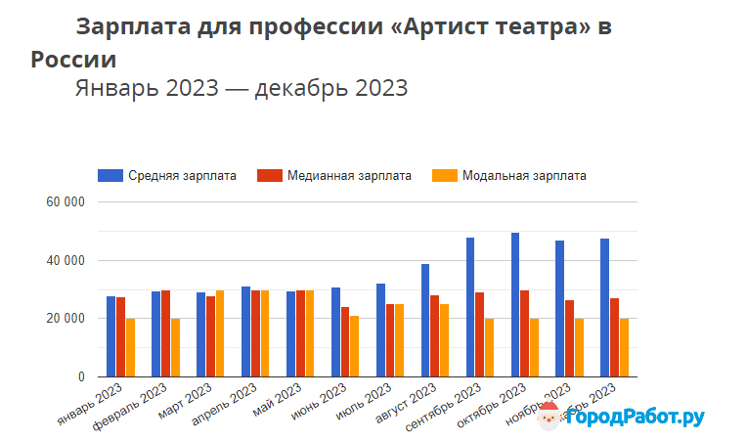
Cultural workers are thus exploited on the same basis as workers in any other sphere, and the interest of the entire proletarian class is in the liberation of labor from capitalist exploitation.

Conclusion
The organized struggle of the workers of the two guilds had its result - the producers made concessions. The unity of the workers in the different spheres and the realization that the root of their situation is the capitalist pursuit of profit is encouraging. Nevertheless, the success of the strike is relative, and after a while the workers will again have to develop their struggle to maintain the gains they have made.
The individual strike is only part of the general struggle of the working class against the class of businessmen, and success in it is an unequivocal good. However, victories in the economic sphere do not eliminate exploitation per se, but only temporarily improve the situation of the worker. The exploitation or alienation of the results of labor on a private basis will disappear completely only under socialism. The construction of such a system is the true aspiration of the workers as a class.
At the same time, the capitalist market hinders the cultural enrichment of mankind, because it demands what sells well and often ignores artistic value as such. The actor, director, screenwriter, writer, as well as any other cultural worker, is alienated from the results of their creativity, and at the same time is forced to adjust to the market conditions to survive. In this sense, the capitalist world does not give a person any real freedom of creativity.
Even George Lucas, despite his controversial reputation for being self-serving and ruthless to his colleagues, described the Walt Disney studio as "white slavers":
"George Lucas: I loved them [Star Wars films], I created them and was very intimately involved in them…
Charlie Rose: And you sold them.
George Lucas: And then I sold them to the white slavers, and they take this things and er..." - he explained, without finishing the phrase [12].
Thus, the only way to free labor and creativity from the capitalist conditions that constrain their development is to build a new socialist society based on public ownership of the means of production and the rejection of the exploitation of man by man.
Sources
[1] US Screen Actors Guild prepared to go on strike - dated July 13, 2023
[2] Actors will go on strike after contract talks collapse - dated July 13, 2023
[3] US screenwriters compare AI content to plagiarism - dated March 23, 2023
[4] Actors vs. AI: Strike brings focus to emerging use of advanced tech - dated July 15, 2023
[5] Hollywood writers warned of strike over pay cuts - dated May 1, 2023
[6] Hollywood writers strike ends - dated February 13, 2008
[7] Hollywood Studios' WGA Strike Endgame Is To Let Writers Go Broke Before Resuming Talks In Fall - dated July 11, 2023
[8] Hollywood Screenwriters Announce End of Nearly 150-Day Strike - dated September 27, 2023
[9] Hairdressers, camera-people, caterers: the 'scary' ripple effect of the Hollywood writers' strike - dated May 3, 2023
[10] VFX Artists Fear Layoffs and Hope to Unionise as Hollywood Strikes Continue - dated July 19, 2023
[11] Burbank Mayor Takes Aim At Hollywood CEOs Amid Actors Strike: "We Need to Keep the Money Here" - dated July 14, 2023
[12] George Lucas on 'Force Awakens': It's like a "break up" (Dec. 25, 2015) | Charlie Rose - dated December 25, 2015

Original article

