The Great October
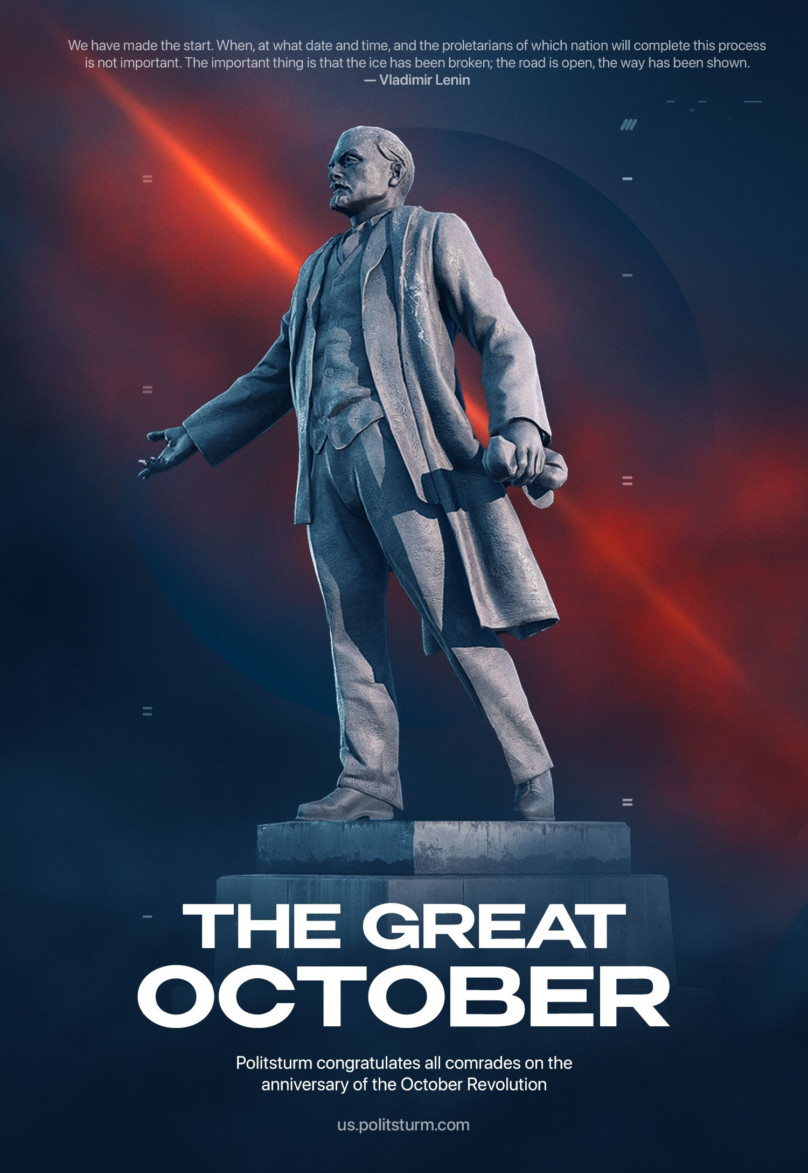

Original article
2023-11-07
4 min read

"The question of imperialist wars, of the international policy of finance capital which now dominates the whole world, a policy that must inevitably engender new imperialist wars, that must inevitably cause an extreme intensification of national oppression, pillage, brigandry and the strangulation of weak, backward and small nationalities by a handful of “advanced” powers—that question has been the keystone of all policy in all the countries of the globe since 1914.
It is a question of life and death for millions upon millions of people. It is a question of whether 20,000,000 people (as compared with the 10,000,000 who were killed in the war of 1914-18 and in the supplementary “minor” wars that are still going on) are to be slaughtered in the next imperialist war, which the bourgeoisie are preparing, and which is growing out of capitalism before our very eyes. It is a question of whether in that future war, which is inevitable (if capitalism continues to exist), 60,000,000 people are to be maimed (compared with the 30,000,000 maimed in 1914-18).
In this question, too, our October Revolution marked the beginning of a new era in world history. The lackeys of the bourgeoisie and its yes-men—the Socialist-Revolutionaries and the Mensheviks, and the petty-bourgeois, allegedly “socialist”, democrats all over the world—derided our slogan “convert the imperialist war into a civil war”. But that slogan proved to be the truth—it was the only truth, unpleasant, blunt, naked and brutal, but nevertheless the truth, as against the host of most refined jingoist and pacifist lies.
Those lies are being dispelled. The Brest peace has been exposed. And with every passing day the significance and consequences of a peace that is even worse than the Brest peace—the peace of Versailles—are being more relentlessly exposed. And the millions who are thinking about the causes of the recent war and of the approaching future war are more and more clearly realising the grim and inexorable truth that it is impossible to escape imperialist war, and imperialist peace (if the old orthography were still in use, I would have written the word mir in two ways, to give it both its meanings)[In Russian, the word mir has two meanings (world and peace) and had two different spellings in the old orthography.—Translator] which inevitably engenders imperialist war, that it is impossible to escape that inferno, except by a Bolshevik struggle and a Bolshevik revolution.
Let the bourgeoisie and the pacifists, the generals and the petty bourgeoisie, the capitalists and the philistines, the pious Christians and the knights of the Second and the Two-and-a-Half Internationals vent their fury against that revolution. No torrents of abuse, calumnies and lies can enable them to conceal the historic fact that for the first time in hundreds and thousands of years the slaves have replied to a war between slave-owners by openly proclaiming the slogan: “Convert this war between slave-owners for the division of their loot into a war of the slaves of all nations against the slave-owners of all nations.”
For the first time in hundreds and thousands of years that slogan has grown from a vague and helpless waiting into a clear and definite political programme, into an effective struggle waged by millions of oppressed people under the leadership of the proletariat; it has grown into the first victory of the proletariat, the first victory in the struggle to abolish war and to unite the workers of all countries against the united bourgeoisie of different nations, against the bourgeoisie that makes peace and war at the expense of the slaves of capital, the wage-workers, the peasants, the working people.
This first victory is not yet the final victory, and it was achieved by our October Revolution at the price of incredible difficulties and hardships, at the price of unprecedented suffering, accompanied by a series of serious reverses and mistakes on our part. How could a single backward people be expected to frustrate the imperialist wars of the most powerful and most developed countries of the world without sustaining reverses and without committing mistakes!
We are not afraid to admit our mistakes and shall examine them dispassionately in order to learn how to correct them. But the fact remains that for the first time in hundreds and thousands of years the promise “to reply” to war between the slave-owners by a revolution of the slaves directed against all the slave-owners has been completely fulfilled—and is being fulfilled despite all difficulties.
We have made the start. When, at what date and time, and the proletarians of which nation will complete this process is not important. The important thing is that the ice has been broken; the road is open, the way has been shown.
Gentlemen, capitalists of all countries, keep up your hypocritical pretence of “defending the fatherland”—the Japanese fatherland against the American, the American against the Japanese, the French against the British, and so forth! Gentlemen, knights of the Second and Two-and a-Half Internationals, pacifist petty bourgeoisie and philistines of the entire world, go on “evading” the question of how to combat imperialist wars by issuing new “Basle Manifestos” (on the model of the Basle Manifesto of 1912).
The first Bolshevik revolution has wrested the first hundred million people of this earth from the clutches of imperialist war and the imperialist world. Subsequent revolutions will deliver the rest of mankind from such wars and from such a world.
– Vladimir Lenin, Fourth Anniversary of the October Revolution.
Politsturm congratulates all comrades on the anniversary of the October Revolution. Join our struggle against capitalism: https://forms.gle/e8B8KhtmxomUXAGU6

Original article

