The Fall of Assad - What Will This Mean for the Region
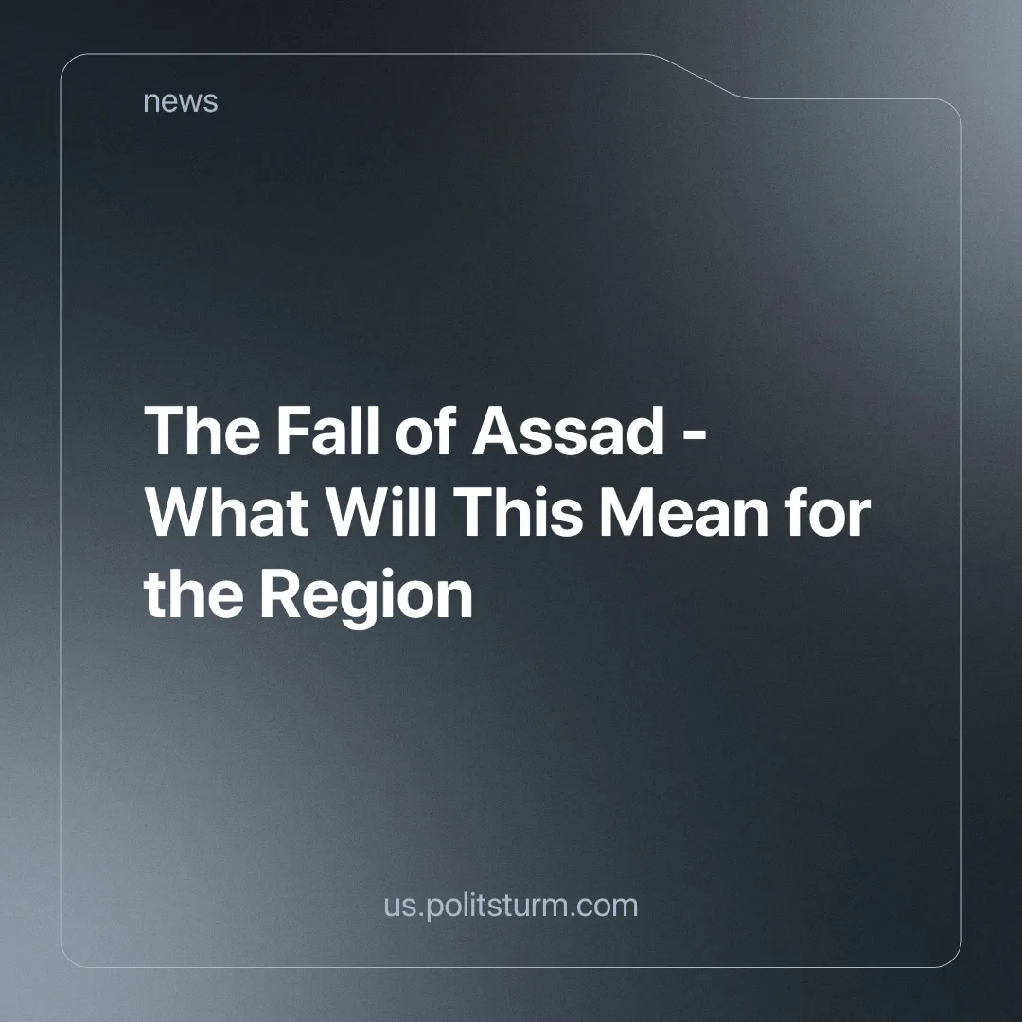

Original article
2024-12-13
3 min read

The fall of Bashar al-Assad's regime marks an important milestone in the tragic destruction of Syria. A decade of war and plunder has brought this nation to its knees. Neither Assad nor the NATO-backed rebels have offered any real way forward for the people of Syria. The accumulated pressure of widespread poverty and the isolation imposed by Western powers has brought Assad's autocracy down. In the meantime, Iran's influence in the region has received a serious jolt: the loss of its key ally in Damascus upsets its so-called "Axis of Resistance." (read our material on The Axis of Resistance)
Neither the brutal regime of Assad nor the NATO-supported opposition represent the interests of ordinary working Syrians. Assad held onto power through a corrupt network of oligarchs and military elites, relying heavily on foreign support from Iran and Russia. His regime was never interested in uplifting the Syrian people but in maintaining a stranglehold over their aspirations for liberation.

Inside Assad's luxury car garage [1] as 90% of Syrians live below the poverty line [2] according to UNICEF.
On the other side, NATO-backed Islamists cynically exploit the language of democracy to whitewash their ideological makeup. These forces have not fought for the liberation of Syrians but for the redistribution of the country's wealth and strategic position to the USA, while carving out a little niche for themselves as profitable middlemen.
The rebels, who have yet to take firm control of the country, hasted to reaffirm their allegiance to a "free market" economy. "It will be a free-market system based on competition," said Bassel Hamwi, head of the Damascus Chamber of Commerce [3]. Their "victory" will not bring freedom for the workers, but rather a freedom for Western corporations to plunder Syria's resources and labor.

The Cracks in the “Axis of Resistance”
The Islamic Republic of Iran suffers a severe setback with the fall of Assad's regime. For decades, Syria was a strategic partner and a linchpin in Iran's regional ambitions. Now is Syria currently being ravaged by relentless Israeli airstrikes aimed at crucial military infrastructure [4], as well as a land invasion through the Golan heights.
Iran's influence is greatly reduced, and all of its rhetoric of resistance rings empty. The Iranian supreme leader blames this outcome on a Western and Zionist plot [5], but by exploiting the working class inside Iran and relying on rogue capitalists abroad, he has made their "resistance" vulnerable to the slightest blow.
The fragile Iranian discourse is highlighted by Ayatollah Khamenei's threats against so-called "scaremongers" [6]. This was his desperate attempt to deflect attention from the regime's waning legitimacy. Ridiculously, in an attempt at damage control, the regime's ideologues have started to claim that the resistance is purely an "idea" or a part of Iranian identity rather than an actual material force in the region [7].

Libya Club Membership?
While today's celebrations in Western capitals by the Syrian diaspora and on the streets of rebel-controlled areas may appear triumphant, they mask a grim reality: Syria now risks joining Libya in becoming another victim of its own supposed salvation, greatly assisted by Western powers. Decimated by foreign intervention, and torn apart by factional strife, the country stands to be carved up by rival imperialist powers, with its people condemned to suffer under further chaos and exploitation.
The "victory" of Assad's opponents is not a victory for the working class, but a cynical redistribution of power among competing oppressors. But this does not mean mourning Assad, as some self-styled "communists" shamefully do.
Only a revolutionary, actually communist movement can bring the people of Syria and the wider Levant together, to rebuild the region based on the collective ownership of the means of production. Rather than deciding between two reactionary camps, the working class needs to organize itself independently against the domination of imperialism and sectarian divisions.
Syria’s fall is a reminder that without the class independence and leadership of the proletariat and the guidance of Marxist-Leninist principles, the region will remain a playground for imperialist ambitions. The time has come to build a truly revolutionary movement in the Levant. Only the workers, united under the banner of communism, can bring lasting peace and order to Syria and beyond. Join Politsturm to begin building workers' power!
Sources:
[1] CTV news – "Inside Assad's luxury car garage" – December 10, 2024.
[2] UNICEF – "Flagship Report: Every Day Counts" – 2022.
[3] Reuters – "Syria's new rulers back shift to free-market economy, business leader says" – December 10, 2024.
[4] Al-Jazeera – "Israel says to impose ‘sterile’ zone in south Syria, launches 480 air raids" – December 10, 2024.
[5] Al-Jazeera – "Iran’s Khamenei says al-Assad ouster a US-Israel ‘plot’, blames ‘neighbour’" – December 11 2024.
[6] Iran International – "Khamenei warns Persian-language media against fearmongering" – December 12, 2024.
[7] MashreqNews (IRGC affiliated agency) – "It is not possible to overcome the "resistance"; why?" – December 12, 2024.

Original article

