The Fall of Afghanistan: What's Next?
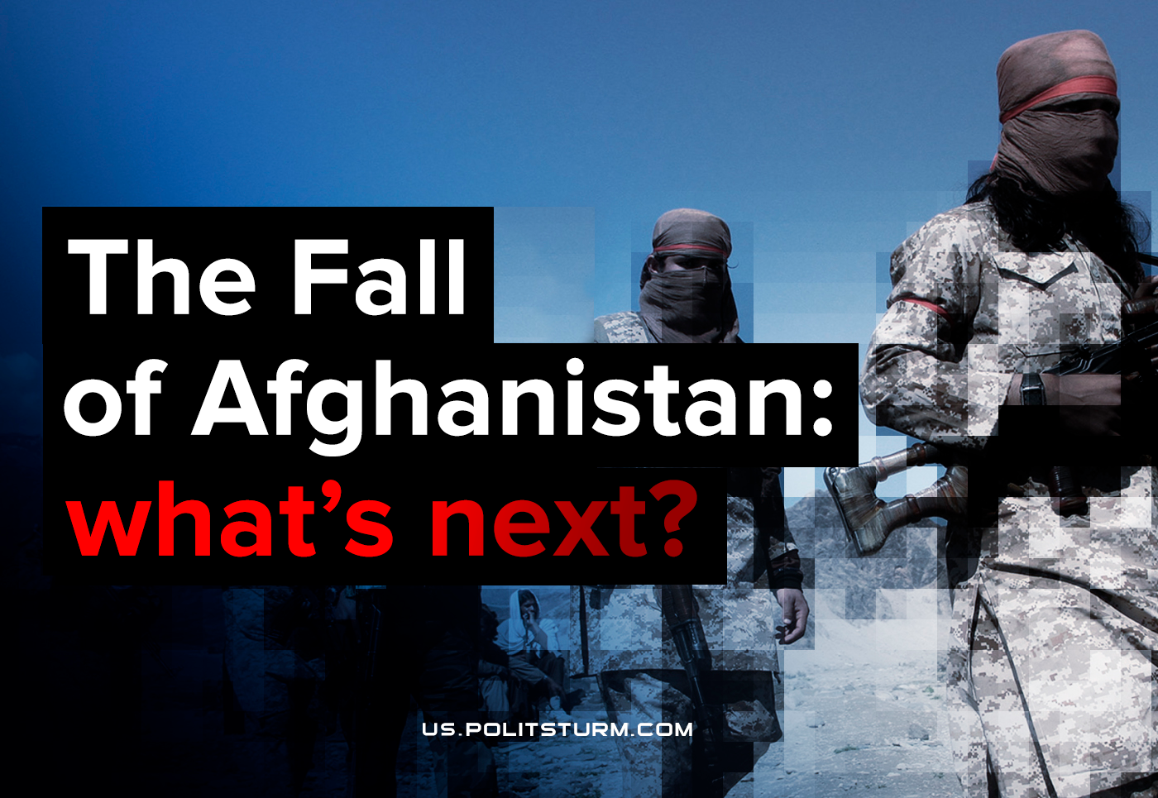

Original article
2021-08-16
6 min read

Recently “Taliban” terrorists occupied the presidential palace in Kabul and announced their full control over the capital of Afghanistan. The Islamists claim that they would soon re-establish the “Islamic Emirate of Afghanistan” – this is the name of the country in 1996-2001, when it was under the rule of the Taliban. Afghan President Ashraf Ghani fled the country, and the remaining government troops went over to the side of the Islamists. Foreign powers are actively evacuating their military forces and citizens.

Why did the US withdraw its troops?
The rapid collapse of the pro-American government as a result of the US withdrawal from Central Asia was the culmination of a complex tangle of inter-imperialist contradictions.
The military operation of the US armed forces and its allies, which has been going on for almost 20 years, was due to several reasons:
- the fight for resources and profits, typical of the imperialists;
- the advantageous strategic position of Afghanistan, which makes it possible to exert influence on neighboring countries and strengthen its presence in Central Asia;
- promoting the interests of the American military complex, which has turned the country into a testing ground for various types of weapons and demonstrating the power of the American army during «the campaign against terrorism» after 2001.
However, the further US military presence in Afghanistan has long been disadvantageous for the ruling group of American capitalists. According to official data from the US Department of Defense, the cost of the Afghan military campaign from October 2001 to September 2019 amounted to $778 billion, and together with the financing of military pensions, medical assistance to veterans and spending by other ministries on military needs, this amount is close to $2 trillion.
Among other things, the protracted military operation undermined the prestige of American imperialism in the international sphere, and also caused discontent among ordinary Americans over losses during the conflict. In total, more than 2,300 people died for the interests of the American oligarchs, and about 20,660 soldiers were injured. Losses among the Afghan people during the years of the campaign are estimated at hundreds of thousands of killed and wounded.

What’s next for Afghanistan?
However, American imperialists are being replaced by others. The place of the main “regulator” in Central Asia is actively occupied by the growing Chinese imperialism. Countries such as Tajikistan, Uzbekistan, Pakistan and Iran have long been the arena of Chinese economic expansion and owe China, with rare exceptions, from 5 to over 25% of their GDP.
Error loading image
Chinese capital is not only expanding in border countries, but, apparently, has agreed to turn Afghanistan into a stronghold of the strongest reaction in exchange for integration into the large-scale system of Chinese imperialism – The Belt and Road Initiative (BRI).
Previously, the PRC had already negotiated with the pro-American government in Kabul on the expansion of the BRI flagship project – the China-Pakistan Economic Corridor (CPEC), worth $62 billion, which includes the construction of highways, railways and energy pipelines between Pakistan and China. According to media reports, in particular, they talked about the construction of the Peshawar-Kabul highway, which will connect Pakistan with Afghanistan and make the latter part of the Chinese BRI initiative.
Error loading image
But the interests of imperialist China are not limited only to the use of Afghan territory for transport needs. Back in 2007, the Chinese company China Metallurgical Group won a 30-year contract worth more than $3 billion to operate the Ayanak copper and gold mine in Logar province southeast of Kabul. Chinese capital actively invested in oil and gas exploration projects and contributed to the development of railway infrastructure.
In 2011, China National Petroleum Corporation (CNPC) won a $400 million tender to drill three fields with 87 million barrels of oil over 25 years.
Beijing is also building a main road through the Wakhan Corridor – a thin strip of mountainous land that connects China’s Xinjiang province with Afghanistan – and on to Pakistan and Central Asia, complementing the existing road network across the region.
Once completed, these new highways should enable Beijing to achieve its goals of increasing trade in Asia and the extraction of natural resources in Afghanistan. According to a 2014 report, Afghanistan may have nearly a trillion dollars’ worth of recoverable rare earths trapped in its mountains.
Considering that the overthrown Kabul government was under the strongest influence of American imperialism and could not ensure security throughout Afghanistan, all this hindered the advancement of the interests of Chinese capital. However, the situation has changed.
A Taliban spokesman said in July that “China is a friendly country and we welcome it for reconstruction and developing Afghanistan…If (the Chinese) have investments, of course, we will ensure their safety”.
At the end of July, representatives of the Taliban made an official visit to the PRC, where they met with the head of the PRC Foreign Ministry Wang Yi for negotiations.
We remind that the main base of the terrorist movement “Taliban” is the north-west of Pakistan, which has been actively supporting the Islamist movement throughout its existence. In turn, Pakistan is one of the targets of Chinese imperialist expansion and is increasingly becoming dependent on the PRC.

Conclusion
1. Ultra reactionary forces came to power in the country, relying on the support of Pakistan and China;
2. Afghanistan is turning again into a closed country based on “religious fascism” and terror, which will entail thousands of casualties among the people;
3. The remnants of progressive sentiments will be suppressed, the Afghan people will be pushed back even further, socially and culturally;
4. The relatively easy victory of the Islamists means the strengthening of reactionary and idealistic religious movements throughout the world, which will be used again by the capitalists for their own purposes and will lead to the strengthening of the dictatorship of capital in many countries;
5. Afghanistan will retain its status as a country dependent on the imperialist powers, having replaced the dominance of American capital for the influence of Chinese imperialism and other capitalist states;
6. In the future, we should expect an increase in Chinese influence in Afghanistan and throughout the region, which will entail a new exacerbation of inter-imperialist contradictions between China, the United States, Russia, India, Iran, etc.;
7. Having become a pawn in the game of the imperialists, Afghanistan is a clear example of the fate of any underdeveloped state in the modern capitalist system.

Original article

