The European Heatwave Has Affected Millions of Lives
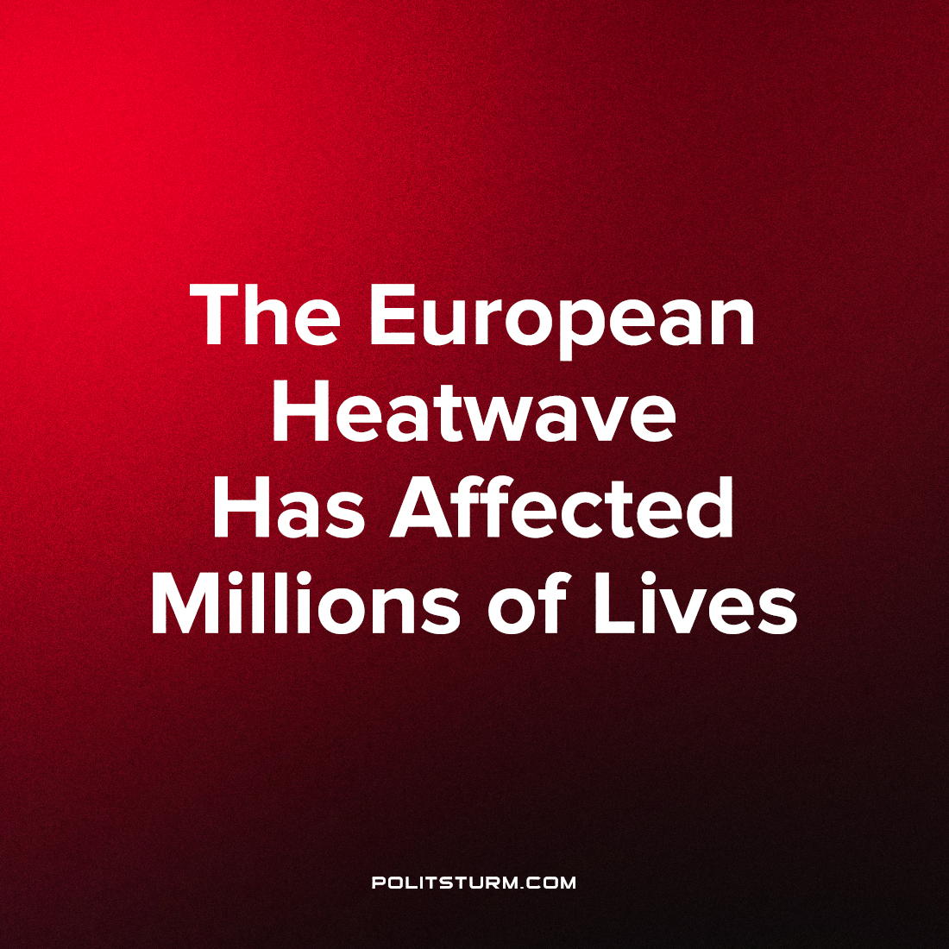

Original article
2022-07-25
2 min read

Last week Western Europe was hit with an exceptionally severe heatwave, with maximum temperatures reaching 40-44°C, which broke many temperature records across the region. The true human cost of this extreme weather event is unknown as it will take a few weeks to verify the exact number of excess deaths, however current figures are in the thousands – and it seems that the Iberian Peninsula is worst affected. Furthermore, the heatwave had moved East to also impact Germany, Italy, and the Balkans.
In Great Britain, temperatures reached 40°C and the estimated death toll is 966 people over the week. Many instances of warping were discovered in the British Rail Network (as picture below).

Error loading image

Error loading image
These damages were promptly discovered and fixed by Network Rail (the state monopoly on rail maintenance) workers before they led to disasters. The British government is attempting to fire 2,500 of them, resulting in less safe railways – which was a big factor in sparking the ongoing and still unresolved industrial dispute between the RMT (Rail, Maritime, and Transport) union and the government and rail cartel, leading to large scale strikes a few weeks ago, with more strikes announced for this Wednesday as well as the 18th and 20th of August. In addition, dozens of fires broke out, especially in London, leading to the busiest day for London’s fire brigade since when fascist bombers littered the sky above the city during the Second World War.
The government has been continuously cutting firefighting jobs and funding over the past decade, leaving those remaining woefully underequipped for a disaster of this scale. In addition, last month the FBU (Fire Brigades Union) rejected a government offer of a 2% pay increase (as when it is compared to the annual inflation of nearly 10%, it is a pay cut in real terms). Despite the increased stress, and many injuries and hospitalisations, the fire service succeeded in putting out all fires. Many are embittered by the government’s treatment of themselves and public safety in general, adding the firefighters of Britain to the long list of disgruntled workers that could go on strike this summer.
In France, which was worse affected, the wildfires had managed to spread to destroy nearly 400 km² of forest and displace 37,000 people as the temperature reached 43°C in some places.
In Spain and Portugal, according to the WHO, the death toll has reached 1,700 as the temperature reached a maximum of 45°C in Spain and 47°C in Portugal (two weeks ago). Infernos have destroyed 2000km² of forest in Spain and 480km² in Portugal over the past two months.
Record breaking temperatures have additionally been recorded in Slovenia, Poland, Ireland, and the Netherlands. Large scale wildfires are still raging on in Greece and Italy.

Original article

