The Cyprus Conflict: The National Question and The Tactics of The Communists
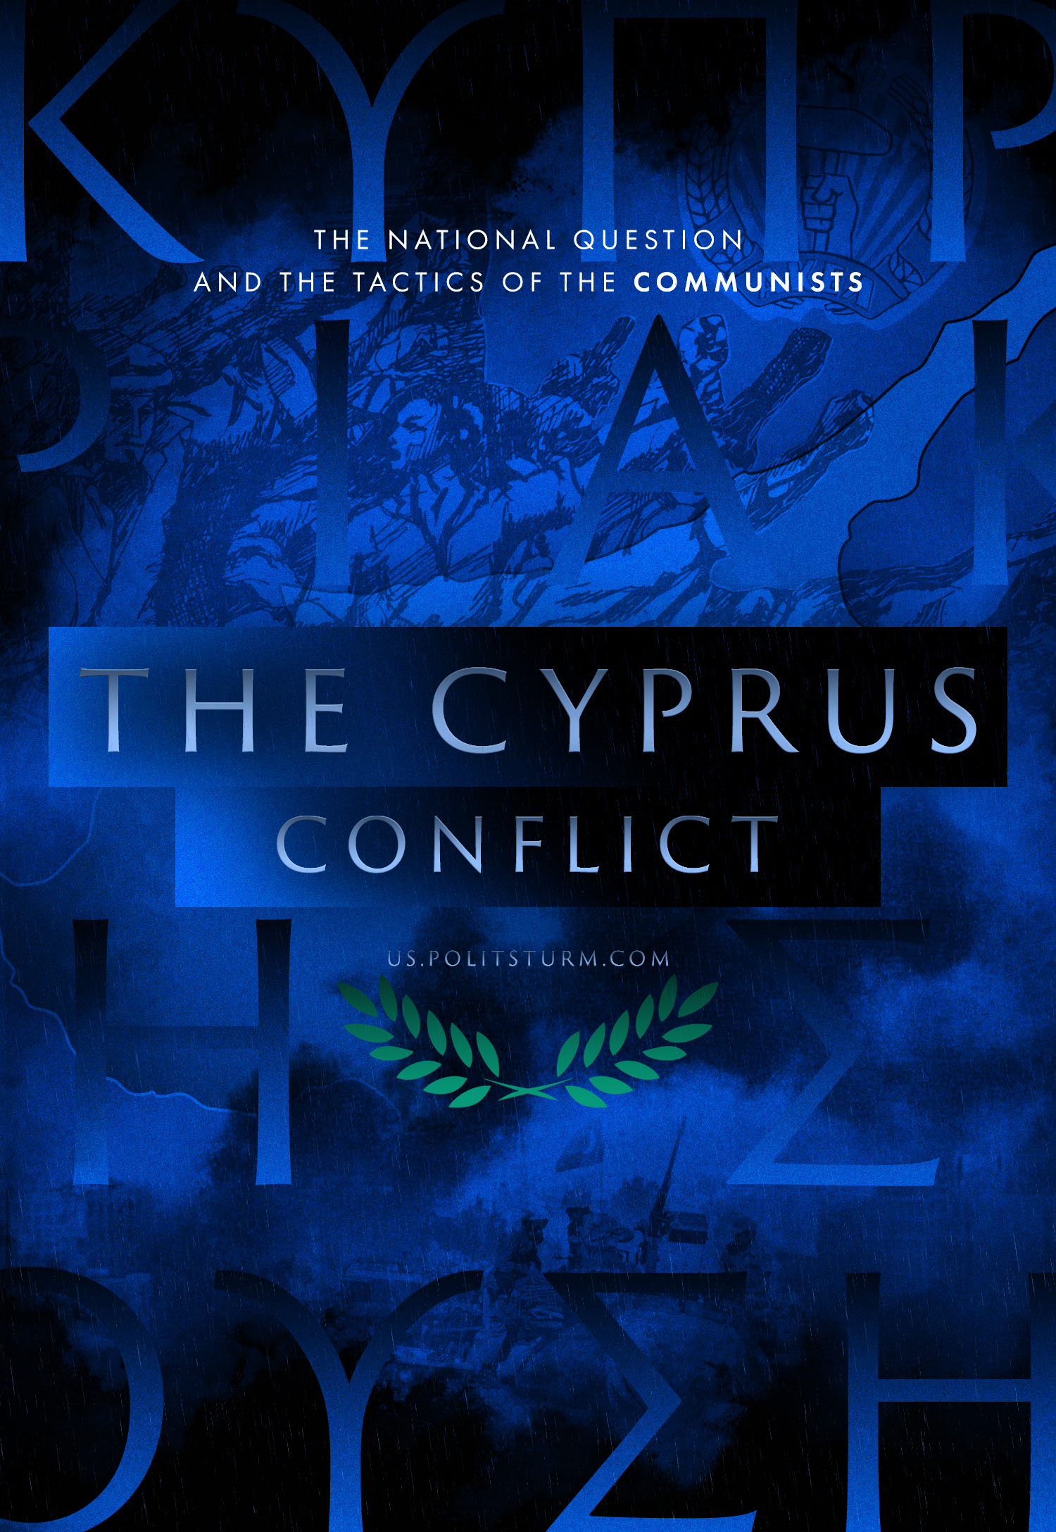

Original article
2022-08-10
21 min read

In the current conditions, not everyone who considers himself as a member of the communist movement can give a clear and understandable answer to the challenges of our time. Considering this, it would be interesting to know how the communists of the past responded to challenges related to such delicate topics as the national question in all its forms, especially slogans of protecting the nation and/or national fatherland in the struggle of capitalist states against each other.
Historical experience in this aspect is quite rich. It is necessary to understand how modern communists can and must act when faced with another example of the bourgeoisie using the flag of national struggle or protecting the nation/national reunification and similar ideological constructs.
We will look at one of the little-known historical examples: the so-called “Cyprus problem”, within the framework of which the right line (the Communist Party of Turkey) and the wrong line (the Communist Party of Cyprus) are very clearly demonstrated.

The Line of Cypriot Communists
British imperialism, which owned Cyprus for almost a century, in the second half of the 20th century, put a lot of effort into sowing national discord between the communities of Greeks and Turkish Cypriots in order to prevent the consolidation of the anti-colonial struggle.
Back in the period of the armed struggle for independence in the second half of the 1950s, Britain pandered to its NATO ally Turkey in opposing the Turkish and Greek population of the island. Numerous right-wing groups were formed under the slogan of “saving the brothers” by Turkey, helping the British fight against the National Organisation of Cypriot Fighters (EOKA), an armed nationalist organisation consisting of Greeks, whose goal was not only the liberation of Cyprus from British rule but also reunification with “mother Greece” (enosis).
The Progressive Party of the Working People of Cyprus (AKEL, communists), at the very beginning of the active operations of EOKA, opposed the militant course of the armed struggle, organizing in 1954-1955, which held huge demonstrations of protest against colonialism, invariably ending in violent dispersal. AKEL responded to this with new peaceful demonstrations, resolutions and appeals.
In essence, it was precisely this principle of refraining from fighting and preaching “peacefulness” with hopes that the world community would pay attention to the problems of the island that led to the fact that the leadership of the national liberation movement was ceded to the right-wing nationalists.
The result was disastrous.
On the one hand, right-wing Greek nationalists built up their own social base by attracting angry Greeks who were dissatisfied with the passivity and peaceful tactics of the communists. On the other hand, a section of the Turkish Cypriots, intimidated by the rampant terror of EOKA and the prospect of enosis, were thrown into the arms of the Turkish secret services, which formed “national self-defence units” from them.
Even worse, AKEL itself was also banned by the British authorities in 1955 on charges of “subversive activities against the British crown”.
As a result, an extremely bad situation developed for the communists: both EOKA and the Turkish nationalist detachments denounced AKEL as “national traitors” and “puppets of imperialism”, persecuting party members among Turks and Greeks, and British imperialism itself beat AKEL as an extremist party that undermined the foundations of colonial domination.
As a result, despite their apparent popularity, the Communists, at such a critical moment in history, found themselves on the sidelines of events.
After the independence of Cyprus in 1960, the Greek, British, American and Turkish intelligence services continued to influence the nationalist elements of the Turkish and Greek communities, setting one against the other.
And if the Greek and Turkish bourgeoisie pursued their purely expansionist goals, covered with patriotic cries of “enosis” (reunification with Greece) or “taksim” (separation from the Greeks), respectively, then British-American imperialism, maintaining an atmosphere of interethnic tension, achieved the preservation of Cyprus in their own sphere of influence.
This was an important factor, given the growth of anti-imperialist sentiments in the Middle East, as two British naval bases built back in the era of colonial rule were preserved (and even expanded). From these bases it was possible to threaten the Arab world, in which national liberation movements were expanding day by day against the neo-colonial domination of Western powers.
Thus, in the 60s, Cyprus turned into an arena of intense clashes between Greek and Turkish nationalists, supported directly by Greece and Turkey themselves – two NATO countries that sought to divide the island between their own spheres of influence. The situation completely suited the “masters” of the North Atlantic Alliance, because the only thing that British-American imperialism really feared was the strengthening of AKEL and the island’s escape from the grip of imperialism.
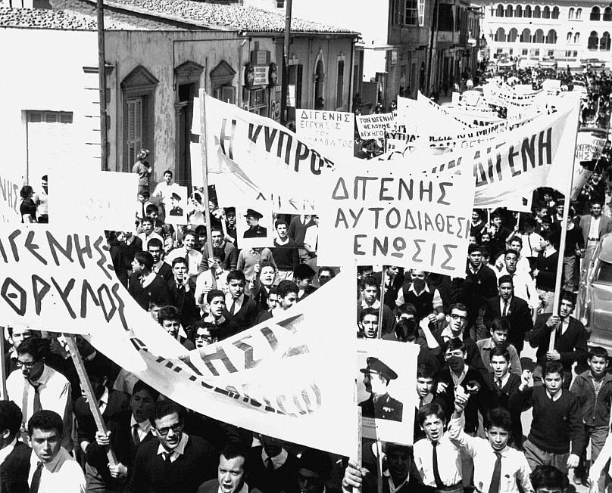
However, their fears were ill-founded: in 1964, against the backdrop of growing nationalist sentiments in the Greek community, AKEL makes the wrong decision to support the “historic aspiration of the masses” (recorded in the new constitution) to create a union of the already independent Cyprus with Greece. This decision did not bring anything but demoralization and disorientation for the Cypriot communists themselves. Consequently, AKEL remained “traitors”; for the Turks, they became the “party of Greek nationalism”; and indeed the rank-and-file party members themselves had abandoned their class orientation, in favour of irredentist positions, bandying slogans to strive towards like “the historical reunification of the Greeks”.
The result of the constitutional crisis of 1963-1964 was the exit of the Turkish Cypriots from the state structures of the republic and the gradual creation of Turkish enclaves in the north of the island, formed by local Turks who were intimidated by the prospect of “reunification”. Thus, AKEL became one of the forces that in every possible way contributed to the creation of conditions that would lead to the division of the country in the future.
Only a right-wing military coup in The events of 1967 in Greece put an end to the Cypriot communists subordinating themselves to “great-power” politics: now the slogans of reunification with Greece, which was under the control of the “junta of colonels” would look completely inadequate.
For this reason, AKEL moved to actively support the neutralist Cypriot government of Makarios, who was under increasing pressure from Greece and the right nationalists.
As the situation worsened on the island, where Greek-oriented neo-fascists from EOKA-B and Turkish right-wing nationalists resumed active activities, AKEL fell back into its prior prostration.
Supporting the Cypriot government in every possible way, which did not fight the right-wing nationalist threat consistently and spread pathetic statements about the readiness of the armed forces of Cyprus (repeating largely the same views as the right-wing nationalists) in order to prevent any attempt at a coup, the leadership of AKEL rejected even its own members’ proposals to form party defence units, all the same relying on endless peaceful rallies, marches and demonstrations in support of the Cypriot authorities.
This is despite the fact that right-wing nationalists on both sides were already launching open attacks against trade union representatives and members of left-wing parties.
Finally, a limited civil war between the government and right-wing Greek nationalists culminated in a military coup against Makarios on July 15, 1974, supported by the Greek military junta. Encountering no resistance from AKEL, the putschists took control of the island. Thus, the numerically powerful AKEL, which recently received 42% of the vote in the municipal elections, went completely bankrupt, relying on the flimsy Cypriot government of Makarios, who did not offer even the slightest resistance to the coup.
The whole mass of party members and citizens loyal to AKEL, confused by the peace-loving and lulling rhetoric of the party elite, turned out to be completely unready to react to these events as they unfurled.
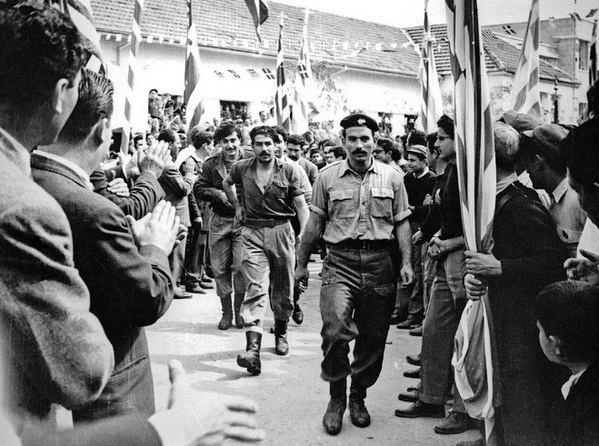
Makarios, who fled Cyprus, turned to the UN Security Council with accusations against the Greek government, which had “made an invasion” using the nationalist forces that it controlled on the island as proxies. A few hours after the appeal, on July 20, an invasion of the island by the Turkish military began with the pretext of restoring Makarios to power.
Just a few days after the start of the invasion, the Greek regime of the “black colonels” collapsed, on July 23 the puppet nationalist pro-Greek government of Cyprus under the leadership of Nikos Sampson fell, and power was passed to the provisional council.
Meanwhile, fighting broke out between the Turkish military and the Greek Cypriots, accompanied by increased nationalist hysteria from all sides. The Turkish army, which landed in the north of the island, with the support of the nationalist Turkish Cypriots, began to carry out acts of ethnic cleansing against the Greek population. The Greek nationalists did the same to the Turkish population in the parts of the island under their control. Henceforth, Cyrpus became divided between Greece and Turkey.
Under these conditions, AKEL again showed their “best” side by joining the general mobilization of the Greek Cypriots for the sake of “saving the motherland”. Completely capitulating to the lead of militant Greek chauvinism, AKEL did not even try to impose at least some kind of left-wing course on the anti-Turkish movement. Regular speeches about imperialism and the Turkish military were interspersed with full support for almost all the initiatives of the new Cypriot government aimed at solving the Cyprus problem, coupled with hopes for the intervention of the UN and the “international community”.
In 1977, AKEL fully supported the Makarios-Denktash agreement to transform Cyprus into a federal bilingual state and to this day adheres to this guiding principle, formulated by Makarios but, in fact, never put into practice.
As you can see, AKEL at all stages of its recent history has never shown itself as a revolutionary party capable of providing a socialist alternative to Cypriot society.
Fearing to lose the image of a “prestigious mass party” and at the same time falling under the dominion of British imperialism, AKEL allowed the right-wing nationalists to usurp the national liberation movement in the second half of the 1950s.
After gaining independence, AKEL still committed tailist errors, following the right-wing Greek nationalists. Despite the commendable efforts of the rank-and-file party masses to rally the Greek and Turkish workers, the leadership of AKEL in 1963-1964 outrightly took the position of Greek nationalism, the position of “fulfilment of the historical dream” of the Greek Cypriots to reunite with Greece, which contributed to the isolation of the Cypriot Turks, the destruction of the historically established system of intercommunal existence.
Uncritically supporting the government of Makarios, AKEL disoriented the party staff and numerous sympathetic citizens, mentally and physically disarming them before the attacks of right-wing nationalists. And after the invasion of Turkish troops, AKEL immediately took a patriotic-chauvinist position, while calling on the UN, NATO and the world community to punish Turkey.
Subsequently, the party was finally transformed into the left wing of the Greek and Cypriot bourgeois governments, enthusiastically accepting all its disingenuous initiatives to “resolve” the Cyprus issue, which, as you know, has still not yet been resolved to this day.

The Line of Turkish Communist Party
While AKEL from the post-war period onwards provided a very poor example, contributing to the aggravation of the “Cyprus problem” and blundered at the national question at all stages of its activity, this cannot be said about the old Communist Party of Turkey.
The TKP, which was previously not very interested in the Cyprus issue, immediately condemned the right-wing nationalist coup against Makarios, calling it a conspiracy of US imperialism, NATO and Greek fascism against the national independence of Cyprus. At the same time, they pointed out that what had happened created favourable conditions for the reactionary and right-wing nationalist circles in Turkey, who were ready to take advantage of the situation to curtail the democratic rights of the Cypriots and implement their own expansionist plans on the island.
At the same time, the TKP initially supported the Turkish government, which carried out a military landing in Cyprus under the pretext of “returning the legitimate government of Makarios” and preventing inter-ethnic unrest. At the same time, the TKP pointed out the danger of this reactionary turn of affairs, because attempts by Turkey to encroach on the national sovereignty of the island would be tantamount to similar actions by Greece, which spurred the actions of the Cypriot junta under the pretence of “reunification”.
A month later, on August 14, when Turkish units began to advance deep into the island and occupied 37% of the territory of Cyprus, it became obvious that Turkey’s real intention was not the return of Makarios, but participation in the division of the island.
As a result of this, the TKP came out strongly against the invasion, seeing it as an imperialist division between the spheres of influence of the two NATO members, which was unambiguously undermining the progressive forces within Cyprus. They realised that the splitting of Cyprus along national lines, supported by both sides, worked exclusively to keep the island in the orbit of imperialism.
In this sense, the Turkish military, which occupied the northern part of the island, was regarded by the TKP as the same wing of imperialism as the fascist junta, because the goals of both were the same: the division of the island along ethnic lines. The investments that large Turkish business almost immediately promised to the northern part of the island clearly indicated that Turkey was not going to leave the occupied territories.
Thus, all the words of Prime Minister Ecevit that “Turkey brings peace and freedom to the island” and “respects the sovereignty of Cyprus” were forgotten. Under the influence of reactionary circles, Turkey has adopted expansionist and nationalist rhetoric, turning into an aggressor and occupier, acting contrary to the decision of the UN Security Council on a ceasefire, continuing to transfer armed forces to the island.
This was precisely the position of the TKP regarding the invasion.
Trying to present the occupation as a kind of “peacekeeping operation”, Turkey put forward the thesis of the federalization of Cyprus along ethnic and linguistic lines. While AKEL as a whole, following the government of Makarios, supported the principle of federalization, the TKP publicly exposed the falsity of this trick.
According to the Turkish communists, federalization is only a “legal” form of the imperialist division of the island. This regime, firstly, favours the further intensification of interethnic hostility to please the reactionary circles from both Turkey and Greece. Secondly, the federal structure increases the danger of a split, as the reactionaries of either side who have seized power could unilaterally decide to break the Cypriot federal union and join Greece or Turkey.
Therefore, federalization is nothing other than the concrete implementation of the plan for the partition of Cyprus by imperialist forces. In addition, the federal structure finally destroys the existing system of existence of interethnic communities side by side with each other all across the island. According to the Turkish communists, only the adaptation of this system to today’s realities can be the key to maintaining the sovereignty and independence of Cyprus.
Based on this analysis, already at the end of August 1974, the TKP issued an appeal to the military with a call to refuse to participate in the occupation of Cyprus. The TKP announced that this operation was carried out not in the name of the people of Turkey, and not even in the name of the Turkish Cypriots, who became hostages of the imperialist division, but purely for the sake of the predatory goals of Turkish reaction and their “friends” the US imperialists in their struggle against the progressive forces of Cyprus, Turkey and the entire Middle East.
Let us note the perspicacity of the Turkish communists as evidenced by the fact that the creation, in February 1975, the puppet state, Turkish Federated State of Cyprus (TFSC) did not lead to a resolution of the Cyprus problem.
Numerous negotiations between the TFSC and the Republic of Cyprus were permanently deadlocked, thanks to the repeated intervention of Greece and Turkey, which considered the island only as a colony and were not at all interested in a real resolution of the Cyprus problem.
In 1983, after the final fiasco of the imperialist federalization plan, the northern part of the island, occupied by the Turkish army, declared independence, and the unrecognized Turkish Republic of Northern Cyprus (TRNC) arose, which still exists today.
Since the late 1980s, TRNC has become a money laundering paradise for the Turkish mafia and oligarchs, while most of the indigenous population left this economically isolated and depressed part of the island, leaving in search of work in Turkey and the Republic of Cyprus.
The TKP, unlike AKEL, put forward a real alternative to solving the Cyprus issue.
But they didn’t just put forward a plan. Thanks to the Turkish communists, who quickly and quite effectively responded to the invasion, the “discourse” set by the TKP took a dominant position in the Turkish left movement.
As a result, it is very difficult to find a left-wing Turkish organization that would support the existence of the puppet Republic of Northern Cyprus. Despite the change in the various approaches of the bourgeoisie to the “blurring” of the Cyprus issue and the ubiquitous patriotic demagoguery, the Turkish communists to this day stand on their former positions:
- Liquidation of the unrecognized republic
- Withdrawal of all armed forces from the territory of the island (including UN peacekeepers)
- The prohibition of any foreign interference in the political life of the country (including in the form of the creation and support of nationalist parties)
- The reunification of the Greek-Turkish community through the creation of all kinds of mixed grassroots committees, including: mixed trade unions, which, since the mid-1960s, have been subjected to ethnic segregation.
It is logical that the communists see the real solution of the national question in this approach. It is equally logical that the position on Cyprus has become another “argument” for the Turkish government to repress the communist movement. The Turkish communists, since 1974, have resisted a large wave of Turkish chauvinism and militarism, accompanied by cries of “historical justice” and “national unity”.
More can be said: it was in 1974, against the background of the events in Cyprus, that a real confrontation between the Turkish communist movement and the Turkish state began, which led to the period of 77-80 where a sluggish civil war that killed more than 5,000 people took place.
In the unrecognized Republic of Northern Cyprus, the truly communist view on the problem is under constant pressure: the puppet government quite intensively opposes any attempts by the left forces of the Turkish community to raise the issue of a real resolution of the Cyprus conflict, seeing this as “national betrayal” and “working for the Greek special services”.
It is curious that it is the Turkish Cypriots who are the main instigators of the struggle against the occupation and for a unitary Greek-Turkish independent state, trying to convey their ideas to the Greek Cypriots, who are predominantly under the strong influence of Greek chauvinism.
Thus, since 1989, the socialist “New Cyprus Party” has been operating in the TRNC, opposing both the “false republic” and the resettlement of Turks from Turkey to the island, which act as the mass base for the occupation administration. Under its auspices, in the 90s and 2000s, youth, sports and cultural projects designed to give rise to grassroots Greek-Turkish interaction were intentionally stifled.
One of the major initiatives of the last 10 years was the largest Turkish Cypriot protest in the history of Northern Cyprus against the neo-colonial policy of Turkey towards the island in the winter and spring of 2011, during which there was even an attempt to fly the flag of the Republic of Cyprus at the Turkish embassy in Northern Nicosia. The immediate result of these “anti-patriotic” demonstrations was the creation of the Union of Cypriots, a Greek-Turkish progressive movement opposed to Turkish occupation on the one hand, and Greek chauvinism on the other.
Unfortunately, on the Greek part of the island, such initiatives are mostly met with strong resistance from the masses, brought up in the last 30-40 years in the spirit of national grievances, and just like the resettled Turks, thoroughly imbued with nationalist-chauvinist prejudices.

Conclusion
Let’s summarize the picture in conclusion.
The Cypriot AKEL, in its attempts to maintain its status as a “prestigious” and “peace-loving” party, at all stages of the Cypriot crisis proved to be more than bad. In fact, during the post-war period, this supposedly communist party turned itself into a party of a social-democratic, parliamentary type, devoid of any revolutionary energy. AKEL – despite its significant numbers and social influence – failed to give the Cypriots of both ethnicities a truly revolutionary alternative to solving the national problem.
This inability forced the party to either fearfully hamper the spontaneous revolutionary movement (during the era of the struggle for independence of the late 1950s), thereby handing the ideological dominance of the national liberation movement to the much more determined, but smaller right-wing Greek nationalists, and to trail behind the bourgeois government of Makarios. At the same time, they approved “from the left flank” almost all of his decisions that were monumental in creating the conditions for the future division of the island and the preservation of this status after the Turkish occupation.
As for the much less influential Communist Party of Turkey, here we see the opposite picture.
From the very beginning, the TKP adhered to the true revolutionary line. Pointing out that the initially declared noble goals of Turkey’s struggle against the fascist Cypriot junta create the conditions for reactionary expansionism and violation of the sovereignty of the island, the TKP stood up in opposition immediately after it became obvious that “fighting fascism” and “saving the Turkish brothers” were not the real reasons for the invasion.
Boldly speaking out against the crazy wave of chauvinism and aggressive militarism raised in Turkish society by the authorities, the TKP also exposed the falsity of the statements of the government, the military command and the occupation administration of northern Cyprus, which tried to justify the imperialist division of the island through patriotic demagogy.
The TKP realized that both the Greeks and the “rescued” Turkish Cypriots themselves became hostages of the partition, having lost the possibility of independently deciding their own fate. From now on, only the occupation administration of the Turkish “saviours” and its proteges in public organizations were to decide what was good for the Turkish Cypriots and what was bad.
A glance at this historical example – demonstrating two different approaches to solving the national problem under the pressure of imperialism – can act as food for thought regarding the current situation, especially for modern communists who are partly or wholly disarmed by the “patriotic”, “anti-fascist”, “defensive” and “liberation” rhetoric of bourgeois governments.

Original article

