The Consequences of the Capitalism Crisis
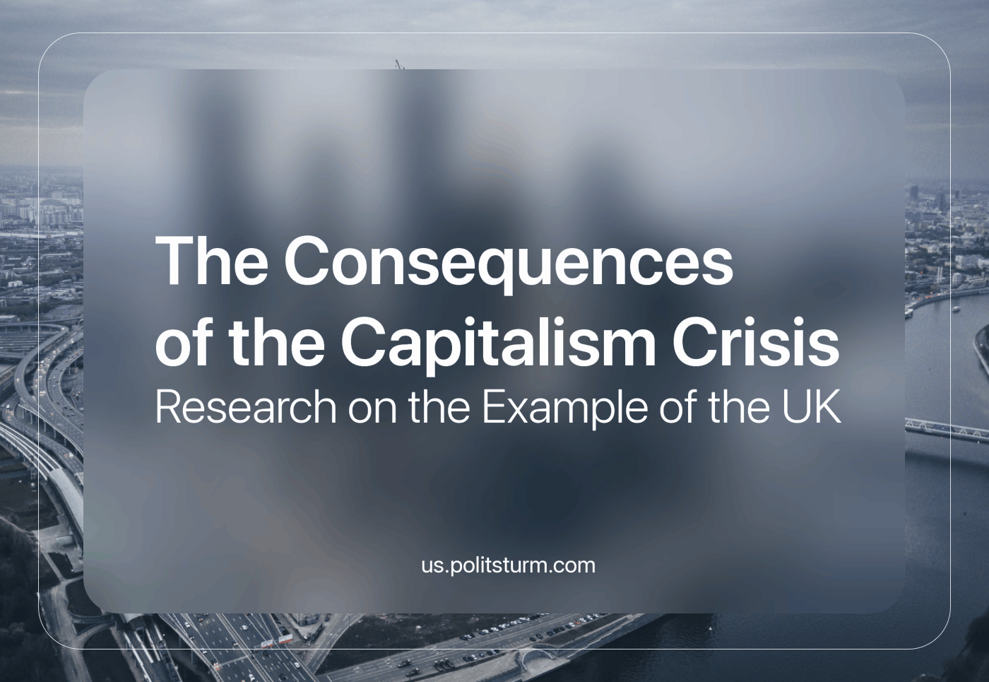

Original article
2023-11-03
16 min read

In recent years, the United Kingdom has witnessed a troubling surge in destitution. This concerning trend is meticulously documented in a 2023 report published by the Joseph Rowntree Foundation [1]. Destitution is defined as people “struggling to afford to meet their most basic physical needs to stay warm, dry, clean and fed”. The report highlights the increasing destitution in the country, primarily focusing on providing statistics that demonstrate the scope and scale of the crisis. In this article, we summarise and discuss the findings from the report, and how they link with other ongoing trends within Britain.

The statistics
· Extent of the Destitution: The report reveals that approximately 3.8 million people in the UK experienced destitution in 2022. Among them were roughly one million children.
· An Alarming Increase: There has been a 61% increase in the number of people experiencing destitution since the last Destitution in the UK survey in 2019. Compared to 2017, this represents an alarming rise of almost two-and-a-half times (a 148% increase).
· The Impact on Children: The number of children experiencing destitution has almost tripled since 2017, with an increase of 186%.
· National Disparities: While British citizens accounted for nearly three-quarters (72%) of the population identified as living in destitution, individuals who have migrated to the UK were over-represented among those experiencing destitution.
· Crime and Begging: Surprisingly, the majority of survey respondents (86%) experiencing destitution do not report complex needs, which are defined as experiencing two or more of homelessness, drug or alcohol problems, domestic violence, and begging.
· Race Disparities: The report highlights that the rate of destitution among black-led households was three times their population share, underlining stark racial disparities in poverty.
· Health Challenges: Almost two-thirds (62%) of destitute survey respondents reported having a chronic health problem or disability.
· Regional Variances: The report highlights regional disparities with London having the highest destitution levels in 2022, followed by the North East and North West. The lowest rates were recorded in the southern English regions.
· Changing Demographics: While destitution has predominantly affected single people, it is now increasingly impacting a broader range of individuals and families. Particularly significant is the rise in single-parent households experiencing destitution.
· Unemployment: In 2022, over one quarter (27%) of all destitute households reported having no immediate source of income in the last month.
· Debilitating Debt: The report reveals that a significant majority of people surveyed (56% of households experiencing destitution) were grappling with problematic debt. This included housing-related and utilities debts, along with consumer debt, such as credit card and catalogue debts.
· The Failures of the Welfare System: The social security system, aimed at preventing destitution, is revealed as a significant source of income for destitute households (72%). Despite this, these households still experienced destitution, indicating that the basic rate of social security is now so low that it fails to clear the threshold to be able to afford the basic necessities for life.
· Universal Credit Challenges: While Universal Credit payments rose in line with inflation in April 2023, most interviewees felt that it made little difference due to the rapidly increasing costs of basic necessities. Issues with Universal Credit administrative procedures and delays persisted, with some interviewees trapped in an endless cycle of repayments due to Budgeting Advances.
The statistics and findings outlined in the report demonstrate the stark reality of the worsening crisis for working people in the UK. However, we shall now move beyond these numbers and delve into the root causes and broader implications of this concerning trend.

How destitution affects different groups in the UK
Within the capitalist system, disabled individuals often bear the brunt of its harsh realities. Capitalism primarily values individuals for the commodities they bring to market, and in the workers’ case they sell only their own labouring power. In the case of disabled people, they are often discarded or inhumanely neglected for their inability to work. The Department of Work and Pension’s is the branch of the State that deals with this and we have written about them previously. The plight of disabled individuals is a stark reminder of the system's disregard for human well-being in its pursuit of profit.
Migrants, often less familiar with the local language and culture, become extra vulnerable to exploitation. Capitalists exploit these vulnerabilities, offering extra low wages and poorer working conditions. Racism is maintained and manipulated by capitalists to maintain a divided and weakened working class.
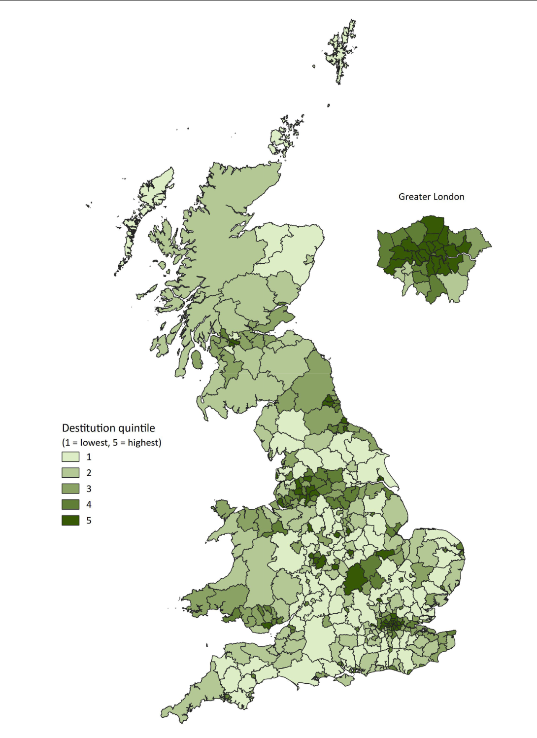
While the report highlights various demographic disparities, such as race, migration status, disability, and regional differences, it is crucial to emphasise that it is the working class as a whole that bears the brunt of the increasing destitution. The capitalist system relentlessly exploits workers, and the conditions leading to destitution are fundamentally rooted in capitalism. Class is what unites individuals and families facing destitution. The disparities based on race, health, and geography are exacerbated by the law of unequal development within capitalism, which still exploits all workers, regardless of their backgrounds.
Destitution is not a consequence of individual failings or inherent characteristics. Rather, it's a symptom of a system that prioritises profit over the well-being of its citizens. In a society where the means of production are privately owned and controlled by a capitalist class, the working class is left with no choice but to sell their labour power to survive. It is through this relationship that exploitation occurs. Workers produce goods and services, but the value they create through their labour takes the form of surplus-value and is siphoned off as profit by business owners, while the workers only receive a fraction of this as their wages. This process is at the heart of capitalism and is what perpetuates economic inequality and poverty.

The rise of austerity
The report hints at the role of government policies in perpetuating destitution. The decline of the welfare state and the rise of austerity measures reflect a broader trend in Britain's diminishing position within world imperialism. The decline in the UK's imperial power is met with a desperate attempt by the ruling class to maximise profits at home to compensate for lost gains abroad. As Britain's position within the world imperialist hierarchy slips further and further, British capital must intensify exploitation at home to extract greater profit. This necessitates austerity policies by the British government and the curtailment of the "welfare state", including reductions in social welfare, leading to the increase of destitution and excess deaths (which we have previously written about) in the country.
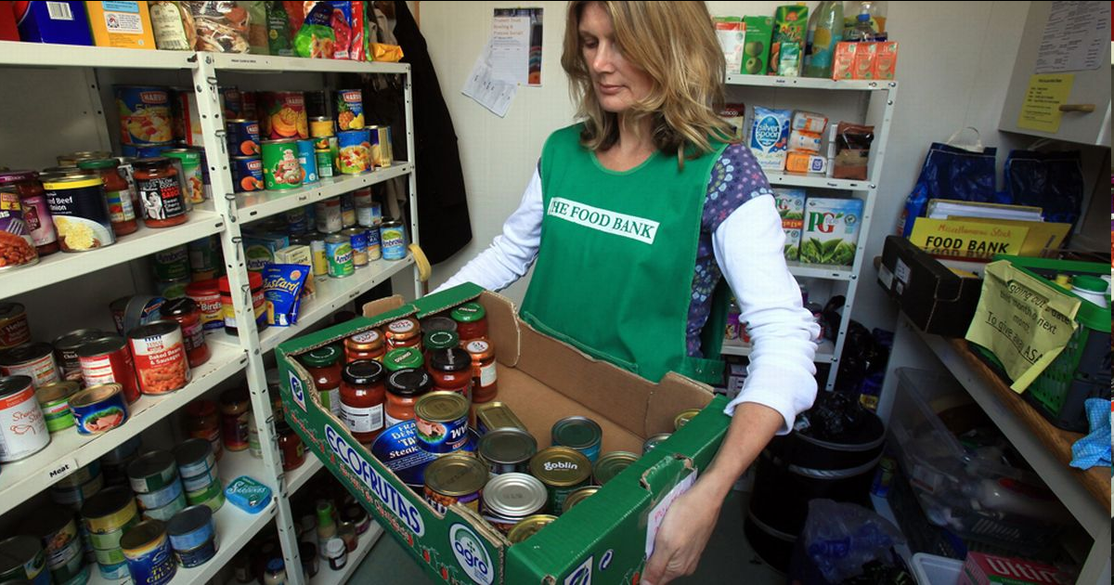
A foodbank in Salisbury. Many who struggle to get by rely on places like this.
Austerity measures, far from being an unfortunate necessity, are a calculated strategy to maintain the wealth and power of the ruling class. By slashing public spending on essential services like healthcare, education, and social welfare, the government is effectively transferring wealth from the working class to the capitalist elite. Instead of going towards social services, taxes (which the richest capitalists generally do not pay) now to a greater degree go towards subsidies for corporations and funding for corruption schemes like HS2 [2]; that is into the pockets of the capitalist class.
The decline of the NHS, the (quite literal) collapse of schools (which we have covered), and the reduction of unemployment payments do not affect the capitalists or their children. They, of course, have private schools, private healthcare and do not work for a living. While capitalism has led to formal equality before the law (although very often does not guarantee even this), social equality remains a million miles away.
As the capitalist appropriates more and more of the social wealth, the working class is left out in the dark to face the grim consequences. Cuts to public services lead to a decline in the quality of healthcare and education, (including the recent crisis of schools collapsing) making it increasingly difficult for the working class to access vital resources for its own survival and to raise the next generation. In the context of the increased destitution we are seeing, this means even less support for those on the brink, pushing them further into despair, which is especially heartbreaking for the millions of children in poverty. Many of them are forced to steal food in school, or chew on rubbers in an attempt to satiate their hunger [3].

The role of finance capital
Finance capital plays a crucial role in the growth of household debt. The relentless pursuit of profit by finance capital often leads to the promotion of “legitimate” financial scams and loans, including credit cards and consumer debt. These financial instruments, while lucrative for finance capital, result in household debt burdens that can push people into destitution. Furthermore, the financialization of the economy, with speculative trading and investment, diverts resources away from industries that produce real social wealth.
Finance capital is the black and rotten heart of the imperialist system. It is a parasitic force that thrives on accumulating wealth without participating in the production of goods or services. Instead, banks’ profit by speculating, lending money and charging interest, having grown from modest middlemen into an omnipotent controlling force over the rest of society.
Household debt, whether through credit cards, mortgages, or personal loans, is a tool through which finance capital extracts wealth from the working class. It's a mechanism that keeps people tethered to financial institutions, as they must pay back borrowed money with considerable interest. These interest payments are a direct transfer of wealth from the working class to the magnates of finance capital.
Consumer debt, as highlighted in the report, is an alarming trend. It signifies that not only are individuals struggling to make ends meet, but they are also forced to borrow just to maintain a basic standard of living, and then borrow more to pay off their already crippling debt. Credit card and catalogue debts, in particular, illustrate how finance capital preys on people's desperation.
Moreover, the financialization of the economy has far-reaching consequences. Instead of investing in productive sectors, finance capital increasingly engages in speculative activities like stock trading. This diverts resources away from industries that create jobs, increase the productive forces, and create a greater social surplus – that is to say things that are the material backbone for a greater standard of living. The priority becomes generating quick profits for the financial leeches, at the expense of society rather than addressing the pressing needs of society.
In fact, the boundless hunger of finance capital is so great that feasting on dying social services is not enough, it begins to cannibalise itself and society with it – a literal embodiment of how imperialism is dying capitalism. Nowhere is this clearer as in the recent announcement of workers of the Atomic Weapons Establishment (AWE), which is responsible for maintaining Britain’s nuclear arsenal, who have balloted (with 61% turnout and 67% in favour) to go on strike over pay [4]. In addition, we have covered the decline in the British military in general previously.
In the midst of this mass impoverishment of the working class, the current government (which represents finance capital first and foremost – the prime minister being a finance capitalist himself and richer than the King) has announced the end of limits on bankers’ bonuses [5] that were put in place after the 2008 financial crisis. The bonuses are already 200% of whatever their grossly inflated salary is, but this is apparently not enough. The stated reason was to “stimulate economic growth”, which they claim will trickle down. In reality, the only thing trickling down is their spit on the faces of the millions of poor and destitute workers as they laugh in their own hubris.
In fact, the policy of removing bankers’ bonuses has been on the ruling class’s recent agenda and was first proposed by Liz Truss’s short-lived government, however this and other policies that openly favoured the capitalists were promptly reversed following public outcry and market instability. However, the fact these policies are now being slowly and quietly implemented reveals the nature of the British state – it is a dictatorship of capital. No-matter whose face is at the foreground the same interests of capital remain in the background and these are what really run the country.

Starvation and malnutrition
The rising dependence on food banks, highlighted in the report, is not merely a consequence of an inadequate welfare system but also a symptom of a wider issue: the epidemic of malnutrition in the UK. It is estimated that approximately 3 million people suffer from malnutrition in the country according to the British Nutrition Foundation [6]. Malnutrition, as a particularly horrible indicator of the destitution crisis, represents a profound failure of the system to meet even the most basic human needs.
Malnutrition is not something confined to the post-colonial dependant states, sometimes called the “global south”. It is a pressing concern even in wealthy nations like the UK, especially now. In the report, the reliance on food banks is a clear indicator of this issue. Food banks, often operated by charitable organisations, have emerged as a critical source of support for those in destitution and poverty. However, most of those struggling to afford food do not even use a foodbank on a regular basis, and even still the food banks are now at a breaking point, running out of supplies for the 600,000 people now dependant on them [7].
Malnutrition poses significant health risks, particularly for children, the elderly, and those with preexisting health conditions. The consequences can be dire, including developmental issues, compromised immunity, and even death. In fact, in the UK, one in three people admitted to hospital have been found to be suffering from malnourishment and every ten minutes, someone in the UK dies with malnourishment in hospital [8].
It's horrifying that in this day and age where one can access the knowledge of all past generations in seconds, where labour productivity and science has reached unprecedented heights, millions of people suffer from malnutrition while 33% of all food produced goes to waste [9]. The social wealth of humankind has grown to unfathomable levels but remains in the hands of a few. A society that does not know material scarcity is more possible than ever, but against the interests of this few.
The capitalist system has long since surpassed its usefulness and historic necessity. It’s a dying system that can only seek to enrich a smaller and smaller handful of people while reducing the standard of living of the broad masses to that of the dark ages, and for an increasing number to even that of slaves.

What can we do?
In light of these findings, the urgent need for change becomes undeniable. The crisis of destitution and the broader crimes of capitalism can only be resolved through a concerted effort by the working class. It is crucial to recognise that the solution to this crisis is not through liberal or reformist policies (in fact these are what have led us here) but a comprehensive and qualitative transformation of the economic and political system. The working class must unite, overcome divisions perpetuated by capitalism, and engage in a struggle for a better world.
The statistics and analysis presented in the report are not just numbers; each one represents the suffering of millions of people. These individuals are not prisoners of their nature or personal failings, but innocent victims of a misanthropic system that has deemed their right to life as inconsequential when compared to the right for an ever-decreasing minority of billionaires to hoard as much wealth as humanly possible.
A future without destitution and malnutrition is possible. It necessitates the establishment of a society of a new type. A society where human life and needs are the only thing held as “sacred”; where ones’ own labour is the only thing that entitles one to the fruits of others labour in equal proportion; a society where exploitation, speculation, war, poverty and homelessness are phenomena relegated to textbooks about our barbarous prehistory – that is communist society.
And we need a communist party to consciously lead and guide the workers’ movement towards this destiny. Every day of inaction perpetuates the suffering of millions in Britain, and billions globally. Our planet is slowly marching towards a climate catastrophe and another imperialist world war; capitalism must be ended or it will end us. The workers have nothing to lose but their chains; we have a world to win.
Sources:
[1] https://www.jrf.org.uk/file/60190/download?token=lGSNsKMj&filetype=full-report
[2] https://www.cityam.com/breathtaking-hs2-failure-slammed-after-whistleblowers-allege-cover-up/
[3] https://www.schoolfoodmatters.org/news-views/news/food-policy/feed-future-children-having-eat-rubbers
[4] https://prospect.org.uk/news/prospect-members-at-awe-vote-for-industrial-action
[5] https://www.theguardian.com/business/2023/oct/24/uk-financial-regulators-scrap-cap-on-bankers-bonuses
[6] https://www.nutrition.org.uk/life-stages/older-people/malnutrition-and-dehydration/malnutrition-matters
[7] https://www.bigissue.com/opinion/food-banks-supplies-winter-poverty-ifan/
[8] https://www.dorsetcouncil.gov.uk/care-and-support-for-adults/nutritional-care-strategy-and-malnutrition-programme-resources
[9] https://www.wfp.org/stories/5-facts-about-food-waste-and-hunger

Original article

