The Communist Manifesto, 175th Anniversary
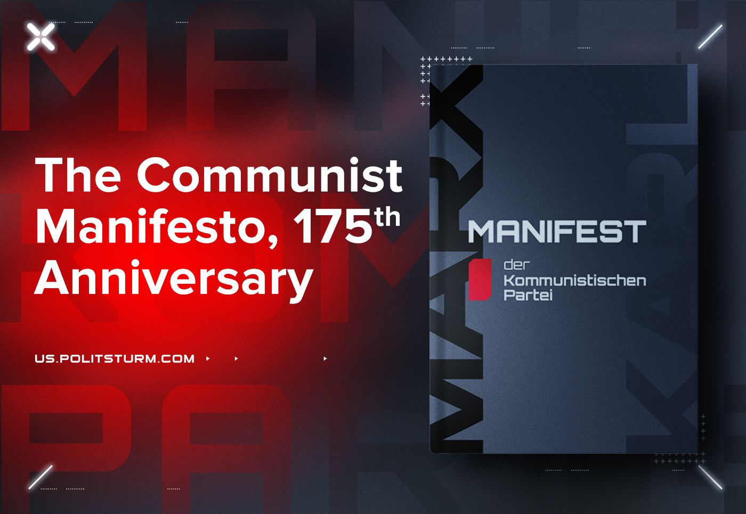

Original article
2023-02-21
5 min read

"A spectre is haunting Europe — the spectre of Communism". These lines are known all over the world. It was through these words that many communists first learned about the "Communist Manifesto" and communist theory itself. Today marks 175 years since the publication of the Manifesto, the first work in which Marx and Engels systematically outlined the foundations of the theory of scientific communism.
The significance of the "Manifesto" for the history of the communist and workers' movement is enormous. In this text the most basic ideas of the then young Marxist theory were set forth for the first time.
Marx and Engels for the first time in the scientific literature gave a general description of the capitalist mode of production and showed not only the main political and economic features, but also the history of its emergence and development.
They outlined the pattern of the emergence of the bourgeois mode of production from the depths of feudal society, put forward the thesis about the law of the correspondence of the nature of production relations to the level of development of the productive forces.
At the same time, Marx and Engels combined their discovery with the theory of classes already known at that time and the class struggle of the proletariat and the bourgeoisie. Thus, it allowed them to see behind the birth of capitalism its death; they came to the conclusion that the task of the proletariat in this struggle is the conquest of political freedoms and power, the elimination of capitalist production relations and the creation of a socialist society.
For the first time in European social journalism, instead of various utopian projects, the idea of overthrowing the capitalist order and building a new society received a solid scientific basis.
Error loading image
The contribution of the "Manifesto" to the revolutionization of the consciousness of the proletariat and the leading representatives of the intelligentsia cannot be overestimated. Spreading first in Europe, and then throughout the world, the Manifesto exposed the system of exploitation and oppression with unstoppable force. Countless are the ranks of fighters, revolutionaries, leaders and leaders of the working class whom it brought up.
Until now, the struggle against injustice and vices in the structure of human society took place in the darkness – ignorance of the laws of its development and change. That is why a whole host of very different socialist doctrines and communist sects flourished. But the publication of the "Manifesto of the Communist Party" opened a new period in the history of the struggle against exploitation – a period when it received a harmonious and correct scientific system. In place of confusion and ignorance, sometimes combined with religious fanaticism, came a harmonious scientific theory.
A period of conscious movement began from the savagery and barbarity of the first millennia of human history to the free and planned development of humanity associated with the labor commune. Despite the fact that after the publication of the Manifesto, Marx and Engels wrote works that were more significant and deeper in content, in which they more fully and accurately revealed the essence of the capitalist system and indicated the path to building a socialist society, it is undoubtedly one of their greatest creations.
The Manifesto became a harbinger of great upheavals in the old bourgeois world. It served as a prologue to the exploits of the Communards in France and the October Revolution in Russia.
Error loading image
At the end of the XX century. the period of world capitalist reaction began. The first socialist state in the world – the USSR – was defeated in the struggle against capitalism, and with it the world socialist system was destroyed. Capital embraced the whole world and created a truly global market. The system of capitalist exploitation of labor has also acquired a truly global character. Workers all over the world found themselves disoriented for many decades, and their consciousness was poisoned by bourgeois propaganda.
The united front of the communist parties collapsed, and everywhere under the guise of "development" and "renovation" countless distortions of Marxist theory began to flourish. Traitors and renegades posing as communists are obligingly diverting the international movement away from the conquest of political power by the working class.
All over the world, people resigned themselves to their fate, "recognizing" the inviolability of the autocracy of capital, limiting their struggle to only the demand for minor reforms and concessions. After forcing communism to retreat, the monopolies divided the legacy of socialism among themselves, and a long period of relative stabilization began for the capitalist system.
However, now we can observe that another period of stable existence of capitalism has ended, and the world is again shaken by trade wars, political crises, coups and armed conflicts.
The contradictions between the various monopoly alliances and their governments, on the one hand, and the contradictions of the entire modern capitalist system, on the other, have again become aggravated to the limit. The threat of a new, hitherto unprecedented world war hangs over humanity.
The capitalists of the whole world, the politicians and parties under their control, are arming and preparing the peoples subject to them for a new clash. At the same time, each side, like 175 years ago, accuses the other of communism.
Error loading image
Under the slogan of "Showing real decommunization", the "Special Military Operation" of the Russian troops is deployed. The Ukrainian government is acting under the slogans of combating the communist past. In early February of this year, the US Congress adopted a resolution "Denouncing the horrors of socialism".
These days, the text of the "Communist Manifesto" continues to expose the hypocritical rhetoric of capitalism and bourgeois politicians, broadcasting from all sources about democracy and individual freedom. At the same time, the Manifesto points out to the workers the reasons for their condition and gives them the means to free labor from the exploitation and parasitism of the ruling class.
Conscious workers and communists must once again follow the path of organizing the proletarian movement, creating strong national communist parties, uniting in a new International, ruthlessly fighting against the line of opportunism and conciliation in the international movement of working people.
Of course, this is not an easy job, moreover, in the most difficult conditions of modern life. But the fate of the whole world depends on whether the communists can accomplish this titanic work and pave the way for humanity to socialism. It's time for new battles.
"The Communists disdain to conceal their views and aims. They openly declare that their ends can be attained only by the forcible overthrow of all existing social conditions. Let the ruling classes tremble at a Communistic revolution."
Let the workers and communists continue to be guided in their struggle by the immortal lines of the Manifesto:
Error loading image

Original article

