The Battle of Blair Mountain: 100th Anniversary of the Biggest Labor Uprising in the US
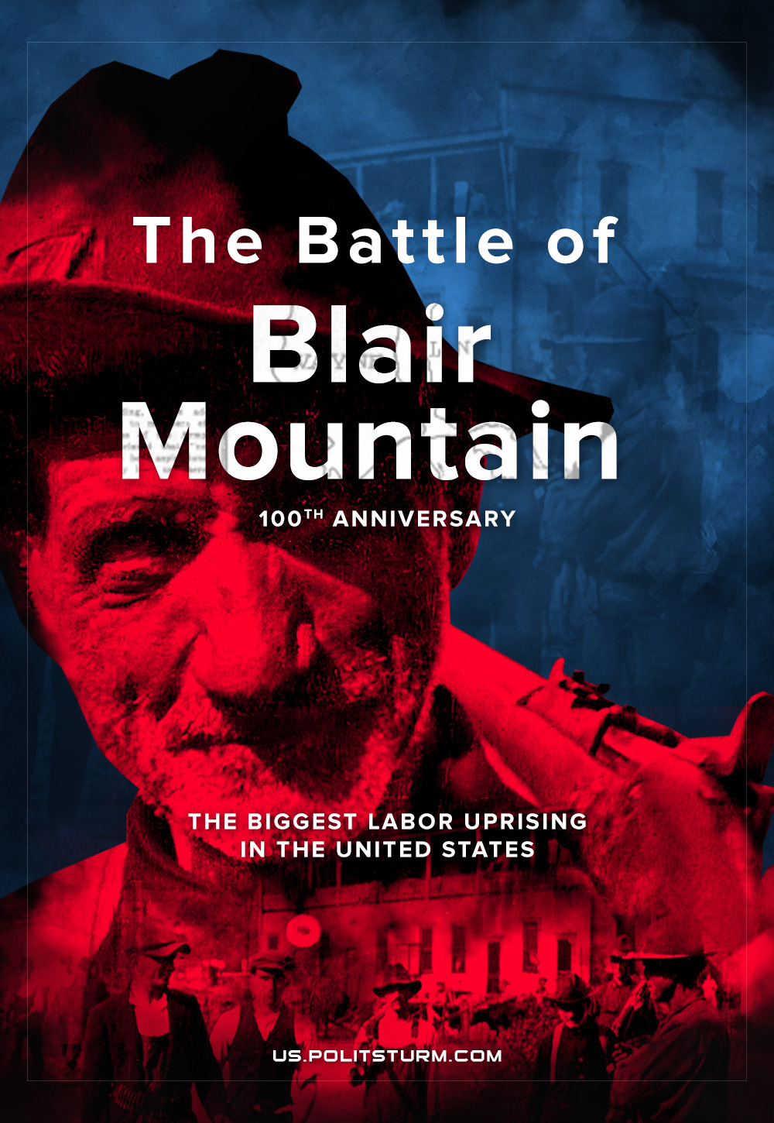

Original article
2021-08-29
9 min read

It all started on the morning of May 19, 1920. Seven men with rifles, submachine guns and revolvers boarded the train to the small mining town of Matewan, West Virginia. Six more followed, armed as well. These were not gangsters heading out to rob a bank, but a terror team hired by the Baldwin Felts detective agency. The head of the agency, Tom Felts, had personally selected each candidate, including his own two brothers. Who could have known that this short journey would open a new chapter in the history of the labor movement in the United States – and a such bloody one? There has not been such an uprising in the United States since the Civil War…
The Battle of Blair Mountain was the largest labor uprising in United States history and the largest armed uprising since the American Civil War. For five days from late August to early September 1921, 10,000 armed coal miners confronted lawmen and strikebreakers who were backed by coal mine operators during the miners’ attempt to unionize the southwestern West Virginia coalfields when tensions rose between workers and mine management.
Matewan, where the drama was staged, is situated in Mingo County, West Virginia, in the midst of some of the world’s richest coal deposits. About 75 mines every year produced a dozen million tons of black gold. There were practically no trade unions in any mine. Most of the quarries were recently opened to meet the increased demand for coal during the World War I. But when the war was over, demand fell, and workers’ wages did not keep pace with inflation. Mines outside the United Mine Workers of West Virginia (UMW) dumped coal on the market at low cost.
And so that the workers would not grow indignant, the Baldwin Felts agency with their “respectable” thugs were at the service of the owners of the mines.
In the spring of 1920, unrest intensified among the miners. By May, more than 3,000 people had already signed up to the union. They knew it could cost them their jobs and housing, one and the same in a company town, but they saw no other way to protest.
Error loading image
The owners of the mining company were not going to put up with this. Miners were fired and evicted along with their families. In May it was Matewan’s turn. The detectives had arrived. Albert Felts, the agency’s field superintendent, had already been in the area to bribe Mayor Cabell Testerman with $500 to place machine guns on roofs in the town; the mayor refused.
The detectives got down to business. Armed men poured into the houses of trade union members and threw their belongings out into the street. When Matewan’s Police Chief Sid Hatfield contacted a colleague by phone, it was revealed that the eviction orders were illegal.
It was around 5 PM on May 19th, 1920, that the fateful meeting took place. Agents had successfully evicted everyone they wanted, ate dinner at the hotel, and went on the train to return home. As they left, they were intercepted by the mayor and the police chief. Hatfield was a smart man and prepared for the event properly. He had an arrest warrant for the agents already written by the Mingo County police chief. He presented it to them with the words: “Gentlemen, you have exceeded your authority.” The agents pulled out their warrant in response. The chief dismissed that it was illegal (it really turned out to be so, but at that time Hatfield did not know for sure – he bluffed). It was at these words that the agents reached for the guns. Thirteen against two – the mayor was not armed. It seemed the outcome was predictable. But the chief had another ace up his sleeve.
While the agents were engaged in the evictions and enjoying their meal, he had gathered miners from all over the city and ordered them to set an ambush. The detectives didn’t suspect that the workers were aiming at them from the windows and alleys.
A skirmish broke out. It isn’t possible to find out who started it. But this was the outcome: about a hundred bullets were fired, and two miners and seven detectives (including Albert Felts and his brother Lee) were dead. Six other agents fled. The mayor was mortally wounded and died that night, not understanding why he was shot. The chief survived and was put on trial.
Error loading image
At a hearing in the US Senate, coal company spokesman Taylor Winson argued that miners earn $400-700 a month. Each. Working with “just” a pickaxe and a shovel. The workers replied that they actually work for a thousand dollars. Not a month, but a year.
At this time, three detectives hired by the same Baldwin Felts on August 1, assassinated union chief Hatfield and his assistant Ed Chambers when they came in to face the state’s charges against them, at the top on the steps of the courthouse, in front of their wives, “in self-defense”.
Unarmed Hatfield received four bullets. Chambers – two. Already wounded, he was finished off with a shot to the head. Meanwhile, the fourth detective began shooting at the stone wall to create the appearance of self-defense.
The victims’ funeral was attended by about three thousand people. The miners were outraged. By August 20, about 600 coal miners camped in a ravine near Marmet station, and hundreds more were on the way. The ranks of protesters grew rapidly – a real army of almost ten thousand soon gathered.
They had an impressive arsenal with them, from .22 long rifles to Army Springfield rifles brought by veterans from Europe, as well as shotguns and various pistols and revolvers.
In the town of Gallagher, miners even managed to seize a Gatling gun from a warehouse of one of the companies, and as well as a machine gun and 10,000 rounds of ammunition.
Panicking police started to dig trenches and arrange roadblocks on the roads. And the armed workers, hearing of massacres behind them, went to the town of Logan to free the comrades mass-arrested for striking. But at the passes near Blair Mountain, police and “volunteers” organized by one Mr. Chafin, ultimately paid hundreds of thousands of dollars, barred the road with machine guns. The rebels tried to infiltrate the mountains and forests. Governor Morgan demanded air assistance.
Error loading image
Famous William “Billy” Mitchell, “the Father of the USAF”, happily told reporters that he was waiting for an order to deal with the rebels. The gas bombs were ready.
Late in the evening of September 1, 1920, 14 bombers arrived at the nearby Canova airfield – 11 DH-4B and 3 Martin MB-1.
Interestingly, out of 21 DH-4B biplanes that were available, only 17 were able to fly. Of these, two were lost and two crashed. Two more had breakdowns. And out of four “Martins” one crashed on the road.
The pilots were strictly forbidden to drop bombs and fire machine guns by the other order. Only aerial intelligence! And General Mitchell himself was not allowed into battle – otherwise he would do some “bad things”.
But no one could prohibit the hiring of private planes. So Logan County Sheriff (where the battle took place) Don Chafin rented the use of three biplanes.
Tear gas cylinders and private homemade bombs with a charge of black powder, bolts and nuts flew from these biplanes at the coal miners. Fortunately, there were no losses: there were few bombs, and they were thrown without sight.
And then on September 2, the National Guard approached, and the plane’s bombs began to drop. The miners understood: it is better not to argue with the state. About a thousand workers had officially surrendered. Later, 985 miners received various terms for their imprisonment (and were released in 1925, after juries refused to convict). The rest had fled.
Error loading image
As a result: over a five-day period, more than ten thousand coal mine workers in Logan County, southern West Virginia fought three thousand local police forces, hired detectives, and then the National Guard. The fighting was fierce. More than a million rounds of ammunition were used by both sides. The exact death toll was never established. It may seem incredible the tiny number of people killed after several days of gunfire. However, in the dense mountain forests, most of the participants in the battles usually did not even see who they were shooting at. In the Battle of Blair Mountain, Americans used aircraft against their own citizens for the first time.

Original article

