The 151st Anniversary of the Paris Commune
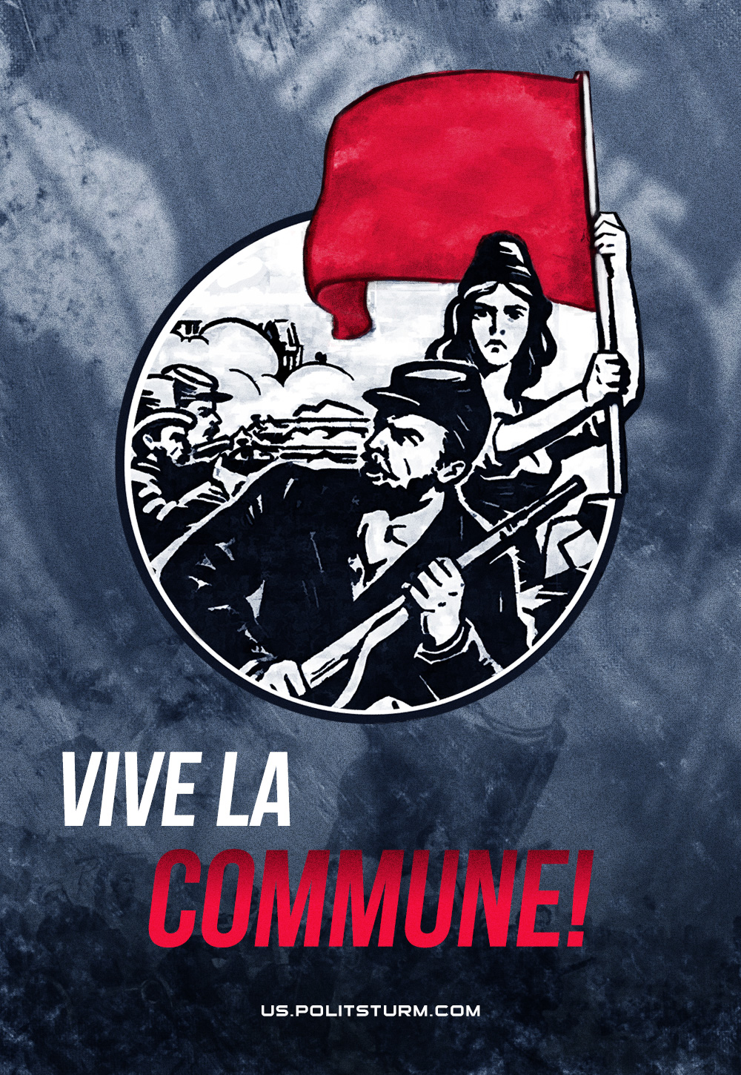

Original article
2022-03-18

Even though the Commune lasted only 72 days, falling in an unequal struggle against the French counter-revolution, supported by the German war machine, it left an indelible mark in the history of the liberation struggle of the working class in France and the world.
The experience of the Paris Commune, confirmed and enriched by the practice of the Great October Revolution, retains its significance for modern communists today.

Original article

