Tesla Workers Speak Out as Company Suppresses Unionization Attempts
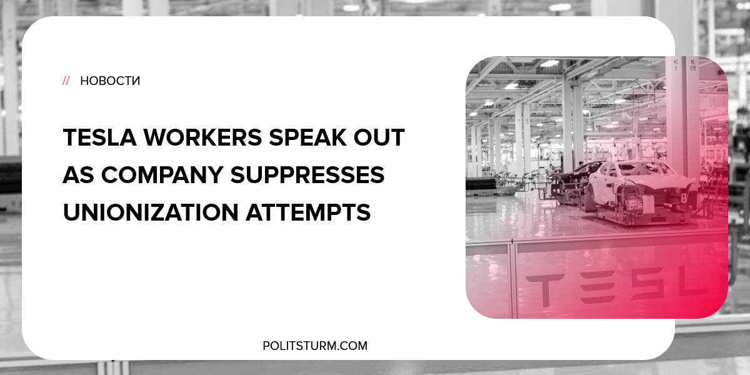

Original article
2018-09-22
1 min read

Despite the corporate posturing that attempts to portray Tesla as “neutral” on the question of unions, Tesla employees are suggesting quite the opposite. Dezzimond Vaughn, a worker at the Tesla factory in Lathrop California, stated that Tesla was actively suppressing the worker’s ability to start a union.
Vaughn was fired from Tesla due to poorly rated performance reviews, but the copies of the reviews reveal that Vaughn was a highly dependable worker.
A Tesla spokesperson stated, “No one at Tesla has ever or will ever have any action taken against them based on their feelings on unionization.”
As we can see, the capitalist class is very skilled at saying one thing and doing the exact opposite. Far from being neutral on the question of unionization, Tesla is actively trying to suppress the formation of unions.
Tesla has recently been facing pressure from investors as rising interest rates have put enormous pressure on their nonexistent profits. The capitalist class, as a rule will try to suppress the unionization of workers whenever possible. The reason for this stems from the fact that increased pay and benefits will reduce profits.
In light of recent developments, many Tesla workers are still committed to forming a union and improving working conditions.

https://www.theguardian.com/technology/2018/sep/10/tesla-workers-union-elon-musk

Original article

