Tech Giant Executives Commissioned into U.S. Army
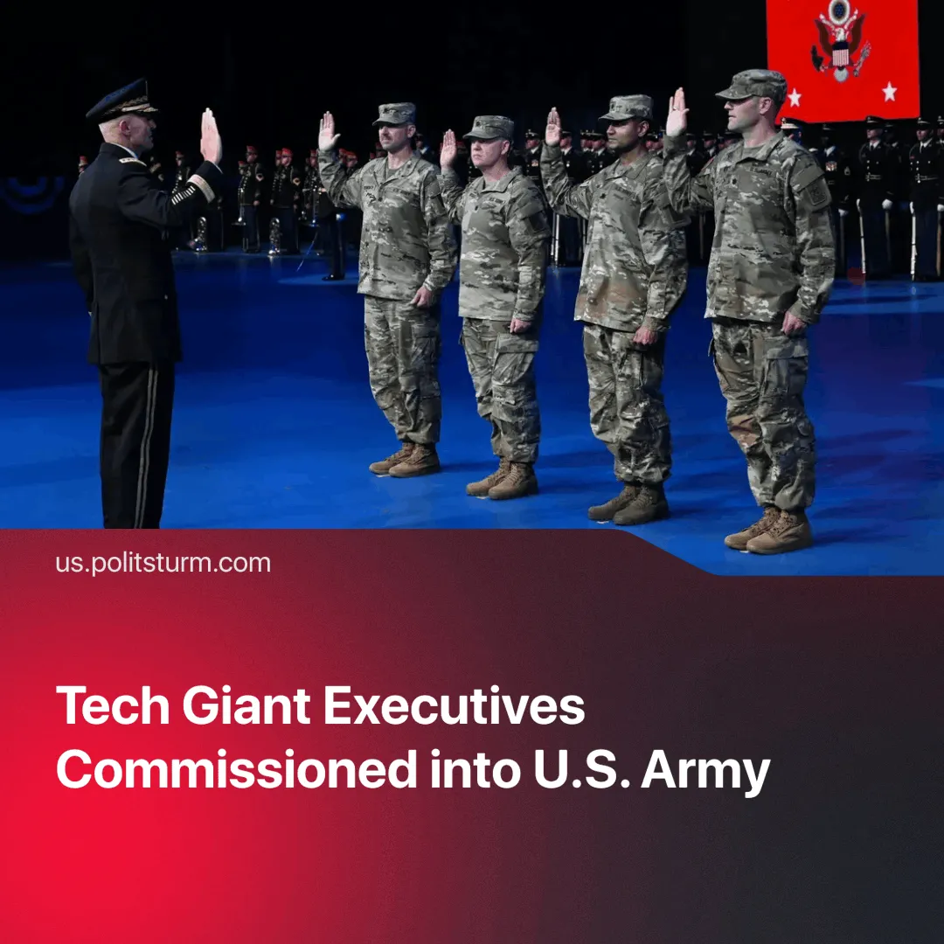

Original article
2025-06-28
1 min read

The commissioning of senior executives from tech companies into the U.S. Army shows the growing direct control of the state by monopoly capital.
Details. Four senior tech executives – Palantir CTO Shyam Sankar, Meta CTO Andrew Bosworth, OpenAI CPO Kevin Weil, and Bob McGrew (formerly of OpenAI) – have been officially commissioned as U.S. Army Reserve lieutenant colonels in the newly formed “Detachment 201,” or Executive Innovation Corps.
► Detachment 201 is a newly created Army unit intended to fuse AI industry expertise with military innovation, serving as a hub for civilian-military tech collaboration. Their roles will be advisory, supporting the Army Transformation Initiative through targeted innovation projects.
Context. Modern warfare is rapidly evolving, with conflicts like Ukraine serving as testing grounds for new weaponry, such as drones and AI systems.
► Palantir already holds extensive data contracts with US agencies such as the DoD (military), CIA and NSA (intelligence), FBI (domestic security), ICE (immigration enforcement), and SOCOM (special forces), demonstrating its deep entanglement in US surveillance and warfare infrastructure.
Important to Know. This example reflects a broader trend in which capital assumes direct control over state functions, thereby bypassing traditional liberal democratic mediation. Under imperialism, monopolies gain enough economic power to embed representatives directly within the state.
► During World War I, Lenin observed this same trend, writing in State and Revolution: “The imperialist war has immensely accelerated and intensified the process of transformation of monopoly capitalism into state-monopoly capitalism. The monstrous oppression of the working people by the state, which is merging more and more with the all-powerful capitalist associations, is becoming increasingly monstrous.”

Original article

