Teacher Shortage In Russia Has Reached 11,000 In Vacancies
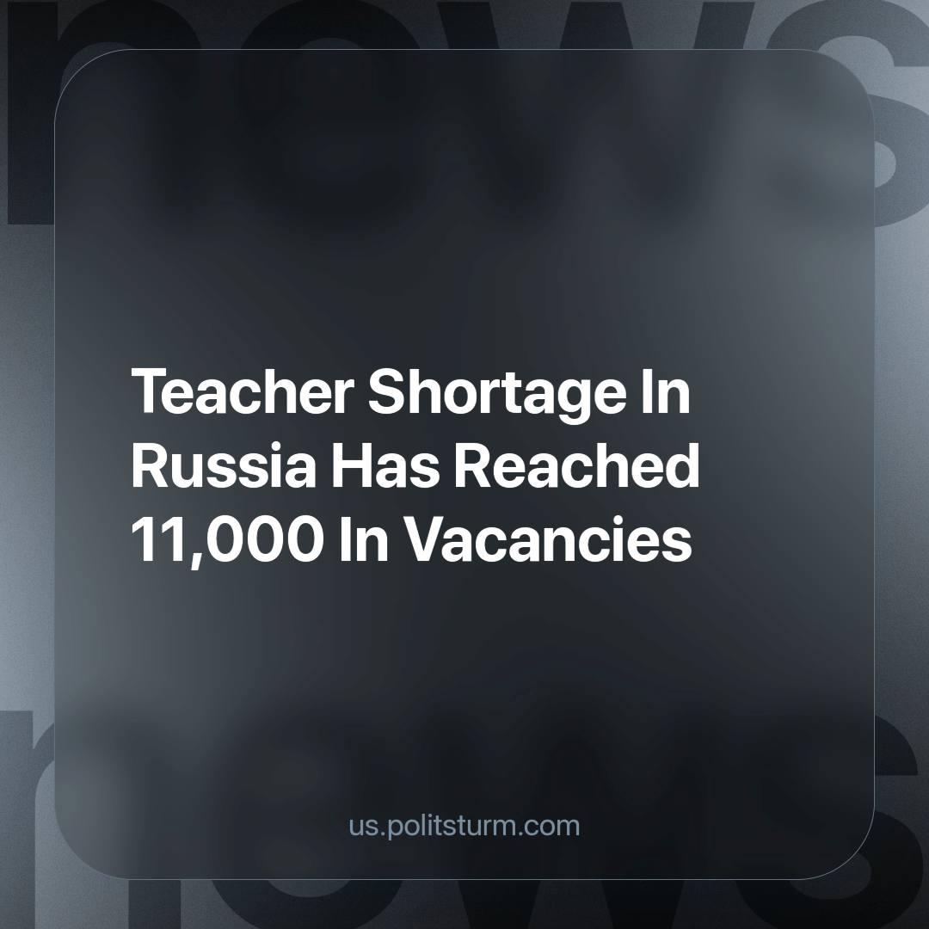

Original article
2023-11-15
2 min read

The Deputy Prime Minister of Russia, Tatyana Golikova, announced at the plenary session of the State Duma that the country has reached a shortage of 11,000 teachers. The "Modernization of the remuneration system" and the “Zemsky* Teacher” programme exist to eliminate this issue.
According to Golikova, the country’s massive shortage of teachers poses a serious challenge to the educational system. She stated that 75,000 students were enrolled in pedagogical specialties according to the data from the last admission campaign. She also stressed that the government is fully aware of the teacher shortage, and its plan to tackle the issue involves heavy reliance of the “Zemsky Teacher” programme, which has already attracted 5,000 new teachers to the education system. The plan also involves modernizing the system of renumeration for teaching staff.
The Russian government has been struggling against this teacher shortage for a long time, yet it still cannot overcome it. It is apparent that they are not actually bothered by the shortage. This becomes clear when one is aware of the functioning of “Zemsky* Teacher” programme. This programme is analogous to the “Zemsky* Doctor” programme; in these programmes, the state provides you with money (in the form of a bonus payment on top of wages)but in exchange you are obligated to work in the most remote regions of the country, regions with very little career prospects. Teachers should not have to be effectively bribed to move to the provinces, it should instead be the case that they are attracted to comfortable living conditions and career prospects that should exist there. However, the capitalist state would rather kill itself than start improving the living standards of those in rural and remote areas.
It becomes immediately clear when one looks closely at the name of the programme, “Zemsky* Teacher”, who the Russian government is inspired by – the Tsarist empire and its living conditions**. After all, it was Tsarist Russia that had a “high” level of education as opposed to the USSR. Golikova did not specify what was meant by the “modernization of the renumeration system. One can only guess that behind such vague wording lies an ever more sophisticated system of exploiting the teachers.
*Zemstvo (Russian: земство, IPA: [ˈzʲɛmstvə]) was an institution of local government in Russian empire. Zemstvo usually was obliged to provide education and medical services in rural areas . Zemsky school was the most common type of primary educational institution in the Russian Empire from the late 1870s to 1917. The quality of education depended on the Zemstvo and was limited to learning pupils how to read and write as well as providing them with basics of Orthodox religion. At the beginning of the XX century, the zemstvos initiated the introduction of universal primary education, however, the relevant law was never adopted in Russian empire; **According to the The 1897 Russian Imperial Census, , the illiteracy rate was 78% excluding the territory of Finland. In the census, literacy meant only the ability to read.
Education plays an essential role in the future of the country, but the oligarchs and officials of the state are indifferent the needs of the people as they can make higher profits elsewhere. This leaves us, the working masses, to educate ourselves and to learn from knowledgeable comrades, so that we may then put this knowledge into practice.
Source: Interfax - "Golikova says there is a shortage of almost 11 thousand teachers in Russia" October 18, 2023.

Original article

