Taxes for Parents, and Jobs for Children in Russia
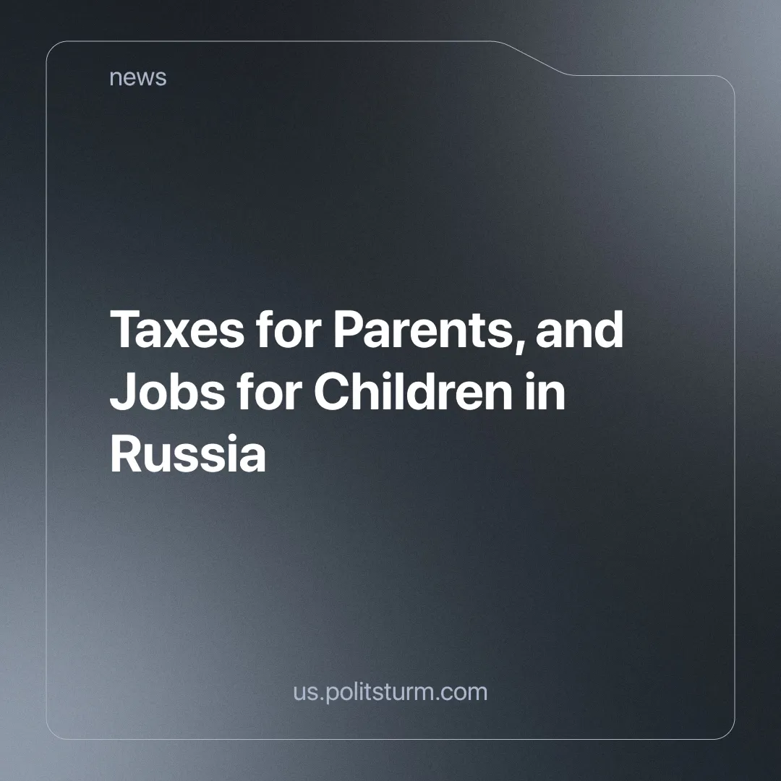

Original article
2024-10-31
6 min read

On September 24 in Russia a bill was approved allowing teenagers aged 14 to 18 to work on weekends and holidays, a practice currently prohibited by the Labor Code [1].
We have previously discussed the proposal from the head of the State Duma committee on this matter. At that time, the bill was sent back for revision. It appears that the initiative (which we previously wrote about) has now cleared the bureaucratic hurdles and is ready for practical implementation.
In this context, as an extreme form of mockery, calls for the introduction of a tax on childlessness are becoming increasingly frequent. This statement originated from the Russian State Social University (RGSU). The proposed tax would apply to both men and women at a rate of 3% on income tax, 5% on inheritance tax, and 0.5% on property tax. All of this is, of course, purportedly “aimed at increasing birth rates”. Citizens without children, including those unable to have them for medical reasons, are expected to adopt. RGSU First Vice-Rector Dzhomart Aliev sees no issue with this [2].
The tax initiative has been criticized even by deputies from the so-called "Communist Party of the Russian Federation" (CPRF). For example, Nina Ostanina emphasized the financial challenges. It is not enough to merely give birth to a child; children must also be raised and supported, which is unfeasible for most under current conditions. Beyond the challenges faced by ordinary citizens, such as earning a decent income, she outlined that military personnel also encounter difficulties when abruptly starting a family. A phrase capturing the essence of this situation has become particularly relevant, illustrating the differences in the same initiative across various historical periods:
“In the Soviet law that established a tax on childlessness, a list was provided detailing the benefits a woman with a child receives: childcare, kindergartens, free transportation, free recreation. And what about now?” [3].
Deputy Mikhail Matveev, a colleague from the same party, echoed these sentiments, noting that many residents do not have the means to even pay this tax, let alone raise children. In conclusion, Matveev reminded everyone of the fuss surrounding migrants and Russian exceptionalism, hinting that if not about yourself, then it is worth thinking about the nation:
“It should be noted that if such a tax is introduced, it will apparently only be levied on Russians and representatives of the indigenous peoples of Russia, because migrants and resettlers from Central Asia and the Caucasus have no issues with childbirth, and they will not pay this tax. In other words, it will, in my opinion, also have a discriminatory nature…” [4].
Regarding children's recreation, which is far from free as it was during the Soviet Union, the aforementioned Ostanina mentioned that Alexander Kolesnikov, a deputy from the Yekaterinburg City Duma representing "United Russia" political party, proposed closing some children's summer holiday camps. In short, there is no funding for their maintenance, and if it is impossible to ensure proper conditions for children, then there is no point in trying. One must start from the "political and economic situation in the country" [5]. After such statements, we can only say that the results are equal to the efforts.
Amid this heap of problems, statements, and initiatives from those in power, it is crucial to sort things out systematically. The issue of involving children in labor is not new in Russia; it started to become more common and lawful from the pandemic to the present day. Year after year, the government has been relaxing legal restrictions regarding the labor of women and children. This category of citizens is needed by the labor market to fill gaps in the workforce as we have previously written about.
The modern economic system — capitalism, operates on the principle of maximizing profit while minimizing costs. In this context, attracting inexpensive labor is a perfectly rational strategy. Women, children, and the aforementioned migrants represent vulnerable segments of the population. For some, labor laws do not apply due to citizenship issues; others, until recently, lacked access to a range of positions and professions, making it difficult to receive proper training and acquire the necessary work experience. In addition, children, due to age and inexperience, cannot claim the same conditions and salaries that adults already enjoy.
The childlessness tax has proven to be so absurd that there is no consensus on it even within the State Duma. Within this structure, conflicting interests of the ruling groups have collided. Recognizing that the introduction of a new tax will provoke sharp discontent among the working class, those who label themselves "communists" are exploiting this situation. They capitalize on the people's problems for political gain. Using overtly populist rhetoric, they appeal to the emotions of the disadvantaged while simultaneously leveraging popular anti-migrant sentiments. This can only lead to a new surge of chauvinism and nationalism. At the expense of ordinary voters, and on the backs of migrants, the Communist Party of the Russian Federation is eager to seize power.
The statements of the "communists," who have long discredited themselves by supporting a regime they claim to despise, are mere empty rhetoric. Their words are not followed by real actions and therefore carry no weight. There has been ample performative discontent against various state initiatives, yet each time they raise their hands in silence, voting for anti-people policies. The CPRF is permeated with the fear of losing budget funding, parliamentary seats, and the privileges that accompany them. They are content with everything, but the working class in Russia holds a different view.
No matter how many words are spoken about spirituality and morality, traditional values, and opposition to the West, this cannot alter the objective reality. The millions of workers in Russia have tangible material needs. This is the only accurate observation made by the pseudo-communists. It is the workers, with their own hands, who create these goods essential for life: homes, apartments, cars, children's camps, and other everyday items. Only in comfortable conditions can a person contemplate lofty matters, spirituality, and philosophy. A hungry person will think only about food because their survival depends on it. Material needs take precedence over spiritual ones — this is the answer to this dilemma.
The critical situation in the country can only be changed by improving the welfare of the working people. Words alone will not suffice; concrete, systemic, tangible changes are needed. The capitalist system is inherently based upon the alienation of the workers from the means of production of which they work, and the private appropriation of the wealth they create, keeping them in a cycle of poverty – desperate enough to continue selling their ability to labor in order to subsist. The real creators of value, the workers, are burdened by policies and taxes that benefit only a select few.
The legalization of child labor, the reduction of social benefits, and the introduction of new taxes pave the way for even greater impoverishment of the working class, transforming them into wage slaves whose lives serve only two purposes: to labor in order to produce goods for the wealthy (who sell them for profit) and to give birth to replenish the labor force — a new generation to be exploited.
To tackle today's demographic and social issues, it is essential to change the very foundation upon which society is built — the economic system. An alternative to capitalism exists, known as socialism. It envisions the maximum enhancement of workers' lives through the dismantling of the exploitative capitalist system. Private property will be abolished, and all material goods will distributed according to the principle of ‘each according to their work’. The state will provide all necessary conditions for the full development of each family, rather than imposing additional taxes for the lack of children. The sentiments of society will be guided not by chauvinism towards anyone, but by fraternal cooperation with fellow workers who also wish to raise their children in prosperity.
Verbal discontent with the situation must be channelled into concrete actions. True communists have repeatedly emphasized these actions: join a Communist organization, enrol in a study group to explore contemporary issues, practically apply the knowledge gained, and collectively work towards the construction of the (actual) Communist Party that would defend the interests of workers rather than engage in empty populism. This is the only way a socialist and just future for the younger generation can be achieved.
Sources:
[1] Trade Union Newspaper "Solidarity" — "State Duma Deputies Continue to Discuss the Issue of Child Employment" — October 5, 2024.
[2] News Agency Nakanuye.RU — "RGSU Proposed Parameters for a Childless Tax" — October 9, 2024.
[3] Political Channel NeKurasov — "Serious Debates Erupt Around the Introduction of a Childless Tax in the State Duma" — October 11, 2024.
[4] News Agency Nakanuye.RU — "Childless Tax Initiatives are Madness and Promise Discrimination Against Russian Families" — October 11, 2024.
[5] News Agency Nakanuye.RU — "Deputy Proposed Closing Some Children's Recreation Camps" — October 10, 2024.

Original article

