Tates Workers Threatened With Deportation Ahead of Union Vote
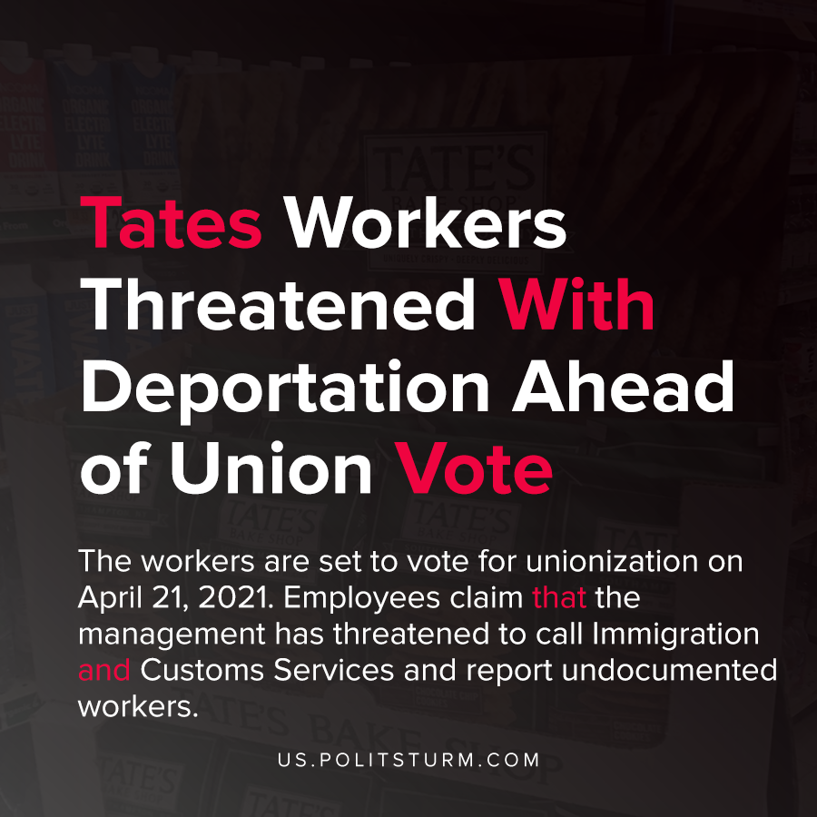

Original article
2021-03-13
1 min read

Union officials say that workers at Tate’s Bake Shop, a cookie company in Southampton, New York, are being threatened with deportation ahead of a unionization vote.
The workers are set to vote for unionization on April 21, 2021. Employees claim that the management has threatened to call Immigration and Customs Services and report undocumented workers.
Under the National Labor Relations Act it is illegal for an employer to retaliate against workers attempting to collectively bargain.
The company, which was acquired by food conglomerate Mondelez, denied any allegation that the company had violated the National Labor Relations Act.
As soon as the monopoly profits of Mondelez were even remotely threatened, management enforces the will of the capitalists who threaten and intimidate workers. It is unsurprising that the capitalists will use every means available, legal or otherwise, to undermine worker organization ahead of a vote. It is also clear to see that the capitalists will use all necessary options to exploit and intimidate the workers. The workers must understand and apply Marxist theory in order to effectively organize and altogether end capitalist exploitation and oppression.
Source: 1 , 2

Original article

