Sweden Extradites First Convicted KWP Member to Turkey
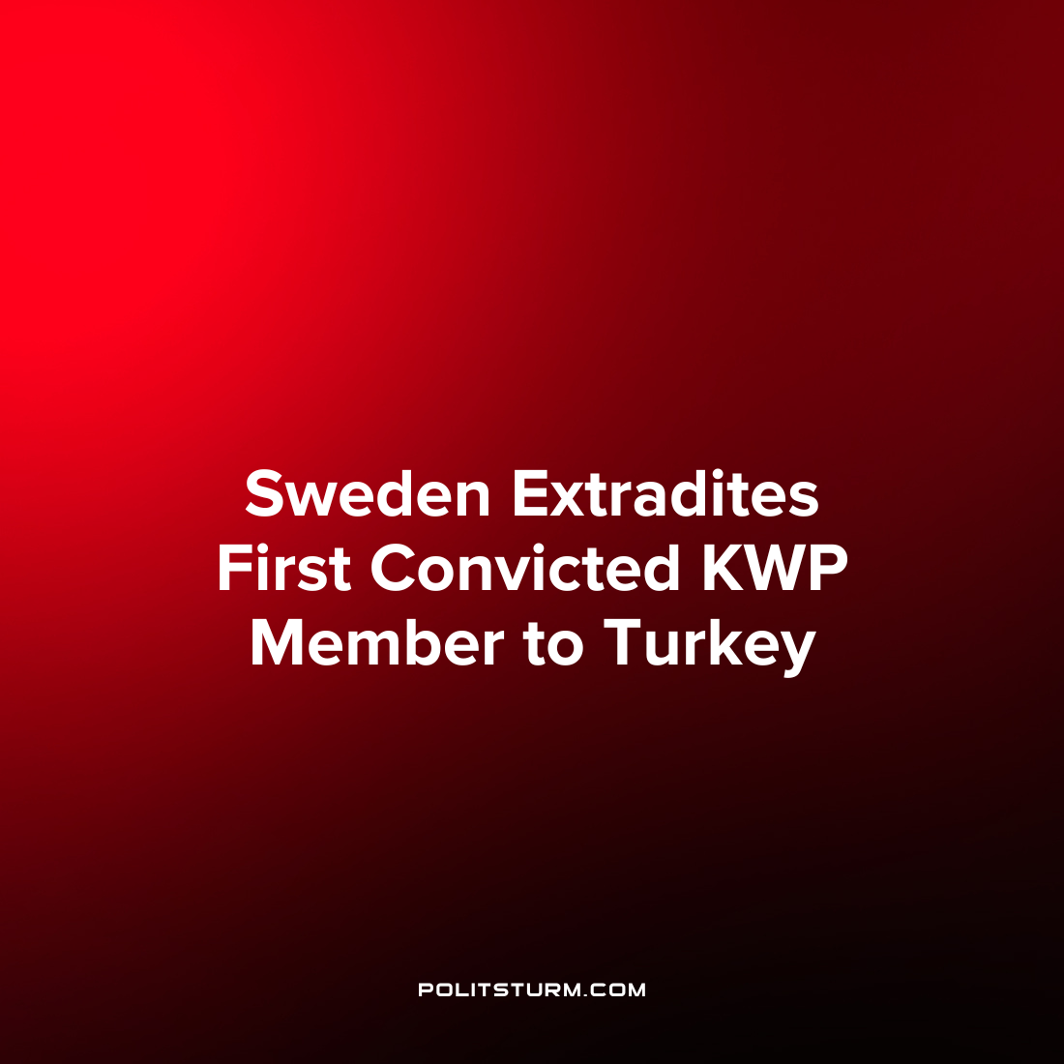

Original article
2022-12-27
2 min read

In June 2022, Turkey demanded that the Swedish government extradite 73 members of the Kurdistan Workers' Party (KWP) as a condition for joining NATO.
The Swedish government is now beginning to comply with these conditions. Last week, Sweden extradited its first convicted KWP member, Mahmut Tata, to Turkey. When he arrived at Istanbul airport on 2 December, Tata was immediately arrested and sent to a detention center. He faces six years and ten months in prison.
In 2015, Tat was convicted of political activity in the Kurdistan Workers' Party, which the Turkish state considers a terrorist organization. Before he could be arrested, however, Tat managed to escape to Sweden, where he sought political asylum.
Six years later, in 2021, despite a clear case of political persecution in his home country, Tat was refused asylum by the Swedish migration authorities for an unnamed reason. After receiving the rejection, he applied for asylum from a number of lawyers in Sweden, making it clear that he had no intention of returning to Turkey. At the same time, he continued to work in a restaurant in Gothenburg - until he was arrested and extradited to Turkey in early December 2022.
Notably, the Swedish state itself does not recognize the KWP as a terrorist organization. In 2017, the National Centre for the Threat of Terrorism (Nationellt centrum för terrorhotbedömning), after a lengthy investigation into the issue, announced that the KWP poses "no threat" to Sweden or other European countries.
"Despite the long and intense conflict between the Turkish government and the KWP, no indication was found that the KWP supports terrorist activities or encourages its members to commit terrorist acts against Turkish interests abroad," the Swedish think tank said in an official report
Nevertheless, Sweden has agreed to extradite its members to Turkey, where they face many years in prison at best, and death at worst. Since Swedish capitalist interests dictate that Sweden join NATO, the Swedish government is willing to do anything to achieve this goal.
The expulsion of KWP members to Turkey by the Swedish government is another glaring example of the hypocrisy of bourgeois-democratic countries. While these governments utter rhetoric about "human rights", they show in practice that they are willing to sacrifice the freedom and even lives of workers for their own financial and geopolitical interests.
Sources:
Riktpunkt – “Erdogan sätter dagordningen och kurdiska kämpar offras för NATO” (8th December)
Proletären – ”Stoppa utvisningen av Mahmut till Turkiet!” (29th November)Kommersant - " Sweden handed over to Turkey the first convict for membership in the Kurdistan Workers' Party" (3rd December)

Original article

