Supreme Court Ruling Undermines Public Unions
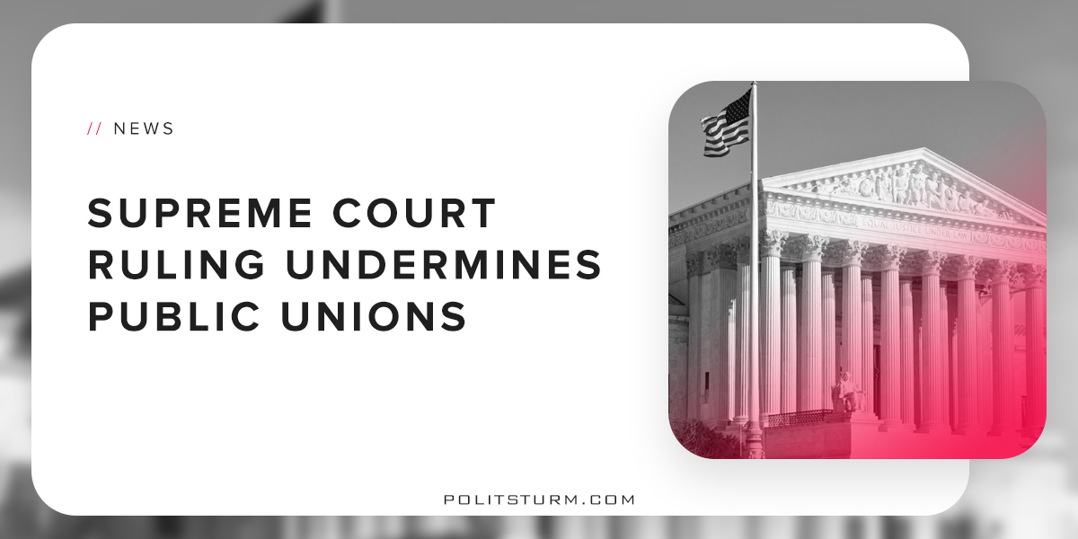

Original article
2018-06-30
1 min read

The Supreme Court ruled that public employee unions cannot collect fees from non-members to defray the costs of collective bargaining. The ruling reflects the opinion that requiring non-union members to pay fees for collective bargaining violated the “free speech” of those that do not wish to contribute to unions.
Justice Alito stated, “It is difficult to how many billions of dollars have been taken from nonmembers and transferred to public-sector unions in violation of the First Amendment.” This ruling is intended to undermine the funding of public sector unions in an attempt to undermine them.
A recent poll showed that 61% of Americans support unions, the highest Gallup poll rating since 2003. However, unions have been on a historic 70-year decline in the United States. Despite the large amount of public support for unions, the Supreme Court has made several inauspicious decisions which have specifically targeted unions and workers’ rights.
The rational explanation for these mediocre results for the working class is that the justices of the Supreme Court do not support the working class. The legislature, executive, and judiciary are structurally intended to support the interests of the oligarchs.
Also, the ability of workers to collectively bargain and organize is a potential threat for the capitalist class. Rising wages and benefits, all other factors remaining the same, will reduce the profits, dividends, interest, and rent available to the bourgeoisie.
As a result, the representatives of the capitalist class are targeting the public sector unions which are much stronger when compared to private sector unions. This ruling is just further proof that the capitalist institutions are diametrically opposed to the interests of the working class and in actuality just support a small group of oligarchs.
https://www.usatoday.com/story/news/politics/2018/06/27/supreme-court-deals-blow-public-employee-labor-unions/590440002/

Original article

