Supreme Court Rules With Employers Over Contraceptive Care
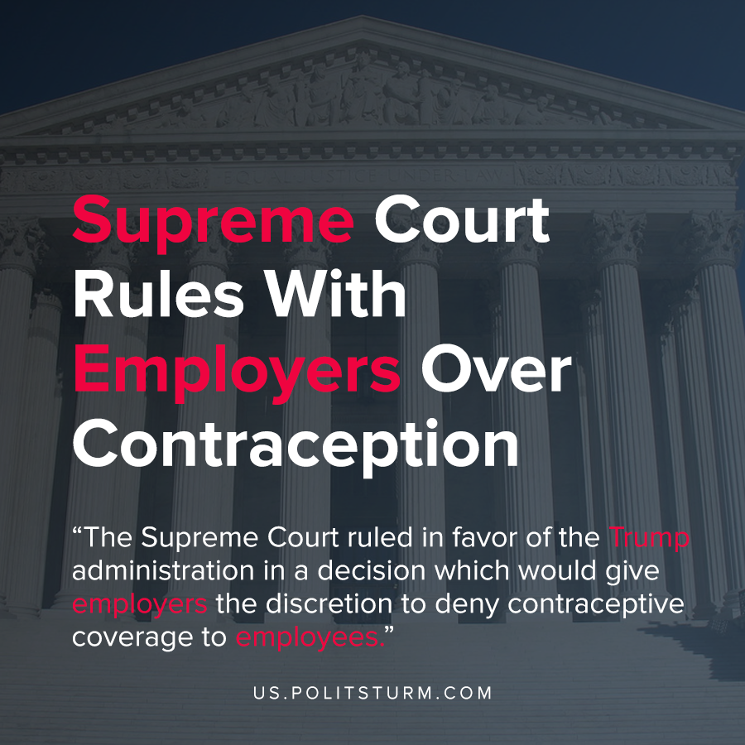

Original article
2020-07-10
1 min read

The Supreme Court ruled in favor of the Trump administration in a decision which would give employers the discretion to deny contraceptive coverage to employees. The Patient Protection and Affordable Care Act, popularly known as ‘Obamacare’, relied on guidelines by the Health Resources and Services administration to determine what constituted preventative care and screenings.
The guidelines mandated that coverage be provided for contraception that was approved by the Food and Drug Administration. As such, employers were mandated to provide contraceptive coverage for their employees.
Religious organizations immediately challenged this rule and brought the case all the way to the Supreme Court. The case that was ruled upon was LIttle Sisters Of The Poor Saints Peter And Paul Home v. Pennsylvania.
The Supreme Court ruled in favor of the employers, that those who held the belief that “deliberately avoiding reproduction through medical means is immoral”, would not be mandated to provide for contraceptive care.
While the Trump administration has framed this question under the guise of protecting the religious freedom of the employers, a more important principle is at play. The religious institutions play an important role in capitalist society in enforcing the class domination of the capitalist class.
In this case, the Supreme Court ruled in favor of the employer to have complete discretion in terms of what contraceptive care their employees receive. This is yet another example of the law serving the interests of the dominant class in society to the detriment of the workers:
Sources: 1 , 2

Original article

