Supreme Court Rules on LGBTQ Workplace Rights
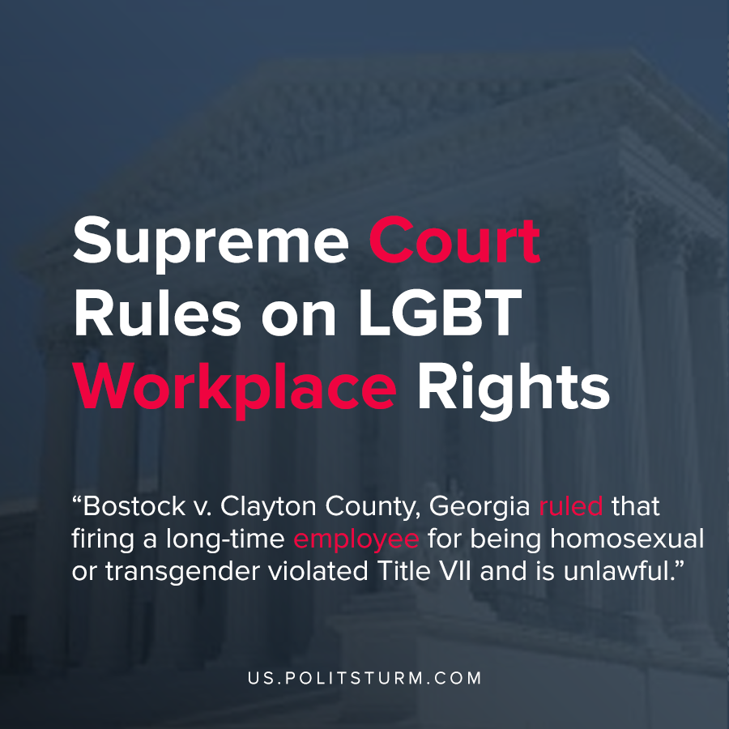

Original article
2020-06-15
1 min read

A new ruling by the Supreme Court in the case Bostock v. Clayton County, Georgia ruled that firing a long-time employee for being homosexual or transgender violated Title VII and is unlawful.
In this case, the municipality of Clayton county Georgia fired Gerald Bostock shortly after learning that he participated in a gay recreational softball league. Bostock was fired on the basis of this conduct being considered “unbecoming” by his employer, and the suit made its way to the Supreme Court.
Title VII makes it unlawful to fire an employee on the basis of their “race, color, religion, sex, or national origin”. Since an employer would need to consider the employee’s sex when firing them simply for being homosexual or transgender, the Court ruling came out in favor of the employee as being wrongly fired.
Legislation and the rulings of the courts, while they may rule against a capitalist in individual instances, always supports the interests of the capitalist class as a whole. While this ruling will provide protection from firings when related exclusively to sexual orientation, the entire edifice of capitalist social relations relies upon discrimination and oppression of the working class. There are additional concerns beyond firing an employee solely on the basis of sexual orientation, such as the right to a job, pay discrimination, hiring discrimination, etc. These issues are simply beyond reconciliation within the capitalist framework.
The protections and freedoms granted to the workers will always be within the limits acceptable to the bourgeoisie until the capitalist economic system is replaced by a socialist, planned economy run in the interests of the working class.

Source : 1

Original article

