Supreme Court Rules in Favor of Employers in Labor Dispute
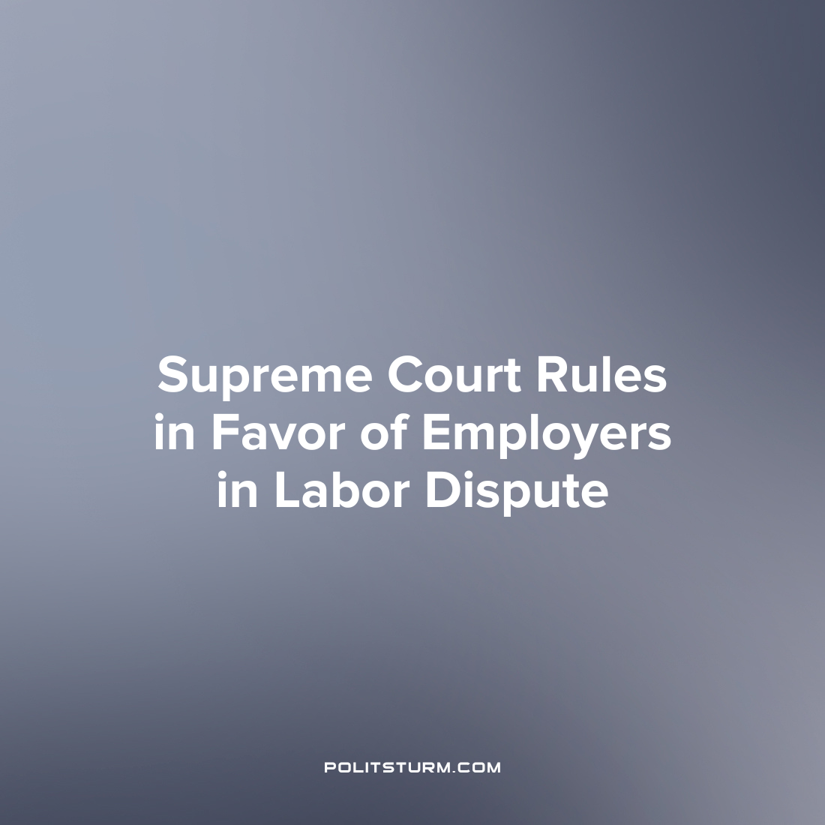

Original article
2023-07-06
1 min read

The U.S. Supreme Court has issued a ruling that favors employers in cases involving labor union strikes causing property damage. In an 8-1 decision, the court overturned a lower court ruling and permitted Glacier Northwest, a Washington state concrete business, to proceed with a lawsuit against a local Teamsters union. The lawsuit alleges intentional property destruction during a 2017 strike, which led to the company discarding unused concrete at a financial loss. The court determined that the union's actions endangered the company's trucks and were not protected under federal labor law.
The ruling by the Supreme Court, with its conservative majority, strengthens the position of employers in cases involving labor disputes. Writing for the majority, Conservative Justice Amy Coney Barrett stated that the union's actions not only destroyed the concrete but also posed a risk of harm to the company's trucks. The ruling suggests that the NLRA does not protect conduct that endangers an employer's property instead of taking reasonable precautions to mitigate the risk.
It is not surprising that the Supreme Court ruled in favor of the employers, namely the capitalist class, against the workers. In bourgeois society, despite posturing the interests of societal institutions such as the Supreme Court as “impartial” or “apolitical”, they rather serve the interests of the dominant class, the capitalists. The capitalists use their class position to suppress any opposition to their class domination and protect their right to exploit the workers and amass profits at the expense of the masses. As long as the capitalist system continues to exist, so will the exploitation of man by man.
Source: 1

Original article

