Subsidies Reduced For Medical Insurance
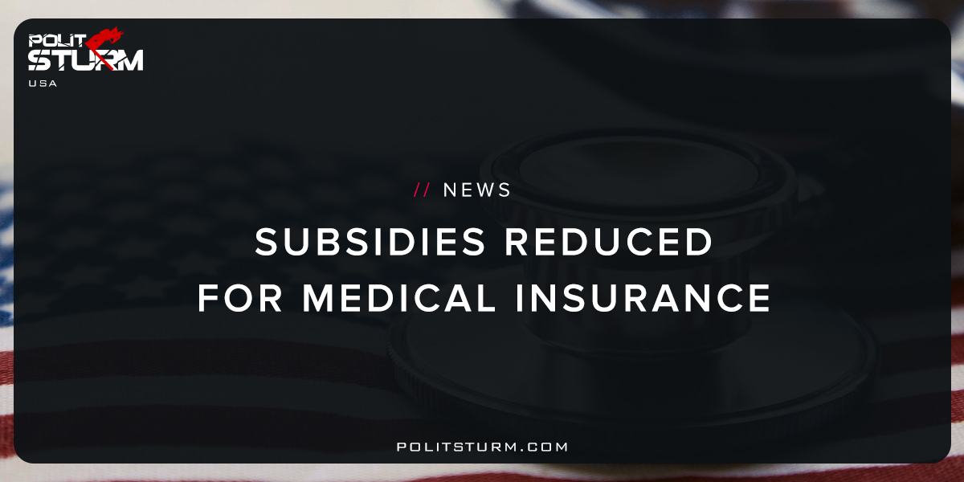

Original article
2017-10-13
1 min read

President Donald Trump plans to cut subsidy payments to insurers in his most aggressive move yet to undermine Obamacare after months of unsuccessful repeal efforts on Capitol Hill, according to two sources.
The subsidies, which are worth an estimated $7 billion this year and are paid out in monthly installments, may stop almost immediately since Congress hasn’t appropriated funding for the program.
Scrapping the funding is likely to provide another jolt to the already fragile Obamacare markets. The impact may be cushioned by the fact that many insurers had priced next year’s plans higher than they otherwise would have, fearing this decision. Others have already fled the Obamacare markets, which are set to begin open enrollment in Nov. 1 for the 2018 plan year.
Insurers rely on the subsidies to reduce out-of-pocket costs for low-income Obamacare customers. They’re still on the hook to provide the discounted rates to their members under the law, despite no longer receiving the federal funding.
Politsturm: The recent executive order reflects the absurdity of the American health care system which is governed by the capitalist economic system. The government is required to subsidize insurance premiums so that low-income Americans can afford healthcare. In this way tax dollars mainly raised by the working class are syphoned off to become the profits of the oligarchs through executive salaries, dividends, interest and capital gains. The American public subsidizes for-profit insurance companies to sell them policies for the health care. One could not imagine a system more advantageous to the wealthy, and destructive to the working class. The bourgeois class can afford to receive the best treatment in the finest facilities anywhere in the world and are unaffected by these changes. This executive order is just a continuation of the war waged against the working class by our own government. It is imperative that the American working class understand this as their lives are literally at stake.
Sources

Original article

