Strep A Outbreak in UK
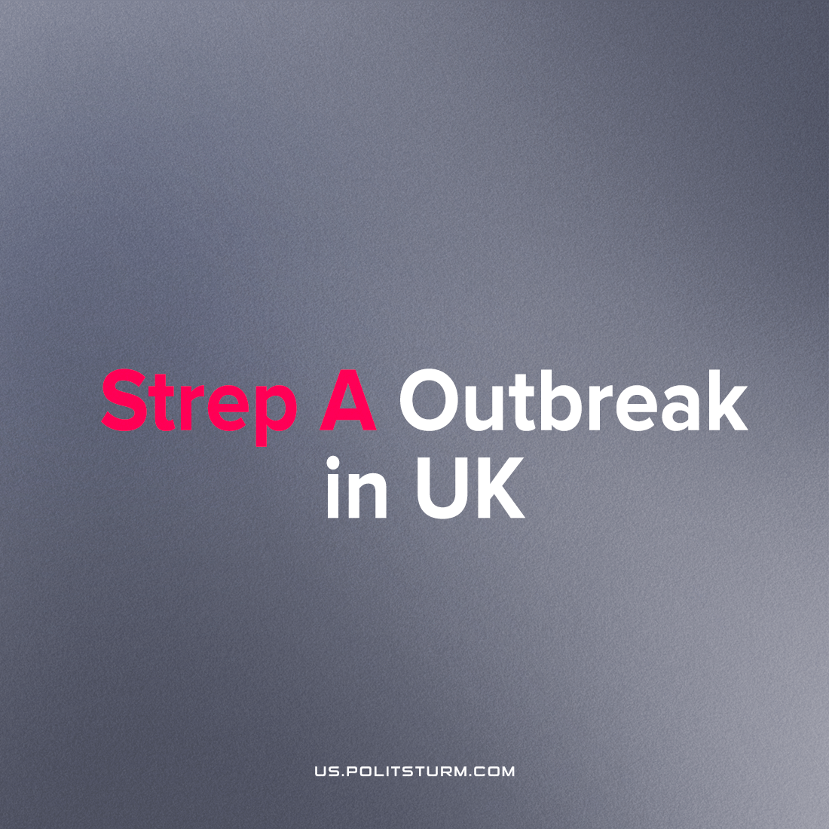

Original article
2022-12-07
2 min read

At least 8 children have died in Britain of Strep A infection since September leading to the UK Health Security Agency (UKHSA) issuing a rare alert on the evening of Friday 2nd of November.
The Prime Minister’s official spokesman stated: ‘We are seeing a higher number of cases of group A strep this year, compared to usual. The bacteria, we know, causes a mild infection which is easily treated with antibiotics and, in rare circumstances, it can get into the bloodstream and cause serious illness. It is still uncommon but it’s important parents are on the lookout for symptoms. But the NHS is well prepared to deal with situations like this, working with the UK Health Security Agency.’¹ He said any parents who were concerned should contact the NHS.
Strep A bacteria is particularly dangerous in children as the complications that can arise from it can lead to: scarlet fever, toxic shock syndrome, rheumatic fever and paediatric autoimmune neuropsychiatric disorders associated with streptococcal infections (PANDAS) among others. These can be fatal if left untreated. Usually only one or two children die as a result of Strep A in a typical winter²: the 8th child to die in just November represents a worrying development in the rapidly expanding health crisis that is affecting the working masses of Britain.
The government and the bourgeois media have speculated that the massive rise could be related to the lowered immune system of children following the isolation of pandemic lockdowns which may be the case. However, this news comes as the health of the British working-class is deteriorating as the National Health Service is buckling under the weight of British imperialism’s crisis. Ambulance drivers, paramedics and nurses have gone on strike as they protest working in awful conditions with little to no pay-rise (which we recently reported on here). It is therefore doubtful that the blame can be placed solely on the COVID-19 Pandemic and the ensuing lockdowns weakening children’s immune systems.
In addition to healthcare crumbling in the United Kingdom, housing in the private sector is, according to a government report, a ‘serious threat to health and safety.’ 600,000 homes according to the National Audit Office (NAO) or about 13% of privately rented homes in England risk their inhabitants lives with a further 25% of homes being ‘non-decent.’ The cost of the proletariat living in squalid housing is costing the NHS £340 million a year.³ Cases of children developing serious complications from mould in their homes entering their lungs highlight the extraordinary poverty that the British proletariat is finding itself in.⁴
It is clear that the bourgeoisie and the media that it controls conceal the reality of this: that dilapidated housing exacerbates the health problems of the workers; that the avarice of the capitalist class leads to dangerous housing, work conditions and the destruction of what little social security the working class has.
Every day brings new evidence to light that the proletarians in Britain are daily being driven en masse further and further into poverty. Without united action, the capitalists will be able to succeed in this endeavour; if the workers wish to end the misery and deprivation caused by capitalist ownership of the means of production and the exploitation of man-by-man they must be organised and directed by Marxist-Leninist theory and tactics to establish a dictatorship of the proletariat. Only then can the workers be truly free from disease, deprivation and destitution.
Sources: 1, 2, 3, 4

Original article

