Public Flogging and Stoning of Women to be Reinstated in Afghanistan
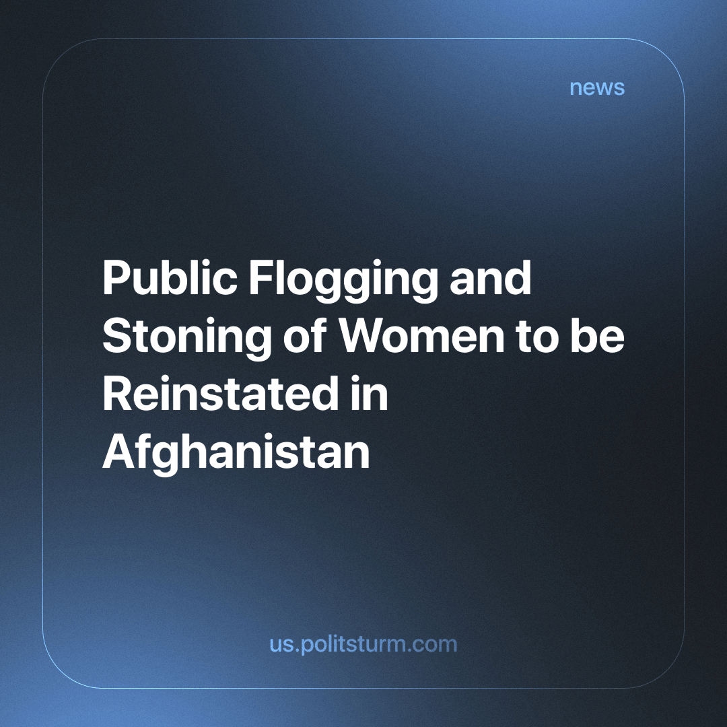

Original article
2024-04-23
1 min read

The leader of the Taliban*, Hibatullah Akhundzada, has announced the reintroduction of public flogging of women and stoning to death for adultery. He also said that human rights are still protected in Afghanistan, but unlike in the West, they are protected as representatives of God, not the devil.
According to Afghan activists, all this is happening because there is no one to hold the Taliban* to account. As there are currently 14 million women in Afghanistan, this news was met with widespread horror.
When the capitalists need to consolidate their power, they can use religion and other means to oppress the working majority. The only way to finally rid ourselves of all forms of inequality is to move towards socialism. Only the power of the workers is capable of establishing complete equality and destroying all forms of oppression.
*The Taliban is an outlawed terrorist organisation in Russia.
Source: Business Online - "Taliban to reinstate public flogging and stoning of women for adultery" dated March 29, 2024.

Original article

