Stephen Ross on the Effects of a Recession
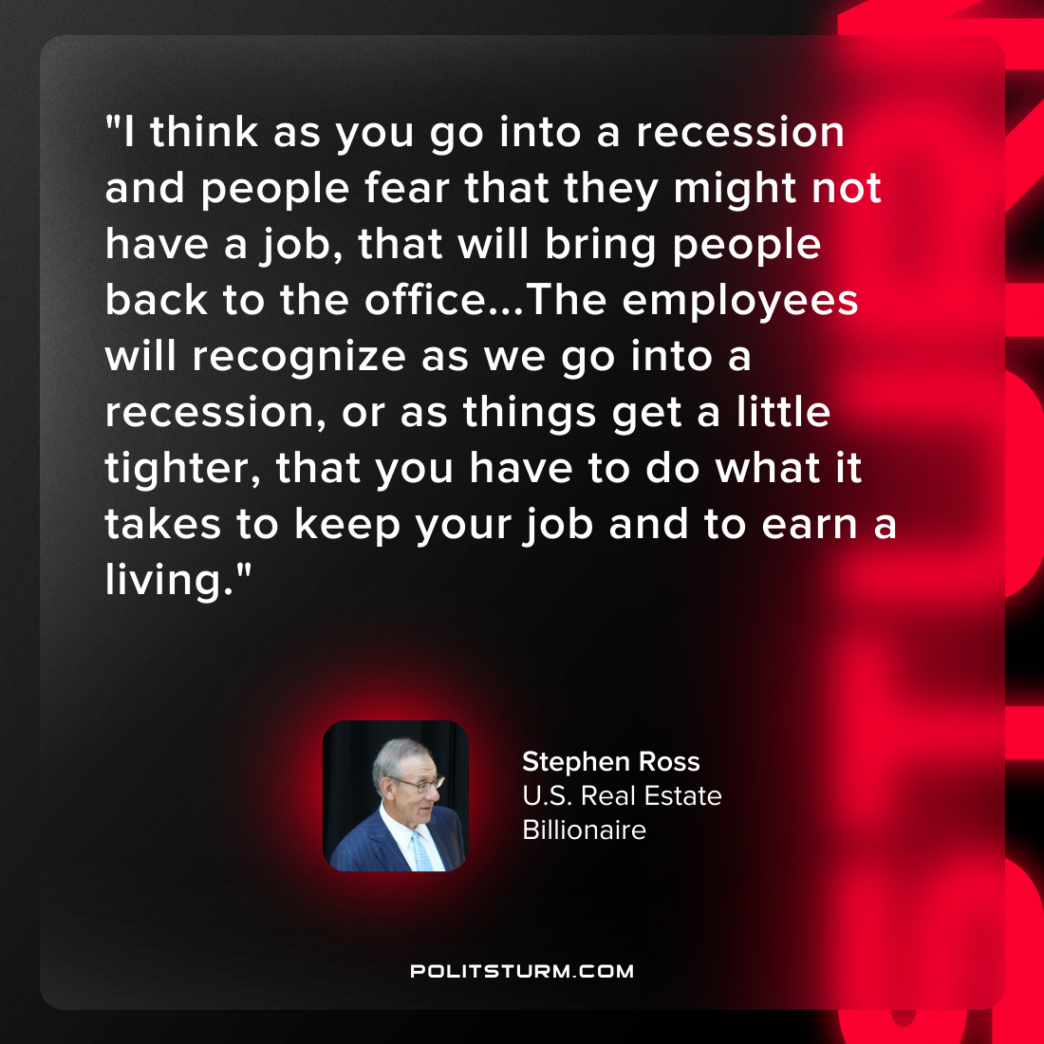

Original article
2022-06-23

“I think as you go into a recession and people fear that they might not have a job, that will bring people back to the office…The employees will recognize as we go into a recession, or as things get a little tighter, that you have to do what it takes to keep your job and to earn a living.”
Stephen Ross
U.S. Real Estate Billionaire

Original article

