Steelworker Union Authorizes Strike Against ArcelorMittal
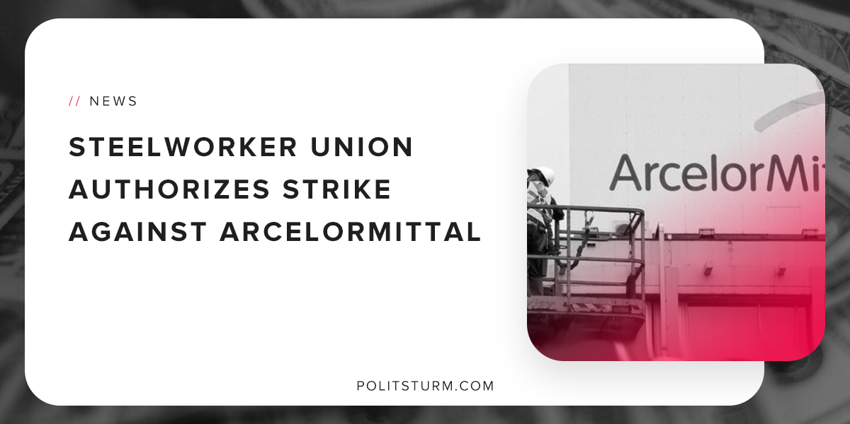

Original article
2018-09-30
1 min read

U.S Steelworkers employed by ArcelorMittal, the world’s leading integrated steel and mining company, have authorized a strike after unsuccessful contract negotiations. Following the implementation of a 25% tariff on steel products imported to the U.S, the company’s income has soared.
Operating income is up 32.5% year-over-year. Net income is up 31.5% year-over-year. Despite these tremendous increases in income and earnings, the company is reluctant to pass the increases along to the working class in the form of increased wages.
It is very important to examine what ArcelorMittal is doing given it’s increased financial position. Interestingly, the company has resumed providing dividends to shareholders. It also bought back $0.2 billion worth of shares in March 2018.
The company is extremely focused on reducing the debt on its balance sheet. Directly from the second quarter shareholder annual report, “Deleveraging remains the Group’s priority and, in the absence of further working capital investment, progress towards $6 billion net debt target should accelerate”.
The company also stated its firm commitment to increasing shareholder returns after reaching its debt target.
If ArcelorMittal increases wages, it will reduce their ability to pass along the profits to its shareholders. This structural foundation of modern capitalist enterprises explains why the company is unwilling to increase wages and working conditions for the workers.
Collective bargaining with the capitalist class has not been a successful strategy for the United States working class. United Steel Worker District 1 Director David McCall is correct when he said, “ArcelorMittal can easily afford the negotiate fair labor agreements with us, but the company has instead insisted on concessions that would more than wipe out any pay increases in its proposal”.
The company could hypothetically provide better wages and working conditions, but instead it funnels dividends to shareholders and reduces debt leverage. There is a simple, rational explanation for this phenomenon. The interests of the capitalist class and workers are diametrically opposed and cannot be reconciled. The working class needs to fight against, and not work with, the bourgeois class.

https://corporate.arcelormittal.com/~/media/Files/A/ArcelorMittal/investors/results/previous-results/2018/pr2018q2-010818.pdf
https://businessjournaldaily.com/steelworkers-union-given-authorization-to-strike-against-arcelormittal/

Original article

