Leader of British Labour Party Praises Margaret Thatcher
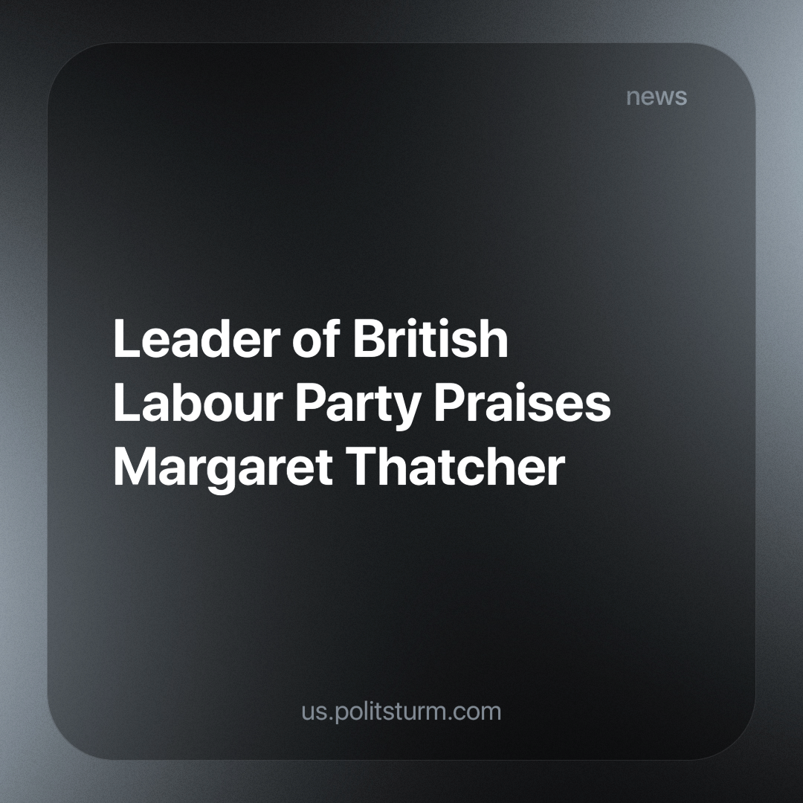

Original article
2023-12-05
4 min read

The leader of the British Labour Party, Sir Kier Starmer, writing in the newspaper “The Telegraph” has offered praise to the infamous Conservative Prime Minister, Margaret Thatcher. He wrote:
“Every moment of meaningful change in modern British politics begins with the realisation that politics must act in service of the British people, rather than dictating to them. Margaret Thatcher sought to drag Britain out of its stupor by setting loose our natural entrepreneurialism. Tony Blair reimagined a stale, outdated Labour Party into one that could seize the optimism of the late 90s. A century ago, Clement Attlee wrote that Labour must be a party of duty and patriotism, not abstract theory. To build a “New Jerusalem” meant first casting off the mind-forged manacles. That lesson is as true today as it was then.”
It is worth remembering, that Clement Atlee, who Starmer is referring to, was elected after the Second World War, and introduced many social-democratic policies we more commonly refer to as the “welfare state”, including the NHS. At the same time, Britain became a founding member of the NATO alliance under him and enacted vicious bombing and terror campaigns against anti-colonial national liberation forces in Malaya and Communists in Greece. He managed to pacify the growing workers’ movement at home with substantial reforms, while repressing progressive movements abroad in an attempt to maintain Britain's prime position in the imperialist hierarchy (which is what funded these reforms).
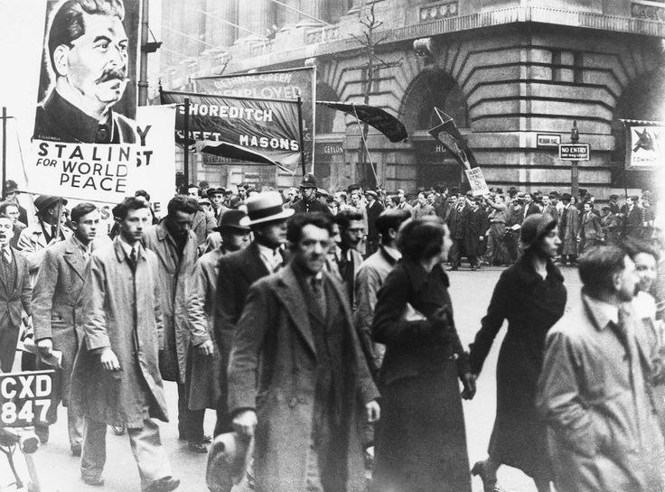
Workers and Communists Protest against Atlee’s government
Margaret Thatcher was elected during a crisis point of British capitalism. Combined with the consequences of the decolonisation process, British heavy industry had become too unprofitable for the industrialists of Britain to maintain. At the same time, they saw greater potential for profit in capital exports and financial speculation. However, there was a militant labour movement that fought back against this, that the capitalists needed to crush. This was the role that Thatcher fulfilled. In addition, she largely initiated and expanded the long and still ongoing process of the curtailment and reversal of the welfare state first as Secretary of State and then as Prime Minister.
It was for this reason that she is exalted as a hero for capitalists. She sought to reduce the state to its bare essentials for them; a tool for the enforcement of their class dictatorship without any of the social programs. This is why during the last Conservative leadership election both candidates sought to brand themselves as new Thatcherites in order to win.
Specifically for ending the state program providing free milk for schoolchildren, she earned the nickname “Thatcher Milk-Snatcher” given to her by the workers of Britain. Funnily enough, this is oddly reflective of Starmer’s’ nickname “Sir Kid Starver” - which he earned by opposing removing the two-child benefit cap which keeps hundreds of thousands of children in poverty.
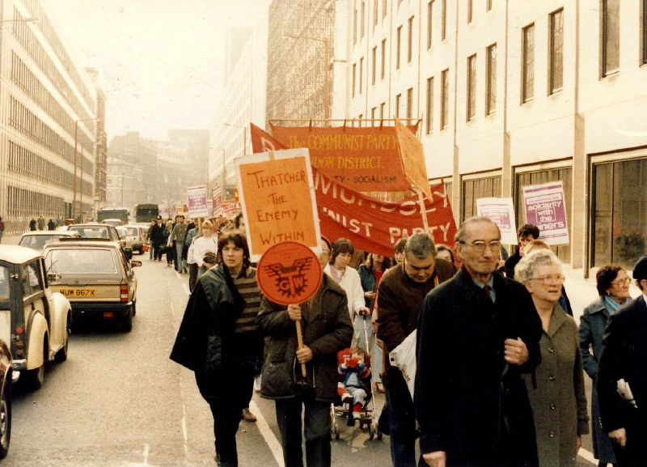
Workers and Communists protest against Thatcher’s government
Tony Blair was a Labour Prime Minister, but unlike his predecessors, he sought to openly re-brand his party as being pro-capitalist, referring to his changes as “New Labour”. Due to his changes the Labour Party dropped all pretences of being socialist and openly sought to curry favour with the capitalists. The greatest demonstration of this was the removal of Clause IV from the Labour Party Rule Book:
“To secure for the workers by hand or by brain the full fruits of their industry and the most equitable distribution thereof that may be possible upon the basis of the common ownership of the means of production, distribution and exchange, and the best obtainable system of popular administration and control of each industry or service”
While the Labour Party’s dedication to socialism was always solely verbal, the removal of Clause IV is significant as it demonstrates the absolute power of the capitalists. They believed the workers' movement had been so thoroughly defeated that veiled opportunism was not even necessary, that socialism had disproven itself, and that we had reached “the end of history”. New Labour continued and expanded many of the privatisation measures that Thatcher started. When Margaret Thatcher was asked what she regarded as her greatest achievement, she is said to have replied: “New Labour”. In addition, Blair is a notorious war criminal responsible for the deaths of millions that resulted from his invasions in Iraq and Afghanistan, which took place against the will of the majority of Britons.
As we can see his praise for historic British leaders is seemingly incoherent, he venerates both the people who erected the welfare state as well as the people who tore it down. However, it is very coherent when viewed from the position of the class that he seeks to represent. His statement is very revealing as all three of these leaders had differing policies that indeed led to change, but what they shared was the fact that they were exemplary servants of the capitalists of Britain. He seeks the affirmation of the capitalists to fulfil this role by winning the general election next year.
Conversely, Marxism-Leninism is the only ideology that recognises society is divided into classes with interests antagonistic to each other; revealing the objective interests of the working class and providing a coherent and consistent framework for fighting for these interests to the full extent. It is through the study of Marxism-Leninism that a true path to liberation is revealed.
Sources:
https://www.telegraph.co.uk/news/2023/12/02/voters-have-been-betrayed-on-brexit-and-immigration/
https://www.thetimes.co.uk/article/i-admire-your-resolve-margaret-thatcher-told-tony-blair-288tjxfst

Original article

