Starbucks Workers Form First Union in Company History
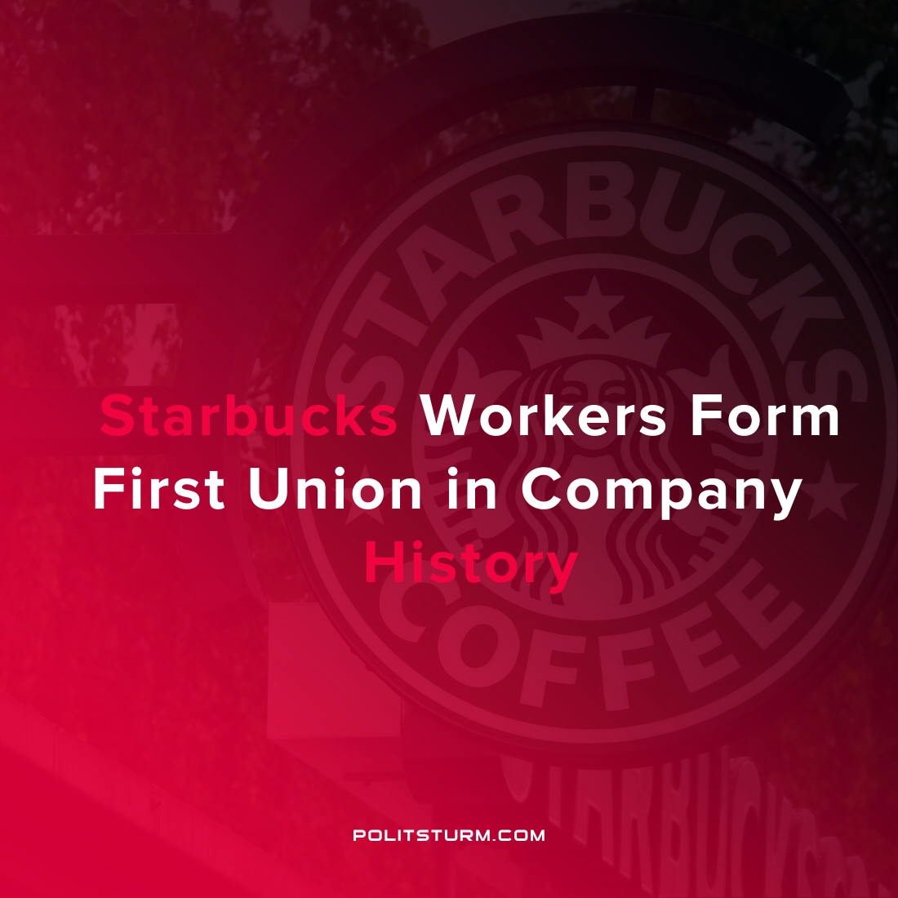

Original article
2021-12-10
1 min read

Starbucks workers at a store location in Buffalo, New York voted to unionize. If certified this would be the first Starbucks store to unionize in the company’s history. The National Labor Relations Board (NLRB) stated that the workers voted in favor of the union by a vote of 19-8. Starbucks has actively fought against the unionization of its stores.
Despite the efforts of Starbucks to undermine the unionization campaign, not all capitalists were fundamentally opposed to the results. Trillium Asset Management and Parnassus Investments, representing over $1.3 trillion in investments, wrote a letter urging the company to accept the unionization results and to proceed according to the results.

“As investors, we believe that Starbucks should abide by international standards and best practices and its own words about engaging in good faith with workers to maintain positive labor relations”
While the results are historic and an encouraging development within the U.S. labor movement, it must be acknowledged that there are definite limitations of concessions that workers can achieve through collective bargaining and unionization devoid of any Marxist-Leninist theoretical foundation. As long as the capitalist economic system exists, investors know that they will continue to profit based on their private ownership of the means of production. While the Starbucks Workers Union refers to the workers as “partners”, the relationship between the capitalists and workers is not a partnership but an exploitative class relation which cannot be resolved through economism.

Source: 1 , 2 , 3

Original article

