Starbucks and Nespresso Found Sourcing Coffee from Child Laborers
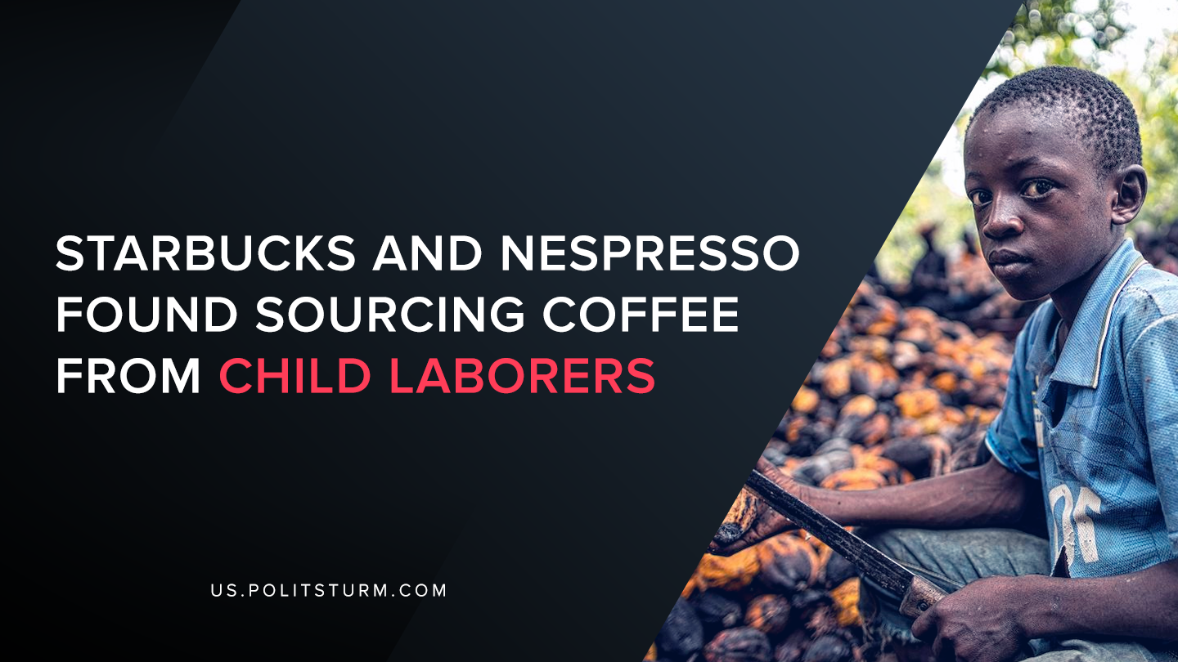

Original article
2020-03-04
1 min read

According to an investigation launched by UK Channel 4’s Dispatches, both Starbucks and Nespresso were being supplied coffee beans that were picked from children as young as 8 years old. Children were filmed working 40-hour workdays picking coffee for extremely low wages and under grueling labor conditions.
In a message to customers and company shareholders, the company stated that they have “zero tolerance for child labor anywhere in our supply chain”. The statement also stated that the company was ‘deeply concerned’ when they were informed about the utilization of child labor in their supply chain.
The company also stated that their practices surrounding child labor were “best in class” and they are taking steps to eliminate the sourcing of products that were produced with child labor.
We see that while the capitalists say that they are against the utilization of child labor, their actions demonstrate their hypocrisy. While the company spouts meaningless phrases about doing more to “support the future of coffee for all”, they continue to amass massive profits at the expense of the Central American children working under grueling conditions.
The capitalist economic system is predicated upon the appropriation of unpaid labor, in this case the appropriation of unpaid child labor. While the companies involved will claim ignorance and rhetorically support future actions against child labor, the continued existence of child laborers under capitalism suggests otherwise.
https://stories.starbucks.com/stories/2020/a-message-from-starbucks-svp-global-coffee-zero-tolerance-for-child-labor/
https://www.channel4.com/press/news/dispatches-starbucks-and-nespresso-truth-about-your-coffee

Original article

