Stalin's Birthday: Anniversary
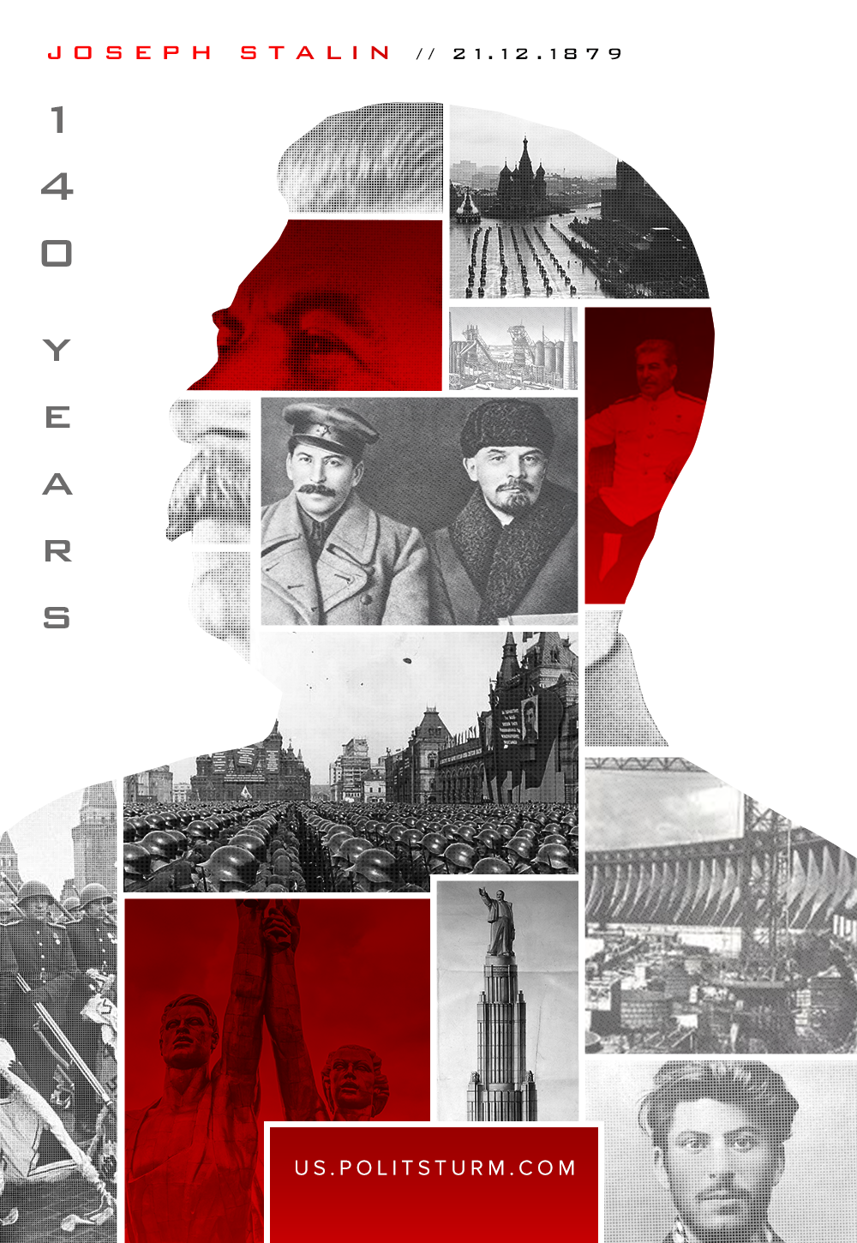

Original article
2019-12-21
2 min read

The greatest builder of communism, Lenin’s student, a Russian revolutionary and a Soviet statesman – Joseph Vissarionovich Stalin was born today. The period of his life marked the greatest period in the history of Russia and of all mankind – the era of victories and decisive transformations.
Having taken the lead in the party after Lenin’s death, Stalin became the leader of the country after the destructive civil war, which drove the young Soviet Republic into a state of utter ruin.
The country faced the problem of further development. Its successful solution was to put the Marxist theory into practice – in the direction that Lenin had set it. Having established the state apparatus, trained personnel and gathered resources, a peasant country with a predominantly agrarian population demanded speedy industrialization and a comprehensive transformation.
During the difficult internal party struggle, the fate of the peoples of the USSR and the entire communist movement was decided. It was under the leadership of Joseph Stalin that the party was able to mobilize forces in order to repulse the opportunists and “fellow travelers”, defeating them in the 20s and 30s.
This was followed by a no less difficult battle: forced industrialization of the country, the creation of a powerful industrial complex that would not only provide material support for the workers, but also prepare for the upcoming war with imperialism. And this task was accomplished by the efforts of the Communists and working people of the Soviet country: the Soviet Union gained industrial centers and modernized agriculture based on the collective labor of collective farmers.
Several decades of development passed almost instantly. Destroyed, impoverished, illiterate and agrarian Soviet Russia, as it was in 1922, by 1941 turned into a powerful stronghold of the socialist system: with its own heavy industry, mechanized agriculture and a wide sphere of social rights and guarantees. Each worker of the Soviet Union had the right to have a job and higher education, which was assigned to him by the Soviet Constitution.
The terrible years of the Great Patriotic War were met by the peoples of the Soviet Union with a mighty force. This force was prepared and nurtured by the Communist Party. It was under the banner of communist ideas that the legendary Red Army defended Moscow, Leningrad, unshakably fought for Stalingrad and liberated the territories occupied by Germany.
The history of the first half of the 20th century showed what the dictatorship of the proletariat is capable of, armed with Marxist-Leninist theory and a disciplined communist party. The history gave the world an example of a better life, free from exploitation and oppression of labor. For modern communists, the experience of the first socialist revolution is very valuable. For them, it’s the main guideline in their current and future struggles. And all these successes would have been impossible to achieve if it were not for the competent leadership of the Bolshevik party, whose leader and responsible person was Joseph Stalin.

Original article

