Stalin on the Definition of a Nation
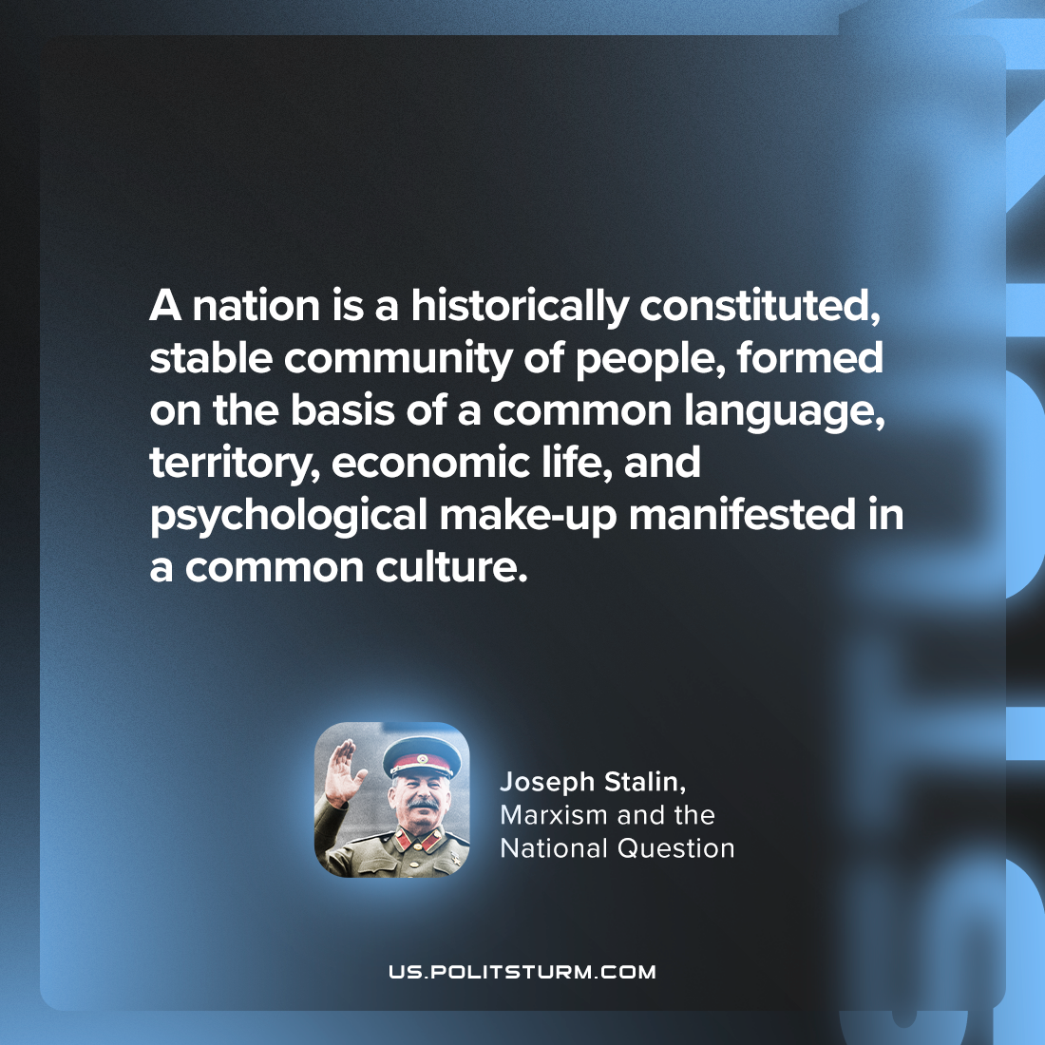

Original article
2024-06-11

"A nation is a historically constituted, stable community of people, formed on the basis of a common language, territory, economic life, and psychological make-up manifested in a common culture."
Joseph Stalin, Marxism and the National Question

Original article

