Stalin on Unemployment
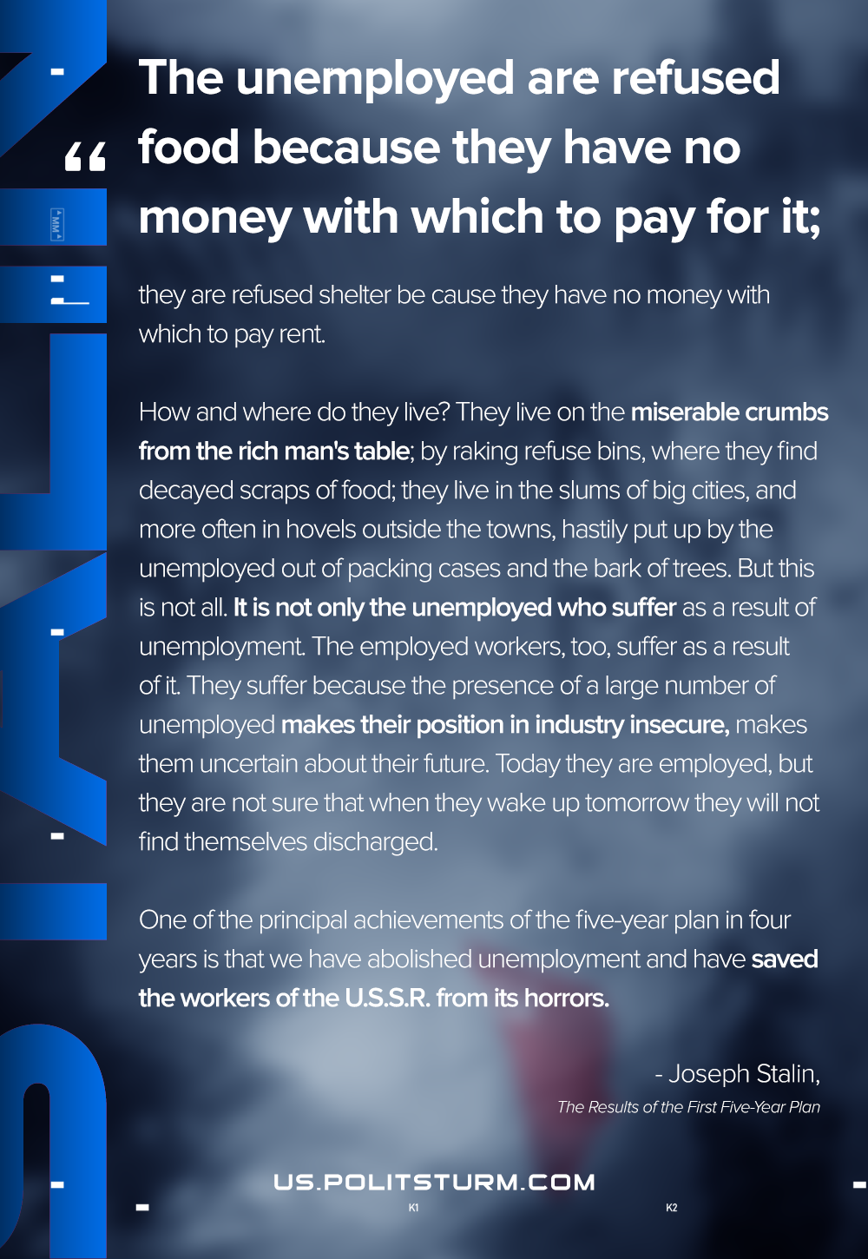

Original article
2021-02-25
1 min read

The unemployed are refused food because they have no money with which to pay for it; they are refused shelter be cause they have no money with which to pay rent. How and where do they live? They live on the miserable crumbs from the rich man’s table; by raking refuse bins, where they find decayed scraps of food; they live in the slums of big cities, and more often in hovels outside the towns, hastily put up by the unemployed out of packing cases and the bark of trees. But this is not all. It is not only the unemployed who suffer as a result of unemployment. The employed workers, too, suffer as a result of it. They suffer because the presence of a large number of unemployed makes their position in industry insecure, makes them uncertain about their future. Today they are employed, but they are not sure that when they wake up tomorrow they will not find themselves discharged.
One of the principal achievements of the five-year plan in four years is that we have abolished unemployment and have saved the workers of the U.S.S.R. from its horrors.
Stalin, The Results of the First Five-Year Plan

Original article

