Stalin on Unemployment
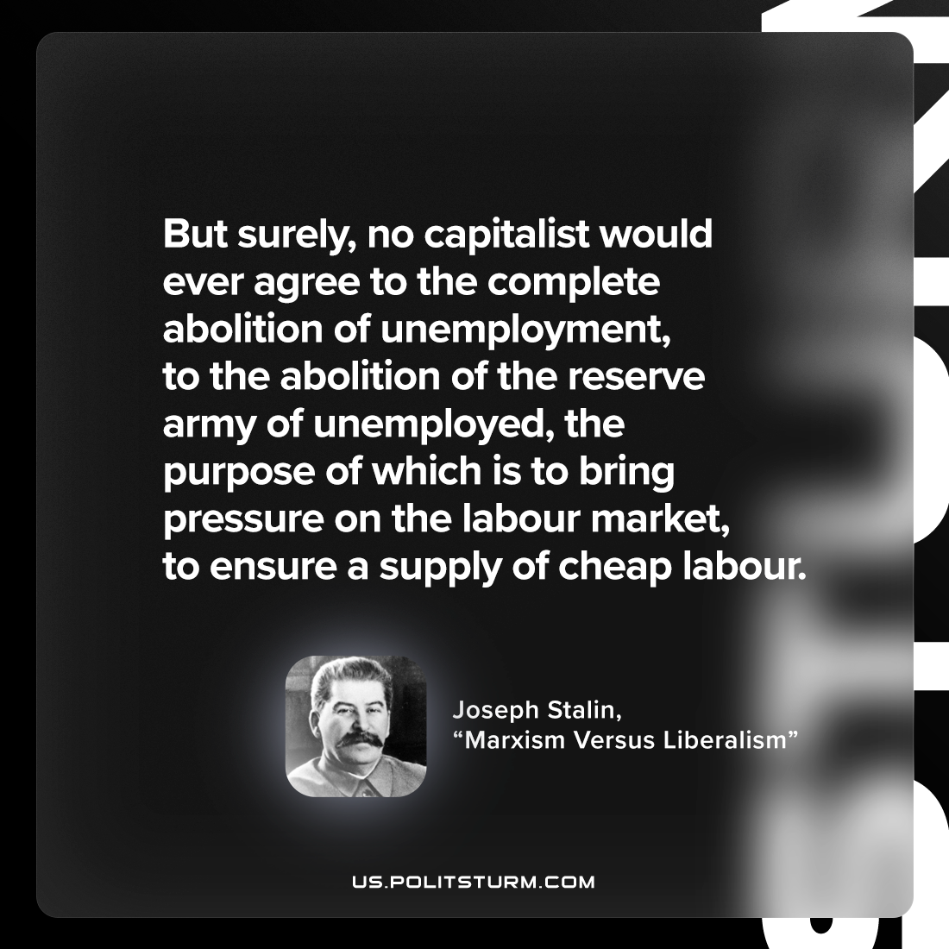

Original article
2022-12-13

"But surely, no capitalist would ever agree to the complete abolition of unemployment, to the abolition of the reserve army of unemployed, the purpose of which is to bring pressure on the labour market, to ensure a supply of cheap labour."
Joseph Stalin, "Marxism Versus Liberalism"

Original article

