Stalin on Theory and Practice of the Party of the Proletariat
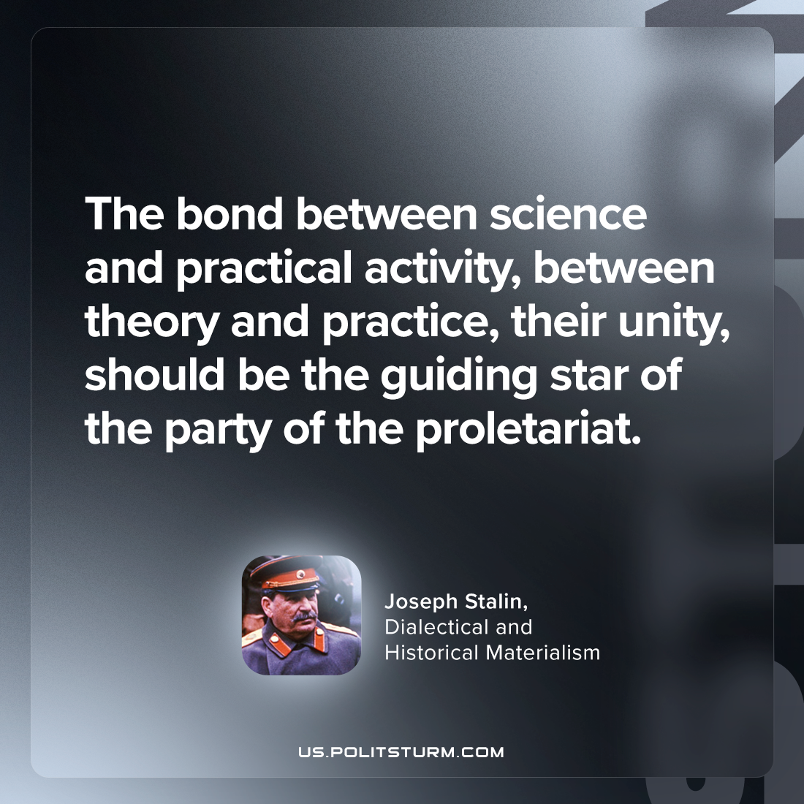

Original article
2023-12-16

"The bond between science and practical activity, between theory and practice, their unity, should be the guiding star of the party of the proletariat."
Joseph Stalin, Dialectical and Historical Materialism

Original article

