Stalin on the Workers' Struggle Against National Oppression
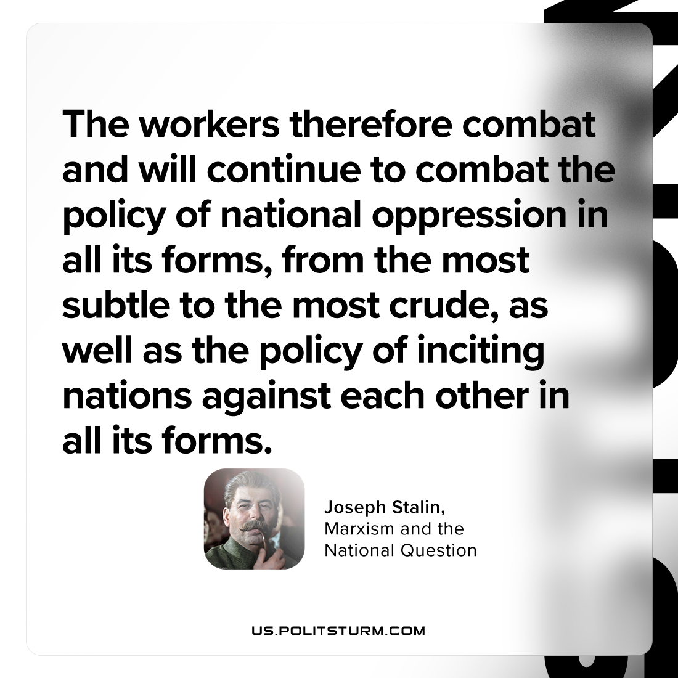

Original article
2023-11-04

"The workers therefore combat and will continue to combat the policy of national oppression in all its forms, from the most subtle to the most crude, as well as the policy of inciting nations against each other in all its forms."
Joseph Stalin, Marxism and the National Question

Original article

