Stalin on the Solution of the National Question
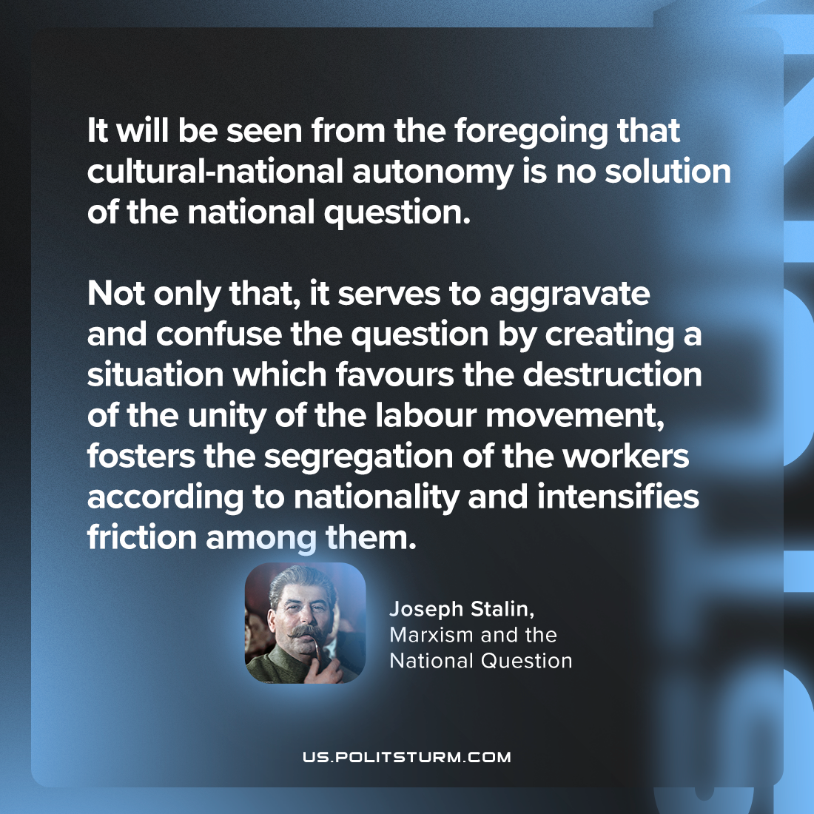

Original article
2024-01-23

"It will be seen from the foregoing that cultural-national autonomy is no solution of the national question. Not only that, it serves to aggravate and confuse the question by creating a situation which favours the destruction of the unity of the labour movement, fosters the segregation of the workers according to nationality and intensifies friction among them."
Joseph Stalin, Marxism and the National Question

Original article

