Stalin on the Role of the Party
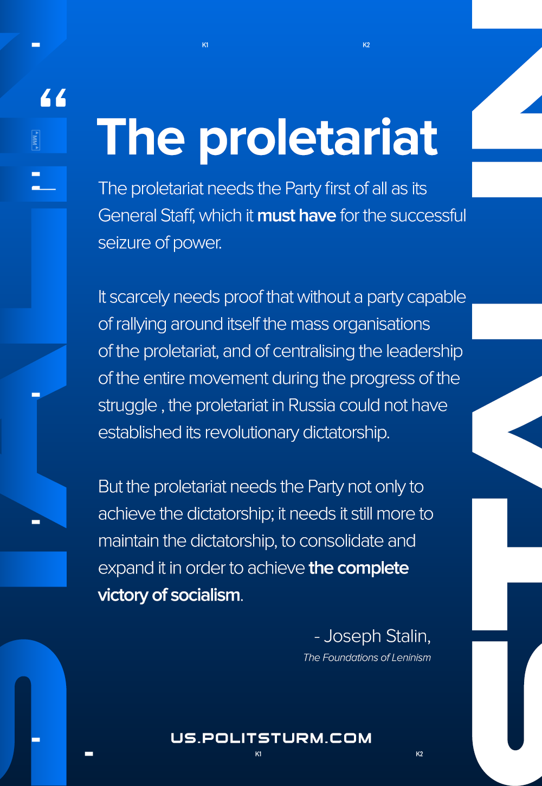

Original article
2020-12-15
1 min read

The proletariat needs the Party first of all as its General Staff, which it must have for the successful seizure of power. It scarcely needs proof that without a party capable of rallying around itself the mass organisations of the proletariat, and of centralising the leadership of the entire movement during the progress of the struggle, the proletariat in Russia could not have established its revolutionary dictatorship.
But the proletariat needs the Party not only to achieve the dictatorship; it needs it still more to maintain the dictatorship, to consolidate and expand it in order to achieve the complete victory of socialism.
Joseph Stalin, The Foundations of Leninism

Original article

